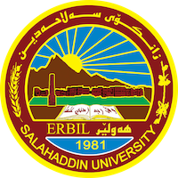
Academic Curriculum Vitae

Personal Information:
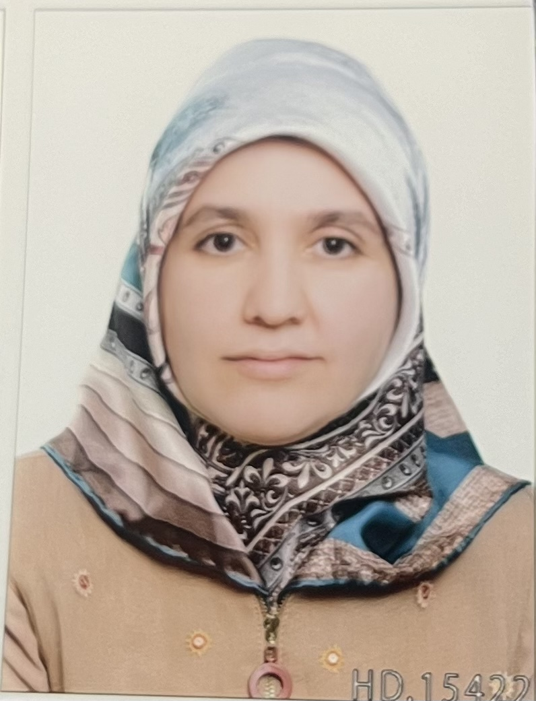
Full Name: Natheerah Ibraheem Abdi
Academic Title: Lecturer
Email: (university email) nazhirah.abdi@su.edu.krd
Mobile: 07507363753

Education:
- BA in Sociology ,Salahaddin University, College of Arts, Department of History,2011-2012.
- MA in Sociology, History, Salahaddin University, College of Arts, Department of History,2017.Master Thesis Title Taking Care of Child with Autism according to Family and Experts prospective (A Field Study in the City of Erbil Center)
- PhD in Department of sociology, Salahaddin University,Erbil ,Iraq,2020-2021. Social Isolation, its Types and Social and Psychological Effects (A Field Study among Young People in the City of Erbil)

Employment:
- Assistant Researcher, Salahaddin University,College of Arts, Department of Sociology 25/10/2012.
- Assistant lecturer, Salahaddin University,College of Arts, Department of Philosophy ,2/11/2017 .Teaching staff member to date.
- Teacher Salahaddin University,College of Arts, Department of Philosophy ,7/12/2023 to date.

Qualifications
- Computer Training Course (ICDL Course), Salahaddin University-Irbil,8.7.2013 .
- IEITS Certificate 25.3.2014.
- English Language Developing Course ,Salahaddin University,Language Centre 2017.
- Teaching Methods and Research Methodology, Salahaddin University,24.7.2017 to 31.10.2017.
- NLP Assistant Practitioner, Canadian training center of NLP, Oct/2006.
- Diploma in neuro linguistic programming, Canadian training center of NLP, Feb/2006.
- The cours of training and growing trainers (TOT), Youth Activities Developing Center, 6/6/2006.

Teaching experience:
- Academic Skills Academic year 2019-2020
- Philosophical texts in Arabic Academic year 2020-2021
- Philosophy of Education Academic year 2020-2021
- Modren Philosophy Academic year 2021-2022
- Aesthetics(Philosophies of Beauty) Academic year 2022-2024

Research and publications
- Types of social isolation and their social and psychological effects
(social research), in Qalaai Zanist.
- Social isolation and theories explaining it, in Journal University of Duhok.

Conferences and courses attended
- Workshop about heart health,27.2.2023.
- Conference about The impact of using social media platforms on society,23.2.2023.
- Conference About the best graduate research,2.2.2023.

