Poultry Products Technology
19/01/2023
Product technology
Aim of this topic is to understand applications in poultry products technology (meat and egg). The overall goal of the food industry is to produce healthy, nutritious, and tasty food to the consumer. Producing healthy, safe food with a reasonable shelf life is a challenge especially when there are so many steps involved in production.
Poultry Products Technology is a specialized area of the discipline of Food Science and Technology emphasizing and dealing with the processing of poultry and eggs and their uses separately and with other foodstuffs. Many food scientists and technologists, dieticians, and others training in the food service industry at some point in their career will handle poultry products and need to have not only some knowledge of how poultry and eggs are processed and prepared, but also how they can be used for optimum portions and servings. Poultry and Animal Science Production majors who have insight into how the products they produce are ultimately processed and used for food can utilize this knowledge to produce better animals and animal products for human food.
Global consumption of meat
Of the total world consumption of meat in 2030 of 45.3 kg, poultry meat is estimated to contribute as much as 17.2 kg (38%), increased from the contribution of poultry meat in 2015 as much as 13.8 kg (33%). Thus, the contribution of poultry meat is estimated to increase from 33% to about 38%. In 2019, the global poultry market increased by 6% to US$ 231.5 billion. Global consumption peaked in 2019 and a continued upward consumption trend is expected.
The countries with the highest volumes of poultry consumption in 2019 were: China (20 million tonnes), the US (19 million tonnes) and Brazil (12 million tonnes). These countries were followed by: Russia, Mexico, India, Japan, Indonesia, Iran, South Africa, Malaysia and Myanmar, Which together accounted for a further 21%.The countries that recorded the highest levels of poultry per capita consumption in 2019 were: Malaysia (63 kg per person), the US (58 kg per person) and Brazil (57 kg per person). The most notable rate of growth in terms of poultry per capita consumption, amongst the leading consuming countries, was Myanmar.

Global poultry forecast 2020-2030
Estimated animal protein consumption worldwide in 2020, by source (in million metric tons)
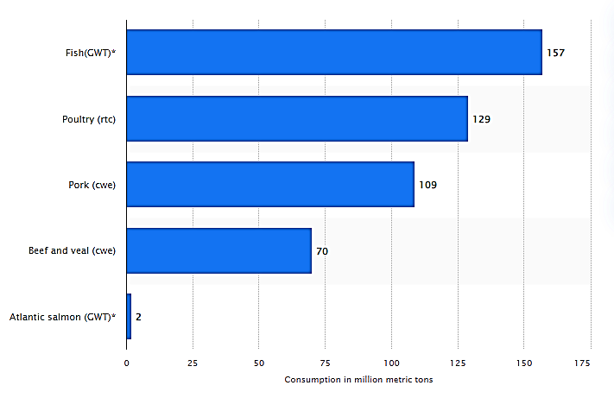
Per capita consumption of meat worldwide from 2018 to 2020, with a forecast for 2030, by region (in kilos)
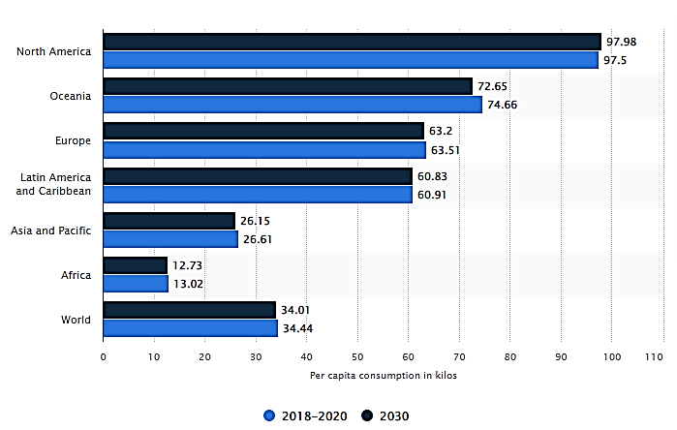

Projected poultry meat consumption worldwide from 2021 to 2030 (in metric kiloton)
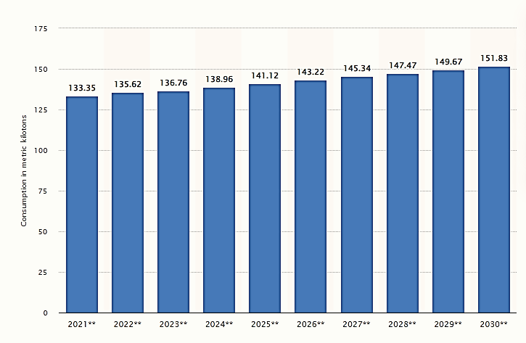
Based on a comparison of 155 countries in 2018, ''Israel'' ranked the highest in poultry meat consumption per capita with 67.5 kg followed by Trinidad and Tobago and USA. On the other end of the scale was Chad with 0.450 kg, Kenya with 0.610 kg and Ethiopia with 0.690 kg.
Average poultry meat consumption per capita reached 15.6 kg in 2018 in the World according to Faostat. This is 0.450% more than in the previous year and 12.5% more than 10 years ago. Historically, average poultry meat consumption per capita reached an all time high of 15.6 kg in 2018 and an all time low of 2.90 kg in 1961. The average annual growth amounted to 2.99% since 1961.
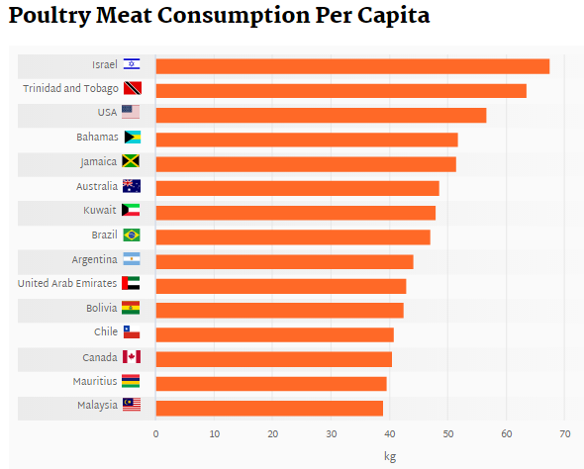
Poultry products consumption in Iraq country and Iraq neighbors
The growing demand for poultry meat, inclusive of products, such as processed burger and sausages. Moreover, poultry meat is anticipated to be one of the most preferred choices among consumers, citing regular protein intake, and readily available products across retail shelves and restaurant menus.
Historically, average poultry meat consumption per capita(kg)
Years | 2012 | 2013 | 2014 | 2015 | 2016
Iraq | 13.41 | 14.86 | 6.26 | 11.3 | 9.61
Iran | 24.7 | 25.4 | 25.9 | 25.5 | 27.2
Turkey | 19.3 | 18.8 | 19.4 | 20.1 | 20
Saudi Arabia | 43.6 | 49.1 | 40.4 | 43.3 | 44.6
Jordan | 33.3 | 33.4 | 30.5 | 28.9 | 26.7
Kuwait | 58.5 | 53.6 | 46.3 | 46.9 | 46.7
Syria | - | - | - | - | -
Kurdistan region | ? | ? | ? | ? | ?

Benefits of Egg consumption
Eggs contain essential nutrients such as vitamins, minerals, and protein needed for a healthy life. They are simple to prepare and a convenient food source. Eggs are also quite affordable which is suitable for the low-income households. Regulation of the egg production industry ensures the eggs produced are safe for human consumption and ensures there is no damage to the environment.
Eggs are sometimes eaten raw or used in salads, baked foods, stews, and as a snack. In most places, eggs are an essential food component due to their nutritious value. Some of the factors that affect consumption of eggs in particular regions are cultural values, religious beliefs, customer preference, and income levels.
The countries leading in the average consumption of eggs per person are Japan, Paraguay, China, Mexico, Ukraine, Malaysia, Brunei, Slovakia, Belarus, and the Russian. Japan consumes more eggs than anywhere else in the world. On average, a Japanese individual eats 320 eggs annually. The demand for eggs in Japan is so high that the poultry population is almost equal to the human population of 120 million residents. Japan is also one of the world’s major importers of eggs and egg products. In some cases, eggs are enriched with minerals and vitamins and sold at a premium. Eggs in Japan are mostly eaten raw. Nonetheless, they are also consumed in pastries, in savory dishes, and with rice.
Eggs are an essential source of protein in Chinese households where the average person eats roughly 300 eggs per year. Eggs are a convenient, cheap, and nutritious food source in China. A large percentage of the eggs consumed in China are produced in small-scale farms in rural China. The Chinese consume their eggs in cooked or raw form. Eggs are also used as ingredients in making desserts such as custard and mousse. The country has restrictions on the use of antibiotics and pesticides in poultry farms.
Based on a comparison of 157 countries in 2013, China ranked the highest in egg consumption with 81,658 kt followed by USA and India. On the other end of the scale was Djibouti with 0.304 kt, Guyana with 0.780 kt and Guinea Bissau with 1.17 kt.
Average egg consumption reached 63,587 kt in 2013 in the World according to Faostat. This is 1.17 % more than in the previous year and 17.3 % more than 10 years ago (2003). Historically, average egg consumption reached an all time high of 63,587 kt in 2013 and an all time low of 14,027 kt in 1961. The average annual growth amounted to 2.95 % since 1961.
Global egg consumption
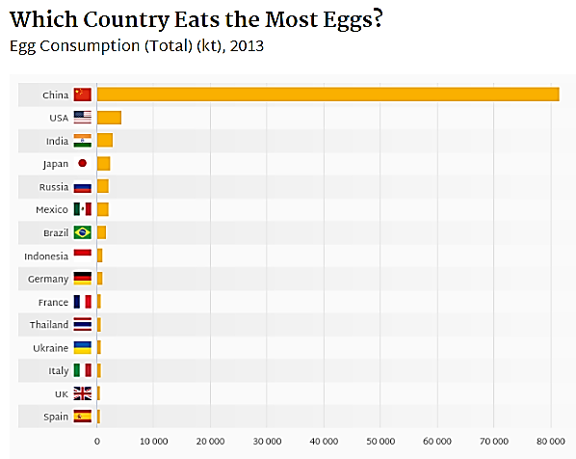
Average egg consumption per capita reached 9.68 kg in 2018 in the World according to Faostat. This is 1.14% more than in the previous year and 9.09% more than 10 years ago. Historically, average egg consumption per capita reached an all time high of 9.68 kg in 2018 and an all time low of 4.54 kg in 1963. The average annual growth amounted to 1.33% since 1961.
Based on a comparison of 155 countries in 2018, Kuwait ranked the highest in egg consumption per capita with 21.9 kg followed by Mexico and Japan. On the other end of the scale was Angola with 0.070 kg, Kenya with 0.150 kg and Congo with 0.180 kg.
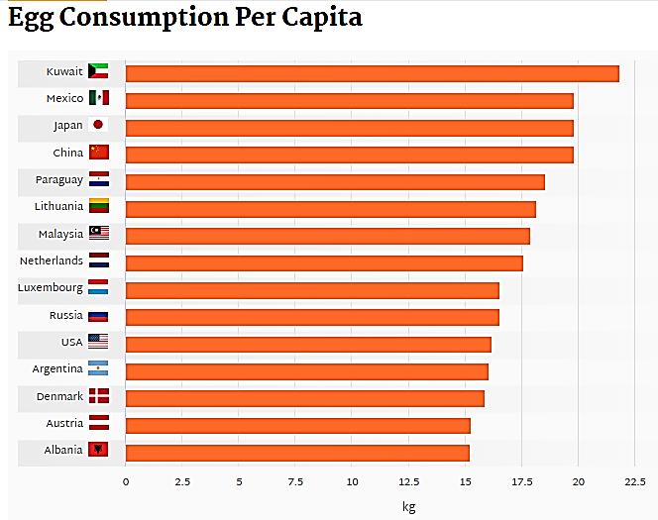
There is still a big difference between developed and developing countries in terms of dealing with food safety and food borne diseases. According to the World Health Organization, about 1.8 million people in developing countries die each year as a result of diarrheal diseases related to contaminated food and water.
Antibiotics are used in poultry production not only for therapeutic purposes; some producers also administer sub-therapeutic dosages for growth promoting purposes, and residues can be detected in eggs and poultry meat if proper withdrawal protocols are not followed. Furthermore, zoonotic bacteria may acquire resistance to antibiotics as a result of administration of sub-therapeutic dosages.
Consumers perceive organic meat as a more healthful food because the birds are not raised with antibiotics, and this is a primary reason why consumers purchase organic poultry products, driving sales of organic poultry meat and eggs, which have continued to increase since 2000.
Because of consumer opposition and concerns over antibiotic-resistant bacteria, gene toxicity and allergies, at the same time, due to the improved standard of living in recent years many countries all over the world have banned or restricted the inclusion of antibiotics in animal diets as a growth promoter. The use of antibiotics in poultry production has resulted in emergence of a niche market consisting of “antibiotic-free”, “organic” or “all natural” labeled products.

