Poultry Products Technology
2/2/2023
PROCESSING POULTRY
Special large-scale plants for processing poultry are common around the world. These plants are specifically designed to process poultry and include slaughtering, de feathering, evisceration, inspection, chilling and packaging operations.

The technological changes in poultry meat processing
Food security means having, at all times, access to healthy, diversified and affordable food. Innovative solutions were created in poultry meat processing driving excellence in performance, food safety and sustainability. Markets demand safer and an ever greater variety of end products. In many markets this leads to automated production and to the desire to produce more different end products. Attention is also being paid to food safety and quality and of course to producing in an ethical and socially responsible way.

In industrial countries before the development of trucks, poultry was shipped live in special train to cities where they were slaughtered just before the consumer purchased them.
Heavy losses caused by respiratory diseases forced the industry to kill and dress the poultry in the areas where it was produced and ship it to consuming areas in refrigerated cars.

During the 1930s, some processors began to eviscerate poultry at the processing plant and freeze it. As a result, practically all poultry is marketed in ready-to-cook form. Perhaps the most important development in the processing industry was the invention of the rubber picking finger.
By the mid-1940s rubber fingered picking machines were perfected to the point where much of the hand labor formerly used for pinning carcasses was eliminated. Mandatory poultry inspection helped to improve the quality of poultry received by consumers. Poultry inspection was available on a voluntary basis in USA was made mandatory in the 1957 Poultry Inspection Act for all processors plants.
To meet inspection requirements many plants had to modernize their facilities, improve the quality of processing, adopt better sanitation practices, and adopt strict quality control programs.
During the 1950s, it was found that the shelf-life of carcasses could be extended by the addition of antibiotics.

Quick chilling of poultry as a means of extending shelf-life came into use and the development of chilling equipment which chills carcasses in a continuous operation rather than in a batch or tank process has been adopted by the industry. Bulk and tray packed items now are on the markets that have longer shelf life because the air has been evacuated and replaced with carbon dioxide.
Cut up whole poultry and breast deboning machines introduced to processing plants that effectively debone breasts without leaving excessive muscle on the skeleton.

Automatic materials handling and automated eviscerating systems have been the most recent advances in technology, allowing further substitution of capital for labor. Automatic live bird catching systems have not been perfected to the point where they are practical under commercial conditions.
The poultry industry is now utilizing its by products as well as the meat packing industries. Poultry by-product meal is widely accepted in the feed industry. Remnants from deboning and further processing are in demand by the growing pet food industry.
Environmental issues such as the disposal of poultry manure may well become an important factor in limiting the size of poultry enterprises in some areas of the country in the near future.

Quality Identification :-
Quality has been defined as “the sum of the characteristics of the given food item which influence the acceptability or preference for that food by the consumer.”
Since only those attributes or characteristics which have significance to users are important in marketing, theoretically there could be two or more sets of standards for the same commodity, depending on its use.

Grades are used to classify a commodity into different levels or ranges of quality such as a good, better, best or C, B, and A grades. Grades are based on standards.

Standards “Descriptions of one or more characteristics of good which divide those on the market into two or more groups called grades.” Commodities are compared against a standard or set of standards to determine their grade.

Standards for poultry can be divided into three general groups:-
- Government standards,
Government standards are those developed by federal, state, county, or local agencies. They can be voluntary, as in the case of certain standards of quality, or compulsory, or in the case of inspection of poultry processed for shipment between states.
- Trade standards,
Trade standards are those expressed or implied grade levels made up by individual companies. Although the consumer may not know the specifications for a particular trade standard he or she soon learns through use that a particular brand infers a certain minimum level of quality
- Research standards.
Research standards are often developed by research workers as a standard or control against which other batches of the product treated or handled in a slightly different manner can be compared.
A number of factors must be taken into consideration when developing standards or grades.

Quality Maintenance
Loss in quality in market channels can be caused by handling live birds during the procurement operation, damage to the carcass during processing, and loss of quality because of poor or prolonged storage conditions. Although losses in quality during marketing generally do not result in condemnation of a whole carcass, the monetary loss caused by a reduction in yield and grade are considerable.

Handling
Although small in size birds are awkward to handle because they are of an odd shape and they struggle and spread their wings when held by the feet. To prevent the escape of birds previously placed in crates, the crate opening is just slightly larger than the minimum size which is needed to allow entrance of the birds. Injury to a bird can result from careless handling of either individual birds or crates of birds.

Shrinkage
Shrinkage is the loss of weight of live poultry between the time it is picked up at the farm and delivered to the processing plant. The following factors influence shrinkage:
- The time in transit from loading to market,
- The ration fed,
- The sex (males lose more weight than females), and
- Changes in temperature and humidity.

As the length of time from loading increases the shrinkage also increases but at a decreasing rate. The decreasing rate can probably be explained by the fact that birds generally straggle and excrete when picked up but relax as soon as they are placed in a crate. Birds fed on high fiber rations show the greatest shrinkage. High temperatures also increase the amount of weight lost; high humidity reduces it. Crowding in coops also appears to influence weight loss.

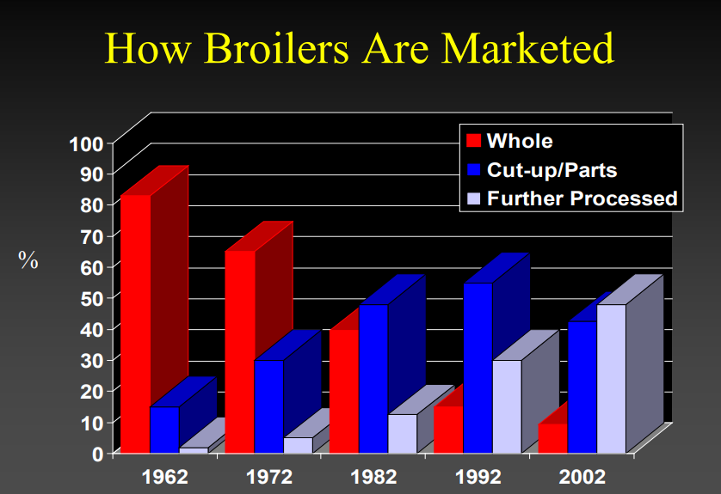

STEPS OF POULTRY PROCESSING IN MODERN SLAUGHTER HOUSES:-
1. RECEIVING AND WEIGHING
This process usually starts with a bulk weighing of the birds received on the truck once the truck enters the processing plant. The live weight is used as the basis for calculating the payment to the farmer
2. UNLOADING
Unloading the birds from the crates and placing them on the shackle lineis often done manually.
3. STUNNING
Stunning is common in most plants except when religious considerations are involved (e.g., according to the Jewish and Islamic laws known as Kosher and Halal, respectively). When stunning is used, it can be done by an electrical current, gas or mechanical means. Stunning prior to slaughtering was originally done to immobilize the animal and allow for easier and safer handling of the animal. This was especially true for large, red meat animals. For poultry, immobilization was not as critical for manual slaughtering, but was necessary for the development of automated equipment. More recently, stunning has been used primarily from an animal welfare perspective as a means to minimize the pain and suffering associated with the slaughter process. From this point of view, stunning should produce a rapid onset of stress-free insensibility of sufficient duration to allow the animal to remain unconscious until dead.

4. BLEEDING
Opening the blood vessels in the neck results in bleed-out. There are several ways of cutting the blood vessels in poultry. The so-called “Modified Kosher,” which is one of the most common methods, results in cutting the jugular vein just below the jowls so that the windpipe and esophagus remain intact.

5. SCALDING
Scalding is the process of immersing the birds in warm water to loosen the feathers. In a small plant, scalding can be performed manually. but in large plants, it is done in a continuous manner employing a single stage or multistage scalding bath while the birds are suspended from a moving shackle line.

6. FEATHER REMOVAL
In large processing plants, feather removal is done by mechanical pickers/pluckers equipped with rubber fingers that rub the feathers off the carcass.
7. OIL GLAND AND FEET REMOVAL
These steps can be done manually or by automated equipment. In an automated oil gland removal process, a set of metal bars/rails, along the shackle line, position the bird at a certain angle, allowing a rotating blade to cut off the oil gland from the tail area.
Feet removal used to be done manually, but in modern plants, automated equipment is used. It is important that the cut be done between the bones and not through a bone because cuts through the bone will appear dark/red in the chilled bird and, after cooking, will turn dark or almost black.
8. REHANGING
After removing the legs, the carcasses are usually moved to another line. This can be done manually as the carcasses fall onto a sorting table or automatically by transferring the birds to another line. After removing the feet, there is a need to resuspend the birds from the knee joint. Transferring the birds to another line also assists in reducing contamination because the dirty shackles used for the live birds are replaced with cleaner ones.
9. EVISCERATION
In this process, the body cavity is opened and the viscera is withdrawn. This process can be done manually using a knife and a pair of scissors or semi-automatically or fully automatically using a circular cutting blade and a scoop-like arm to withdraw the viscera.
10. INSPECTION
The inspection is done at this point because the inspector can see all parts at the same time. The attached or detached viscera can reveal diseases/problems with the internal organs. This process is essential in ensuring that only wholesome birds, free of disease, will get to the marketplace.
11. GIBLET HARVESTING
The viscera is removed after inspection, and giblets (liver, heart and gizzard) are salvaged and washed in a separate line.
12. LUNGS, HEAD AND CROP REMOVAL
The lungs, head and crop are commonly removed after inspection; however, in some operations, one or all of these organs are removed prior to inspection.
13. INSIDE/OUTSIDE BIRD WASH
There are various devices that can be used at different points along the processing line to wash the birds. One of the most common points is prior to chilling.
14. CHILLING
The meat must be quickly chilled to minimize microbial growth. The most common methods include water-immersion chilling, air chilling and spray chilling (which includes air and water). For immersion chilling, it is common to use long chillers with a counter flow of cold water, sometimes supplemented with crushed ice, to bring the carcass temperature to about 4–5°C within 30–75 minutes.
15. WEIGHING, GRADING AND PACKING
After chilling, the birds are usually weighed, graded and later packed or deboned for further processing. In most large plants, automated weighing equipment connected to a computer network is used to record the weight of each carcass. Grading is done either before or after weighing. Grading can be done by a qualified person or with the assistance of a computerized machine vision system. Overall, the final grade and overall meat quality can be affected by different processing parameters (e.g., stunning, chilling) and various feeding, growing and transporting.

