**Salahaddin University Practical Biology Examination**

**College of Science Date: 18/1/2023**

**Geology Department**

**First stage/3bur**

**Q1/Define the following: - (5)**

**1.Botany**

**2.Prokaryotic cell**

**3.Imperfect fungi**

**4. Hermaphrodites**

**5.Diaphragm**

**Q2/Fill the blanks in suitable answers: - (5)**

**1.Phylum: Cnidaria have four classes which are………….,………………..,………………and…………..**

**2. The organisms belonging to the phylum Nematoda are also known as …………………..**

**3.Mode of nutrition in fungi are……………..,………………. And ………………**

**4. A cell is defined as …………………………………………………………..**

**5. The common name of *Asterias* sp. is…………..**

**Q3/ A-Mention four organelles inside eukaryotic cells. (4)**

**B-The plant cell wall is made up of……………… (1)**

**Q4/** **Write the differences between: -**

**1. prokaryotic and eukaryotic organisms (4)**

**2.Polyp and Medusa (6)**

**Q5/A-Count types of microscopes (3)**

**B-Identify this picture (scientific and common name) (2)**

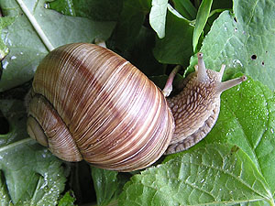

**Q6/A- Identify by writing the common name of this creature (1)**

**B- Classify it (4)**

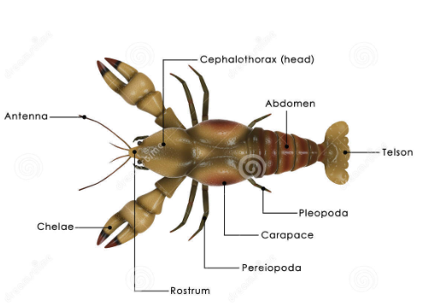

**GOOD LUCK**

**Assistant Lecturer**

**Neveen N. Rajab**