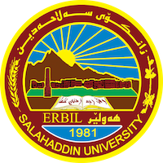
Academic Curriculum Vitae
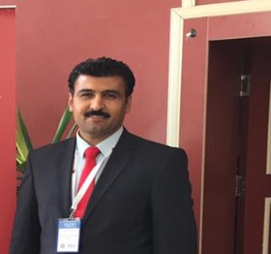
Personal Information:
Full Name: Nihro Mohammed Abdulqader
Academic Title: Phd
Email: nihro.abdulqader@su.edu.krd
Mobile:96407504730502

Education:
Obtaining PhD Degree in field of (Modern and Contemporary History) on 2020. The Thesis has approved by "senior very Good" In the College of Arts-Salahaddin University- Erbil- Iraq which was the first one among all others.
- Obtaining M.A. Degree in field of (Modern and Contemporary History) on 2009. The Thesis has approved by "senior very Good" In the College of Arts-Salahaddin University- Erbil- Iraq which was the first one among all others.
- Obtaining B.A Degree in field of History on 2000- 2004. I occupied the first class in all stages of the collage of the History Department. Here again I have got approval to the degree of "senior very Good". In the College of Arts-Salahaddin University- Erbil- Iraq.
- Gaining Preparatory certificate in 2000 in ( Azadi Preparatory school for boys.
- I have finished the Secondary stage in (1997) in (Iraq secondary School for Boys) in Erbil.
- I have finished the Primary stage in (1993) in (Sharafkandi School for Boys) in Erbil.

Employment:
I had been in the University of Soran as Assistant instructor – Soran University Erbil-Iraq .
Qualifications

I have participated in six months in Methods of Teaching course.
- I have participated in Methods of Computer course in two different curses for two months that was included the programs of (word, windows, excel and PowerPoint as well as internet)
- I have participated in two English learning courses for three months duration.

Teaching experience:
I had been in the University of Soran as Assistant instructor – Soran University Erbil-Iraq .

Research and publications
- State all researches, publication you made.

Conferences and courses attended
- Give details of any conferences you have attended, and those at which you have presented delivered poster presentations.

Funding and academic awards
- List any bursaries, scholarships, travel grants or other sources of funding that you were awarded for research projects or to attend meetings or conferences.

Professional memberships
- List any membership you hold of any professional body or learned society relevant to your research or other life activities.

Professional Social Network Accounts:

- https://www.facebook.com/nahro.muhammad.1

