**Introduction to Biochemistry**

**Biochemistry**

Biochemistry is the study of chemical processes in living organisms. Biochemistry governs all living organisms and living processes. By controlling information flow through biochemical signaling and the flow of chemical energy through metabolism, biochemical processes give rise to the incredible complexity of life.

It is a laboratory based science that brings together biology and chemistry. By using chemical knowledge and techniques, biochemists can understand and solve biological problems.

**Function of biochemistry**

Much of biochemistry deals with the structures, functions, and interactions of biological macromolecules, such as proteins, nucleic acids, carbohydrates, and lipids, which provide the structure of cells and perform many of the functions associated with life.

**Branches of biochemistry**

* Animal biochemistry.
* Plant biochemistry.
* Molecular biology.
* Cell biology.
* Metabolism.
* Immunology.
* Genetics.
* Enzymology.

**Groups of Organic Compounds**

1. Carbohydrates

2. Lipids

3. Proteins

4. Nucleic Acids

5. Enzymes

**Carbohydrates**

Carbohydrates, together with lipids, proteins andnucleic acids, are one of the four major classes of biologically essential organic molecules found in all living organisms. Carbohydrates are organic substances contain Carbon, Hydrogen and Oxygen. A major source of energy from our diet, also called saccharides, which means (sugars). They are defined as polyhydroxy aldehyde or polyhydroxy ketones. The general formula for a carbohydrate is Cn(H2O)n.

Carbohydrates are produced by photosynthesis in plants. Such as glucose are synthesized in plants from CO2, H2O, and energy from the sun. Carbohydrates are oxidized in living cells (respiration) to produce CO2, H2O, and energy.

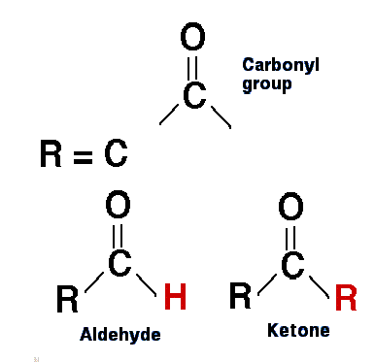

**Functions**

Carbohydrates have a wide range of functions, including:

* Providing a significant fraction of the dietary (Energy) calories for most organisms (average 4 Cal/g). It’s the body’smain energy source (Glucose) and storage form of energy (Glycogen) in the body.
* Precursors of many organic biocompounds in the body (e.g. Fats, Amino acids, other carbohydrates). Sugars are part ofchemical structure of Nucleic acids (Ribose and Deoxyribose).
* Serving as cell membrane components (Glycoproteins and Glycolipids) that mediate some forms of intercellular communication.
* Carbohydrates serve as a structural component of manyorganisms, including the cell walls of bacteria (Peptidoglycan), the exoskeleton of insects (Chitin), and thefibrous cellulose of plants (Cellulose in cell wall).

**Classification and Structure**

On the basis of the number of forming units(Monomers), Carbohydrates are classified into fourmajor classes (Monosaccharaides, Disaccharides, Oligosaccharides, and Polysaccharides).

* Monosaccharides - single sugar unit
* Disaccharides - two sugar units
* Oligosaccharides - 3 to 7 sugar units
* Polysaccharides - more than 7 sugar units

**A: Monosaccharides**

Monosaccharides are simplest form of carbohydrates which can’t be broken down into smaller units by Hydrolysis. The most abundant monosaccharide is D-glucose, sometimes also called Dextrose.

**Classification of Monosaccharides**

**I**: They can be classified according to the number ofcarbon atoms they contain.

Three carbon atoms................ Triose

Four carbon atom ................. Tetrose

Five carbon atom .................. Pentose

Six carbon atom .................. Hexose

Seven carbon atom ....................Heptoses

Eight carbon atom .....................Nonoses

**II**: Monosaccharides can also be classified by the type of carbonyl groupthey contain:

Carbohydrates with an aldehyde group (Aldo group in the end of structure) are called Aldoses sugar, such as Glucose.



Carbohydrates with a Keto group in middle of structure (Usually at C2 atom) are called Ketoses suger. Such as Fructose.



**Glucose**

* Glucose is the sugar of the body, principally used by the tissues to generate energy (ATP). Found in fruits, corn syrup, and honey.
* An aldohexose with the formula C6H12O6.
* Known as blood sugar in the body.
* It’s the building block for: disaccharides (such as Sucrose, Lactose and Maltose) and Polysaccharides (Starch, Cellulose and Glycogen)
* It’s converted to Ribose and deoxyribose for DNA and RNA synthesis.

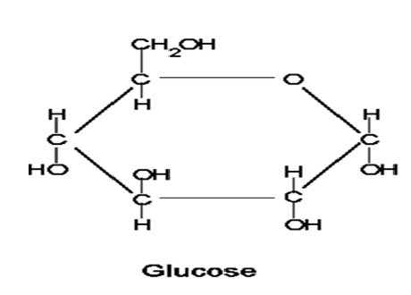

**Fructose**

* Is a ketohexose C6H12O6, is the sweetest carbohydrate, found in fruit juices and honey.
* It’s converted to glucose in liver then used and/or metabolized.
* It’s the universal source of energy for spermatozoa
* Due to sweetness, it can be used as sweetener.

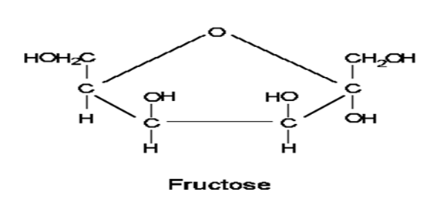

**Galactose**

* An aldohexose C6H12O6.
* Not found as a free form. It’s formed by hydrolysis of Lactose (milk sugar).
* A similar structure to glucose except for the –OH on C4.
* Galactose is converted to glucose then used and/ormetabolized.
* It also majorly used for the synthesis of Milk in mammary glands (in females). It also enters in cellular membranes of brain & nervous system.

