**Disaccharides**

**Disaccharides**

Disaccharides contain two molecules (simple sugars) of the same or different monosaccharide units joined by glycosidic bond. They can be hydrolyzed into two monosaccharide units.

Glycosidic bond: is formed when a hydroxyl group on one monosaccharide reacts with the hydroxyl of another monosaccharide, splitting out water to form a glycosidic bond.



Glycosidic bonds between sugars are named according to the numbers of the connected carbons and with regard to the position of the anomeric -OH group of the first sugar involved in the bond.

* If the anomeric -OH is in the α configuration, then the linkage is an α-bond.
* If the anomeric -OH is in the β configuration, then the linkage is a β-bond.

Lactose, for example, is synthesized by forming a glycosidic bond between C1 of β-galactose and C4 of Glucose. Therefore, the linkage is a β(1→4) glycosidic bond.

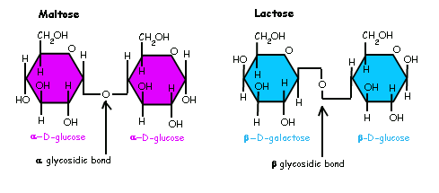

The three most common disaccharides are :

1. Sucrose (Table sugar): Glucose + Fructose
2. Lactose (Milk sugar): Galactose + glucose
3. Maltose: glucose + glucose

**Sucrose**

* Can be hydrolyzed to one molecule of glucose and one molecule of fructose.
* Found naturally in plants: sugar cane, sugar beets, honey
* Sucrose may be purified from plant sources into brown, white and powdered Sugars.

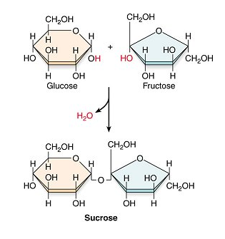

**Lactose**

* Can be hydrolyzed to one molecule of glucose and one molecule of galactose.
* Lactose (Milk sugar): Galactose + Glucose
* The primary sugar in milk and milk products.

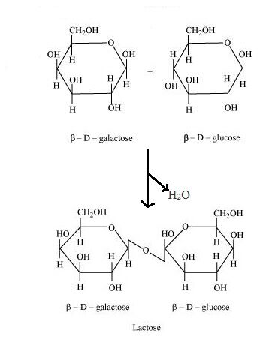

**Maltose**

* can be hydrolyzed to two molecules of glucose
* Maltose: glucose + glucose
* Produced when starch breaks down.

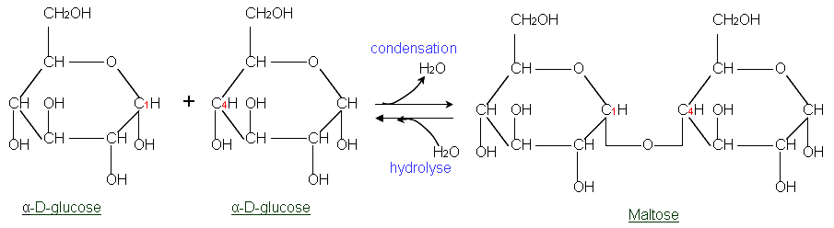

**Oligosaccharide**

* They contain 3-7, monosaccharide molecules for example :
* Raffinose (Galactose + Glucose + Fructose)
* Maltotriose ( Glucose + Glucose + Glucose)

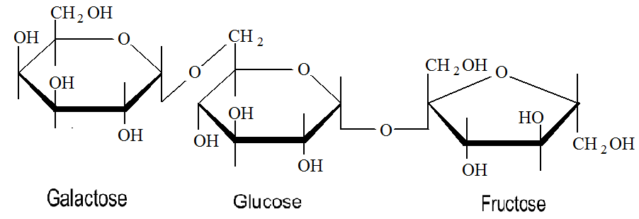

**Polysaccharides**

Polysaccharides also called glycans, they contain more than 7 molecules of monosaccharide units. They are classified in to Homopolysacchardes and Hetropolysacchardes.

* **Homopolysacchardes:** They are polymer of same monosaccharide units. For example:- starch, glycogen and cellulose.
* **Hetropolysacchardes:** They are polymer of different monosaccharide units. For example: mucopolysaccharides.

**Most important Polysaccharides**

1. **Starch**

* The storage form of carbohydrate in plants.
* The major digestible polysaccharide in our diet
* Starch is hydrolyzed by mineral acids (HCl) or in humans by salivary and pancreatic (α-Amylase) enzymes which yields α-Dextrins and finally Maltose and Glucose monosaccharide units.
* Starch composed of the two main constituents which are:
* **Amylose** (15–20%), which has a non-branching α-helical structure. Amylose composed entirely of D-glucose units joined by the α-1,4-glycosidic linkages.
* **Amylopectin** (80–85%), is a branched-chain polysaccharide composed of glucose units linked primarily by α-1,4- glycosidic bonds but the branch points are α 1-6 glycosidic linkage. Branching occurring about every 25–30 units along the Amylopectin structure.

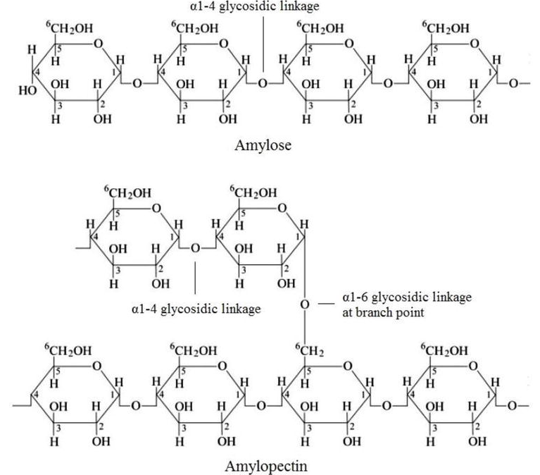

1. **Glycogen**

* Is the glucose storage polymer in humans and all animals.
* Practically all mammalian cells contain some stored carbohydrates in the form of glycogen, but it is especially abundant in the liver and skeletal muscle cells.
* Glycogen is structurally quite similar to amylopectin, but it’s more extensively branched and more compact than Starch. In glycogen, the branches are shorter.
* **Liver glycogen** contributes to maintenance of blood glucose levels, while **Muscle glycogen** is used as readily available source of energy within muscles during exercise.
* Not found in plants.

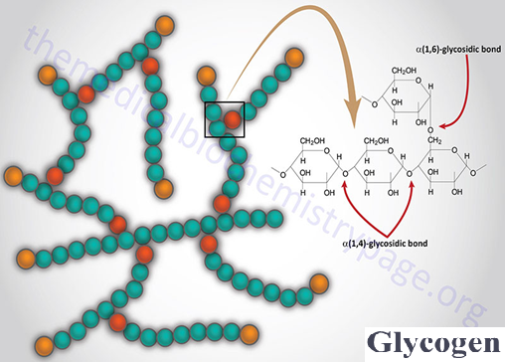

1. **Cellulose**

* Is the chief component of wood and plant fibers.
* It is insoluble in water and is tasteless.
* Cellulose consists of β-D-glucose units linked by β-1-4 glycosidic linkage to form long straight chains (without branch).
* Cellulose cannot be absorbed, digested and metabolized by humans, because of the absence of an enzyme that hydrolyzes the β-linkage (Cellulase) in human digestive system.
* Though not digested in humans, cellulose has great important in human nutrition.

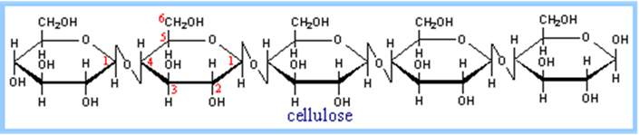

1. **Chitin**

* Is a structural long-chain homopolysaccharide containing nitrogen linked together through β-(1→4)-linkages
* Structural similar to cellulose with hydroxyl group replaced by acetyl amine group.
* It occurs in the exoskeleton of animals such as shrimp, crabs and insects or in cell walls of fungi, yeast and other microorganisms.
* It is the second most abundant organic substance on earth after Cellulose.

