**Chemical properties of carbohydrates**

* **Isomerism**

The isomers of monosaccahrides are different compounds that have same formula, they contain the same number and kind of atoms, but they are attached to each other in different ways, therefore they have different properties

The presence of asymmetric carbon atoms (carbon atoms attached to four different atoms or groups) allows the formation of isomers.

The number of possible isomers of a compound depends on the number of asymmetric carbon atoms (n) and is equal to 2n

Example: **glucose** have 4 asymmetric carbon atoms, therefore it has 16 isomers (2n =24 =16). Asymmetric centers found in (C2, C3, C4, and C5).

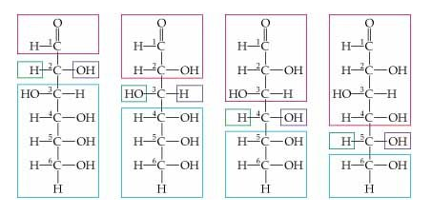

* Carbohydrate isomers that differ in configuration around only one specific carbon atom are defined as **epimers** of each other.
* Glucose and Galactose are C-4 epimers because their structures differ only in the position of the –OH (hydroxyl) group at Carbon 4.
* Glucose and mannose are C-2 epimers.

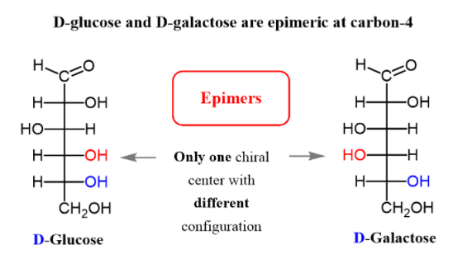

* **Stereoisomerism**: such compounds which are identical in composition and structure but differ in spatial configuration, include :

1- **Enantiomer**: D and L- sugars are referred to as enantiomer. Their structures are the mirror images of each other.

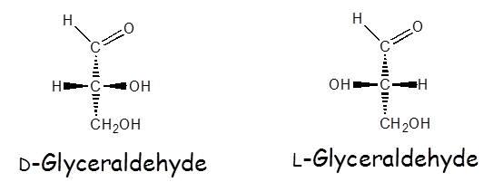

* When the –OH group on this carbon is on the right, the sugar will be D-isomer (designated D from Latin ***Dexto***)
* When the –OH group on this carbon is on the left, the sugar will be L-isomer. (designated L from Latin ***Laevo***)
* Carbon atom 5 (C5) in glucose determine whether the sugar belongs to the D or L isomer
* Only D- glucose or D-sugars are utilized by humans.

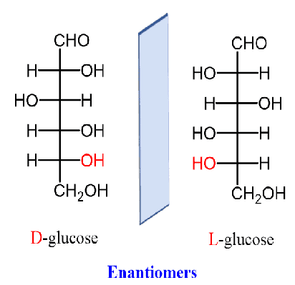

**2-Pyranose and furanose ring structures**

The ring structure of monosaccharide is similar to ring structure of **pyran** or **furan**.



* Ketosugar form Furanose ring structure.
* is formed by combination of keto group and hydroxyl group (-OH) at carbon atom C5

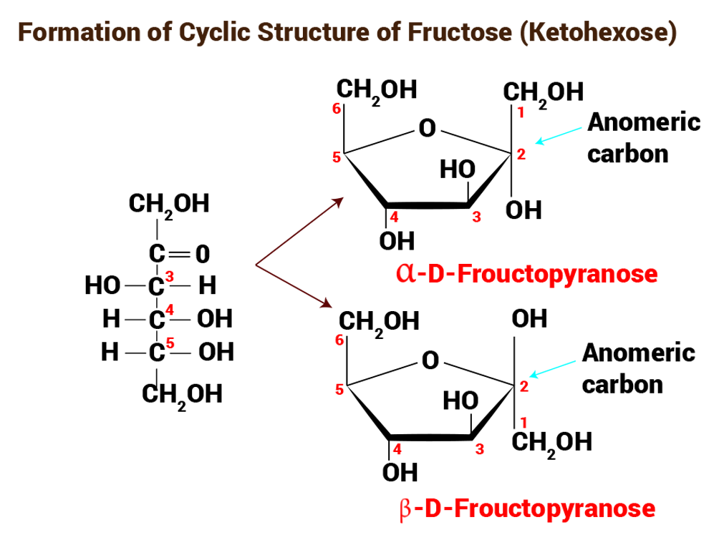

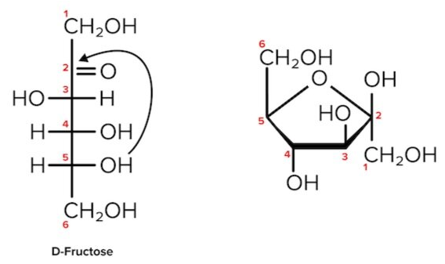

* Aldosugar form pyranose ring structure
* It is fromed by combination of an aldehyde group and hydroxyl group (-OH) at carbon atom C5.

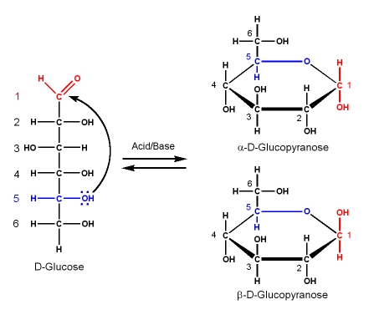

[**Deoxyribose**](https://en.wikipedia.org/wiki/Deoxyribose)

Is one in which an -OH group has been replaced by -H group. In biological systems, this occurs at C2 atom, 2-deoxy-D-[ribose](https://en.wikipedia.org/wiki/Ribose), a constituent of the [DNA](https://en.wikipedia.org/wiki/DNA) molecule

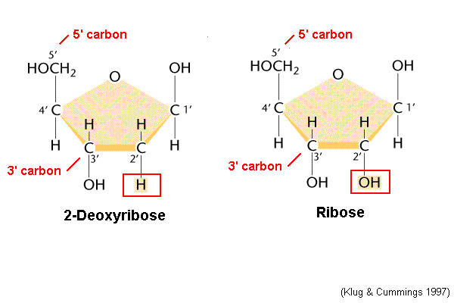

**Carbohydrates** **Functions**

* 1. Energy for cell activity
  2. food reserve (starch)
  3. part of bacterial cell wall
  4. part of DNA and RNA (deoxyribose and ribose)