Lipids

Lipids are a heterogeneous group of organic compounds that are related to fatty acids. They are insoluble in water and soluble in non-polar organic solvent like ethers, chloroform, benzene and acetone. The terms (fats) are solid and (oils) are liquid at room temperature.

Food sources of Fat
- Plants (nut, seeds, cottonseed, corn and olive oil.
- Animals (nervous system, blood, fatty tissues and Egg yolk).
- Dairy Fats and products (cream, butter, cheese.)

Function of Lipid
- Source of energy (9 kcal/g)
- Help carry fat soluble vitamins, absorption of vitamin A, D, E and K depend on the presence of lipids in the diet.
- Insulation- Lipids are excellent insulators.
- They combine with proteins forming different plasma lipoproteins which are the transport forms of lipids.
- Helps in the formation of cell membranes (Phospholipids)
- Supply Essential Fatty Acids (EFA) (Linoleic acid and linolenic acid)

Classification of lipids
Lipids are classified depending to chemical composition:-
1- Simple lipids
2- Compound lipids
3- Derived lipids
- Simple lipids
Esters of fatty acids with alcohol
(a)Fats: They are esters of fatty acids and glycerol e.g.:- Triglycerides (T.G.)
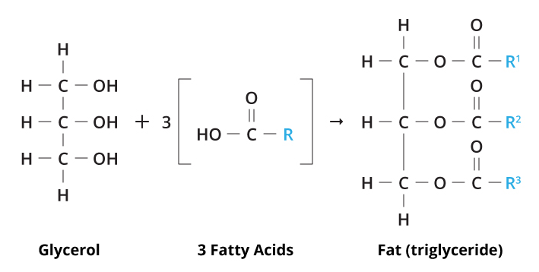

(b) Waxes: They are esters of long chain fatty acids and higher molecular weight alcohols other than glycerol.
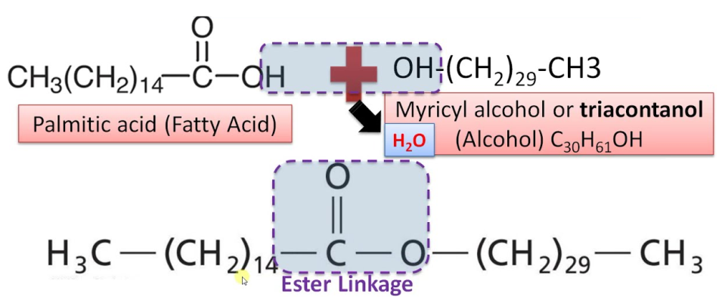

- Solid form at room temperature from animal sources (rich in saturated fatty acids) are called fat.
- Liquid form from plant source (rich in unsaturated fatty acids) are called oil.

- Compound lipids
They contain other groups in addition to fatty acids and alcohol and include:-
(Fatty acid + alcohol + other substances)

Phosphorus
Protein
Sulphate
Sugar

- Glycolipids (Glycosphingolipids): These lipids contain fatty acids, sphingosines (nitrogenous) and carbohydrates.
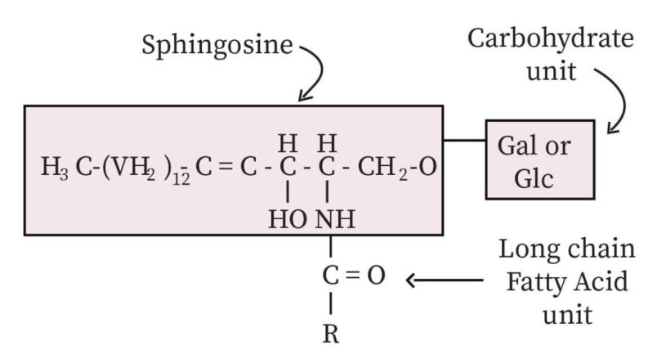

- Lipoproteins: Lipids attached to proteins, they are present in plasma and tissues
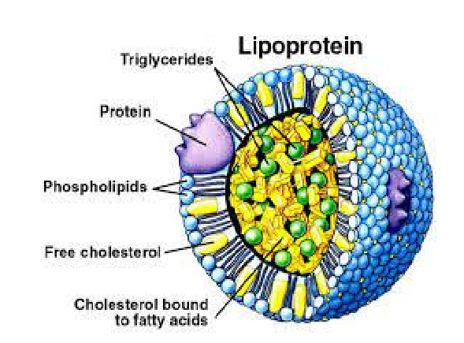

- Sulpho-lipids: Lipids containing carbohydrates and sulphate group.
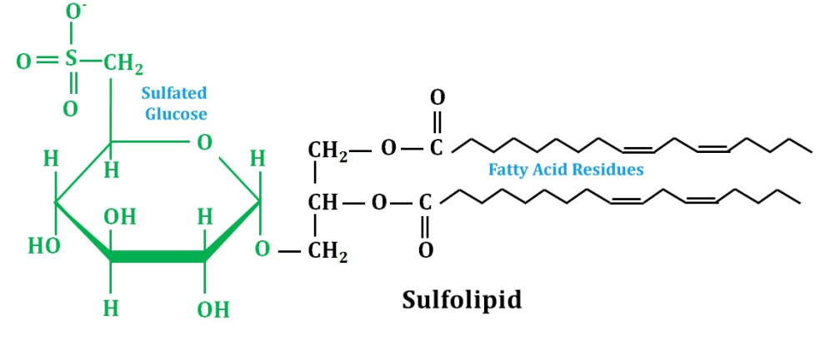
D. Phospholipids: They contain fatty acids, glycerol, phosphoric acid, and nitrogenous compound
Phospholipids found in cell membrane. Such as:-
- Lecithin: found in the cell membrane.
- Sphingomyeline: contain saphingosine, found in large amount in brain and nerve tissues
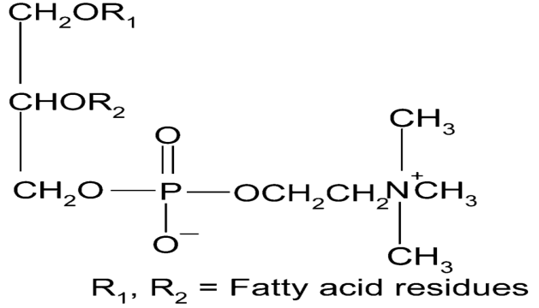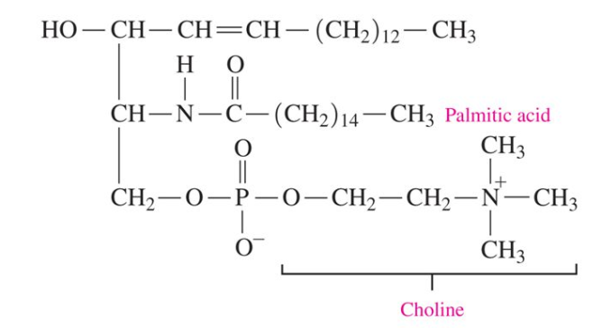
Lecithin structure Sphingomyeline structure

- Derived lipids: They are derived from hydrolysis of simple lipids or compound lipids such as: Fatty acids, Glycerol, Sphingosine, and steroids (cholesterol).

Triglycerides (Simple lipid)
- Most abundant dietary fat.
- Compose 95% of all fat stored in adipose tissue (storage form of lipids).
- TG represents the most common class of lipids in nature.
- Found in both animal and plant tissues.
- Chemically they are esters of fatty acids and glycerol.

Formation of Triglycerides
They are esters of 3 molecules of fatty acids and glycerol
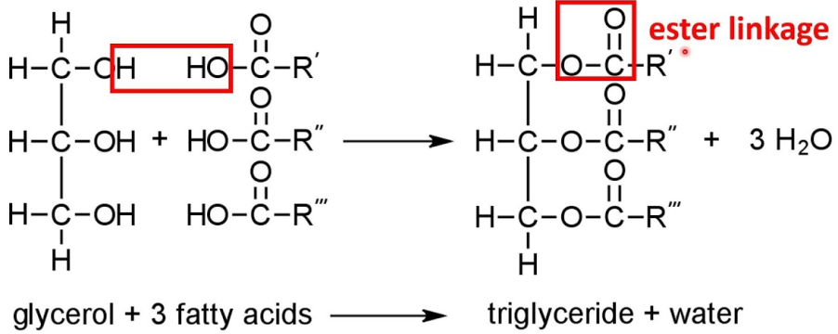
Fatty acids
- Fatty acids are organic acids that occur in the natural triglycerides.
- Long-chain carboxylic acids, Insoluble in water
- Have the general formula R-(CH₂) _{n}-COOH
- Fatty acids that occur in natural fats are usually straight-chain derivatives containing an even number of carbon atoms.
- The chain may be saturated (containing no double bonds) or unsaturated (containing one or more double bonds)
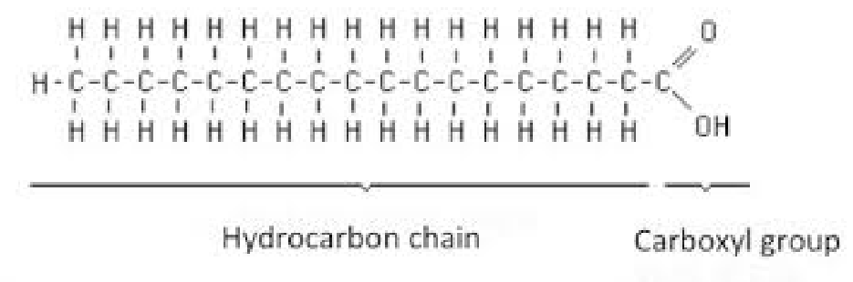
Classification of Fatty acids
Fatty acids can be classified depending on:
- Double bonds are present or not into:
- Saturated fatty acids: They have no double bond (s)
- Unsaturated fatty acids: They have double bond (s).

- According to chain length:
- Short chain FA: 2-4 carbon atoms
- Medium chain FA: 6 –10 carbon atoms
- Long chain FA: 12 – 26 carbon atoms.

- Nutritionally classified into:
- Non-essential fatty acids (NEFAs)
- Essential fatty acids (EFAs)

Nomeclature of fatty acids
- The systematic name of fatty acids is derived from the name of the hydrocarbon. The term oic being substituted for the final –e in the name of hydrocarbon.
Examples:
Butane = Butanoic (4 carbon atoms).
Octane = Octanoic (8 carbon atoms).

- Carbon atoms are numbered from –COOH group, where –COOH takes number 1. the next is C2 (alpha α) and terminal carbon atom is called omega ω
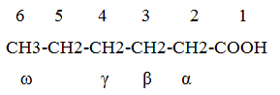
- To indicate the number and position of double bonds the symbol ∆ is placed.
Example:
If we have oleic acid C₁₇H₃₃COOH, so it is expressed 18:1; ∆⁹
Generally fatty acids are expressed by a formula to indicate:
- Number of carbon atoms.
- Number of double bonds.
- Position of double bonds
Saturated Fatty acids
- They have no double bond (s)
- Genral formula CnH₂n+COOH.
Examples for saturated fatty acid:

n = 4: butyric acid
n = 6: caproic acid
n = 8: caprylic acid
n = 10: capric acid
n = 12: lauric acid
n = 14: myristic acid
n = 16: palmitic acid
n = 18: stearic acid

Unsaturated fatty acids:
They have double bond (s). Subdivided into:
Mono unsaturated fatty acids:
- contain only one double bond
- Example Oleic acid (C₁₇H₃₃COOH) which was found nearly in all fats.
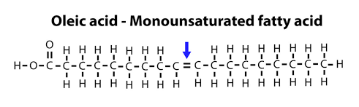
Poly unsaturated fatty acids:
- They contain two or more double bond.
- Linoleic acid (18:2;9,12): It contains two double bonds between C9 and C10 and between C12 and C13.
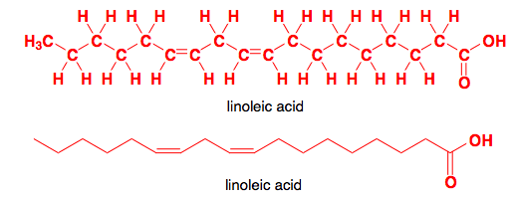

- Linolenic acid (18:3;9,12,15): It contains 3 double bonds between C9 and C10 and between C12 and C13 and between C15 and C16.
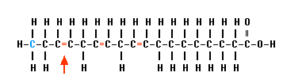
- Arachidonic acid (20:4;5,8,11,14): It contains 4double bonds between C5 and C6 and between C8 and C9 and between C11 and C12 and between C14 and C15.
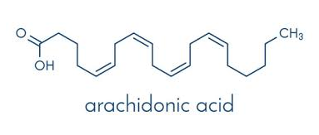
Non-essential fatty acids:
- Cannot be made (synthesized) in the body
- Examples: palmitic acid, stearic acid ….etc

Essential fatty acids (EFAs) :
- Cannot be made (synthesized) in the body.
- They have to be provided in diet
- Example: Linolenic acid

Omega(ω) Fatty acids
- Omega-3 Fatty acids
- Omega-3 Fatty acids are a family of unsaturated fatty acid
- That has in common a carbon-carbon double bond in the position n-3, which is the third bond from the methyl end of the fatty acid.
Examples:
- Linolenic acid C18:3 (9,12,15)
- Stearidonic acid C18:4 (6,9,12,15)
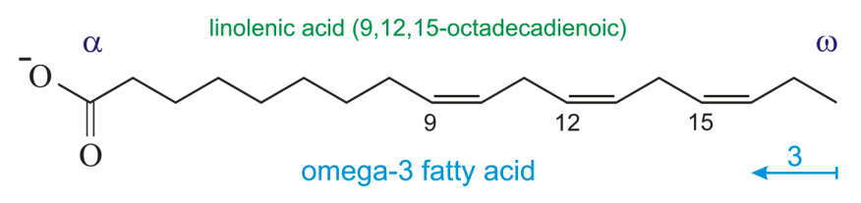

The function of Omega-3 Fatty acids:
- Anti-inflamatory and anti-coagluant properties
- Can provide against cardiovascular disease, arthritis, skin conditions, depression, and other disorders.

- Omega-6 Fatty acids
- Omega -6 Fatty acids are a family of unsaturated fatty acid
- That have in common a carbon-carbon double bond in the position n-6, which is the sixth bond from the methyl end of the fatty acid
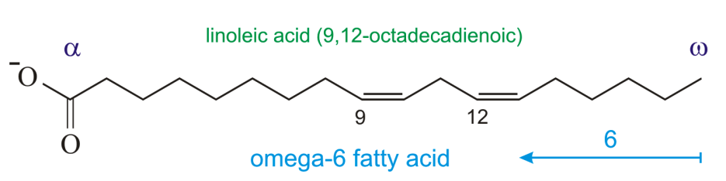
Examples:
- Linoleic acid C18:2 (9,12)
- Eicosadienoic acid C20:2 (11,14)
The function of Omega-6 Fatty acids:
- Omega-6 have anti-inflammatory properties.
- It maintains healthy skin, hair and nails, and helps to bring hormonal and emotional balance.
- Omega-9 Fatty acids
- Omega-9 Fatty acids are a family of unsaturated fatty acid
- That has in common a carbon-carbon double bond in the position n-9, which is the ninth bond from the methyl end of the fatty acid.

Examples:
- Oleic acid C18:1 (9)
- Erucic acid C22:1 (13)
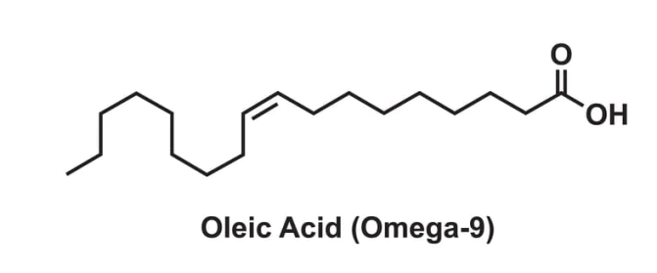
Omega-9 Fatty acids function
- Help to reduce the risk of cardiovascular disease, artherosclerosis, and stroke.
