The Cell
The cell (from latin cella, meaning “small room”) is the basic structural, functional and biological unit of all known living organisms. Cell is the smallest unit of matter that can carry on all the processes of life. The study of cells is called cell biology or cytology
Introduction to the cell
Both living and non-living things are composed of molecules made from chemical elements such as Carbon, Hydrogen, Oxygen, and Nitrogen. The organization of these molecules into cells is one feature that distinguishes living things from all other matter.
Cell Theory consists of three principles:
- All living things are composed of one or more cells.
- Cells are the basic units of structure and function in an organism.
- Cells come only from the replication of existing cells.
Internal organization
- Cells contain a variety of internal structures called organelles
- An organelle is a cell component that performs a specific function in that cell
- There are many different cells; however, there are certain features common to all cells
- The entire cell is surrounded by a thin cell membrane
- All membranes have the same thickness and basic structure
- Organelles often have their own membranes too – once again, these membranes have a similar structure
- The nucleus, mitochondria and chloroplasts all have double membranes, more correctly called envelopes
- Membranes can thus be used to transport molecules within the cell e.g. endoplasmic reticulum.
- Proteins in the membrane can be used to transport substances across the membrane– e.g. by facilitated diffusion or by active transport.
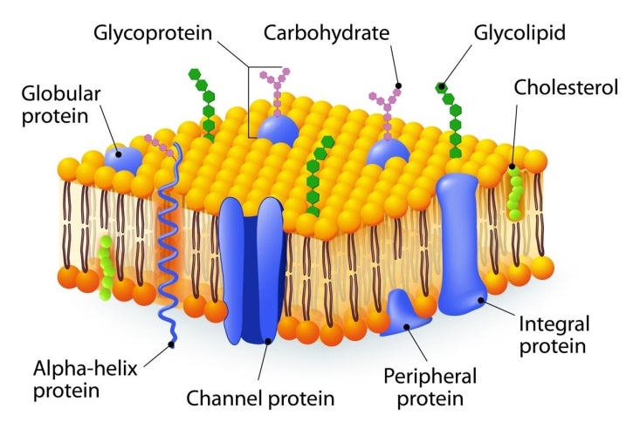

Prokaryotes vs. Eukaryotes
Organisms whose cells normally contain a nucleus are called Eukaryotes; those (generally smaller) organisms whose cells lack a nucleus and have no membrane-bound organelles are known as Prokaryotes.
Animal Cell
The cell is the fundamental unit of life. All living organisms on planet earth are composed unicellular (single cell) (or) multicellular (many cells). A cell range in its size from a millimeter to microns and generally varies in their shapes. Few cells are flat, oval, rod, curved, spherical, concave, rectangular, and various other shapes are also found. Most of the cells are microscopic in size and can only be seen under the microscope.
Some cells are fairly long and large. For example, a neuron in the human body is approximately 100 microns or 1 meter long and the ostrich egg is the largest cell which ranges from 14-15 cm long and 12-13 cm wide.
Animal cells are a typical eukaryotic cell with a membrane-bound nucleus with the presence of DNA inside the nucleus. They also comprise of other organelles and cellular structures which carry out specific functions necessary for the cell to function properly.

Animal Cell Structure
The Animal cells are smaller than the plant cells which vary in their sizes and are irregular in shape. It comprises of the following parts:
Cell Membrane: A thin semipermeable membrane layer of protein and fats surrounding the cell. It helps in permits entry and exits of nutrients into the cell.
Nuclear Membrane: It is the double membrane that surrounds the nucleus.
Lysosome (Cell Vesicles): They are round organelle surrounded by a membrane comprising of digestive enzymes which help in digestion, excretion and in cell renewal process.
Cytoplasm: A jelly-like double membrane organelles found outside the cell nucleus in which the organelles are located.
Golgi Body: A flat smooth layered, sac-like organelle which is located near the nucleus and involved in manufacturing, storing, packing and transporting the particles throughout the cell.
Mitochondrion: They are spherical to rod-shaped organelles with a double membrane. They are the powerhouse of a cell as they play an important role in releasing energy.
Ribosome: They are small organelles made up of RNA-rich cytoplasmic granules and they are the sites of protein synthesis.
Nucleopore: They are tiny holes present in the nuclear membrane which are involved in the movement of nucleic acids and proteins within the cell.

Habitats for Plants and Animals
What is an environment?
- Plants and animals live together in many different environments all around the world.
- An environment is all the living and nonliving things in a place. The environment is the surroundings: air, water, plants, and animals. Each kind of environment has many different kinds of animal habitats.

What is a habitat?
Every animal has a habitat. The place where an animal or plant lives and grows is called its habitat.
A habitat is where an animal finds the food, water, and shelter it needs to live. For example, a toucan’s habitat is the rainforest.

Different Land Habitats
- Desert Habitats
A desert is a very warm place. The air is very hot and dry. There is very little rain. The soil is very sandy.
- Most animals that live in the desert sleep during the day because it is too hot. They come out at night to eat. They are called nocturnal.
- Some desert animals burrow in the ground during the day
- Many plants have thick leaves in the desert to retain water.
- Most desert animals get their water from the food they eat.

- Rain Forest Habitats
A rain forest is an environment where rain falls almost every day.A rain forest has warm weather year round.
- A rain forest has millions of plants and animals.
- Many of these plants are used to make medicines to fight diseases and illnesses.
- Rain forests are located along the equator.

- Forest Habitats
A forest is an environment that gets enough rain and warm temperatures for lots of trees to grow.
When the fall arrives, the leaves will turn red, orange, and yellow. Once winter comes, the trees lose their leaves.
- Tundra Habitats
A tundra is an environment that is very cold and windy. It is a treeless area.
- It is the coldest environment. The land is covered with snow and ice most of the
year.
- Much of the land has ground that is permafrost, permanently frozen. The summers are short.

- Freshwater Habitats
It contains:
- Pond
- Lake
- Stream
- River
You might find frogs, ducks, beavers, turtles, dragonflies, and many kinds of fish in a freshwater habitat
- Saltwater Habitats
It contains:
- Oceans
Sharks, starfish, whales, dolphins, lobster, and coral are some of the animals found in the ocean.
Ecosystem
An ecosystem is how plants, animals, and nonliving things in an environment affect each other.

