Physical properties of fatty acids
- Physical and physiological properties of triglycerides are determined by chain length and degree of unsaturation.
- The melting points of fatty acids increase with chain length and decrease according to unsaturation.
- Melting point of lipid is directly proportional to the chain length of fatty acids and inversely proportional to the number of double bonds.

Compound lipids
Phospholipids
- The phosphoglycerides and sphingomyelin, containing phosphate, are classified as phospholipids, which phosphoric acid is esterified at the carbon atom.
- Choline phosphoglyceride (lecithin) and sphingomyelin are the two most common phosphoglycerides in membranes.

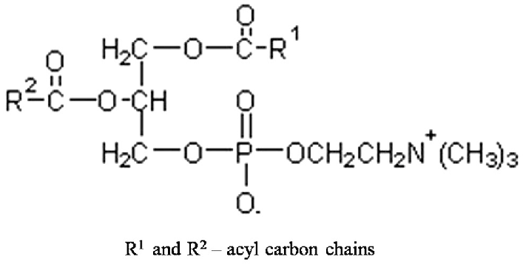

- Diphosphatidylglycerol (cardiolipin) found nearly exclusively in the inner membrane of mitochondria and in bacterial membranes.

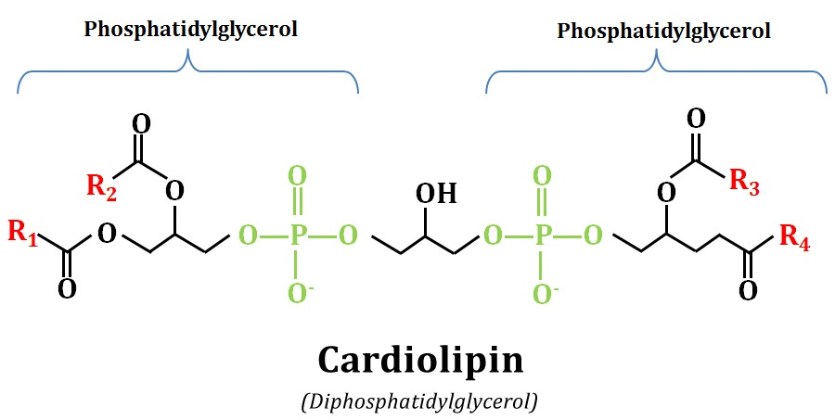

Liposomes
- Is composed of bilayer phospholipids
- A lipid bilayer will close in on itself forming a spherical shape
- Separating the external space from an internal compartment
- Liposomes have been prepared with drugs and enzymes encapsulated inside and used as carriers for these substances to target organs.

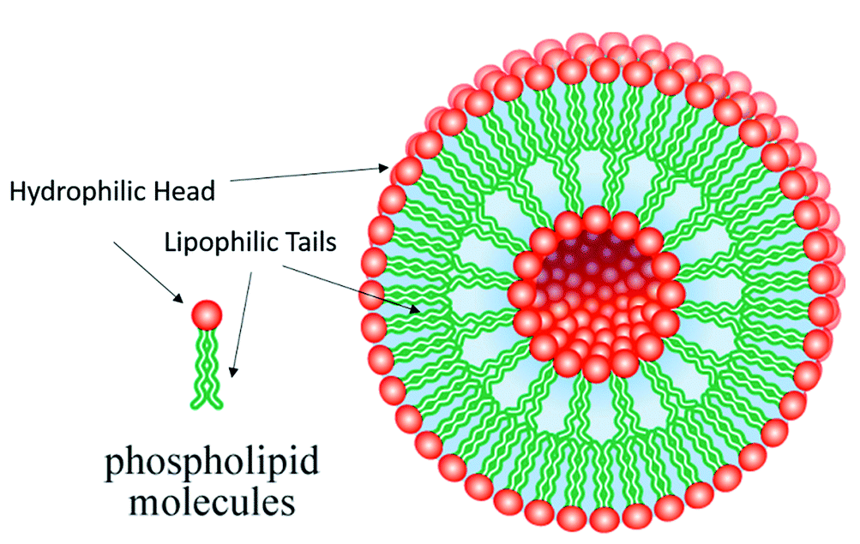

Micelles
- Is composed of a monolayer phospholipids
- These phospholipids compounds with a hydrophilic head and hydrophobic tail
- The lipid molecules will come together to form spherical structure, termed micelles
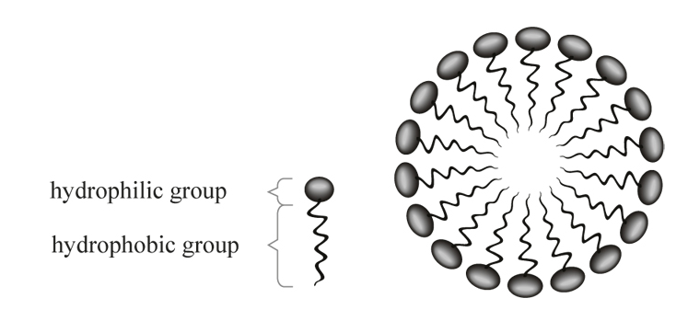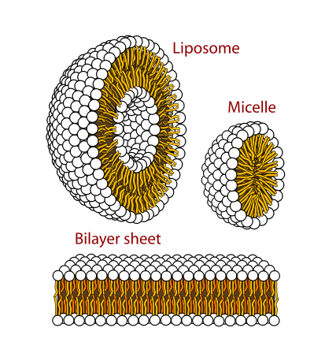
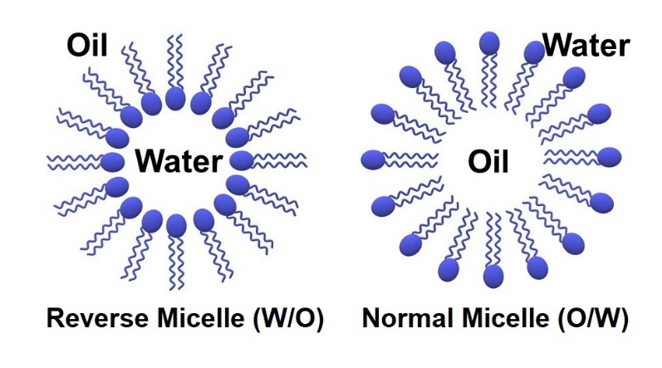

Derived lipids
- Glycerol
- It is commonly called glycerin.
- It is simplest derivatives alcohol as it containing three hydroxy groups.
- In the body Glycerol have a very nutritive value which can be converted to glucose and glycogen by the process called gluconeogenesis.

- Steroids: cholesterol
Cholesterol: is widely percent in all cell of the human body, but mainly in nervous tissues, it’s an animal steroid. So it’s found only in animal products such as: eggs, milk, meat, liver.
The body cholesterol has two origins:-
- Exogenous origin (diet): about 0.3 gm/day.
- Endogenous origin: about 1 gm/day.
All steroids have similar cyclic structures: Phenanthrene ring (A,B, and C) Cyclopentane ring (D) attached.
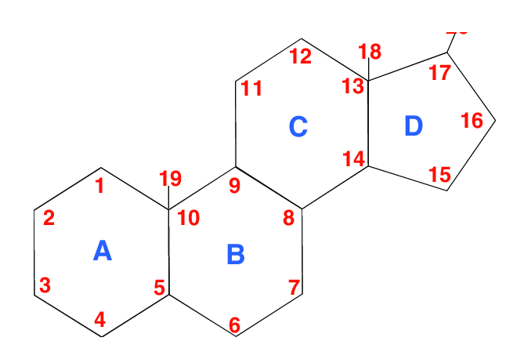
Structure of cholesterol
Cholesterol has a formula C27H45OH. It’s a complex alcohol formed of four fused rings, a side chain, and –OH group at C3, it has unsaturated double bond between C5 and C6
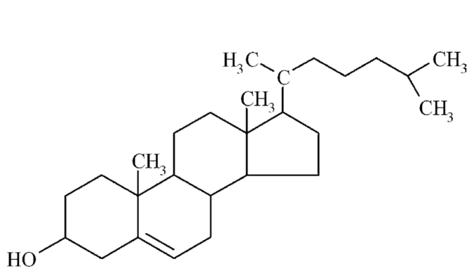

Role of cholesterol
- Structural component of all cell membranes
- Precursor of steroid hormones
- Bile acid/salt precursor: It is derivatives of cholesterol, helps fat absorption and digestion.
- Vitamin D precursor

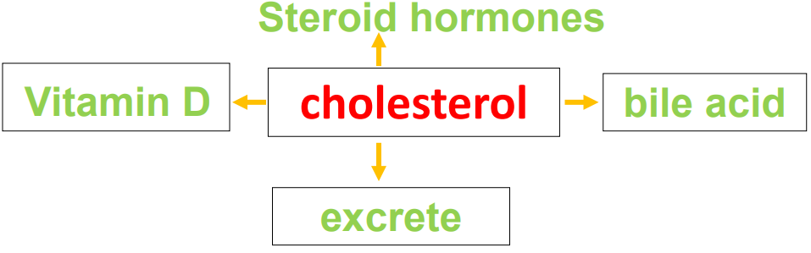
- Cholesterol is the immediate precursor of the bile acids such as glycocholic acid and taurocholic acid that are synthesized in the liver and that function to facilitate the absorption of dietary triglyceride and fat-soluble vitamins.
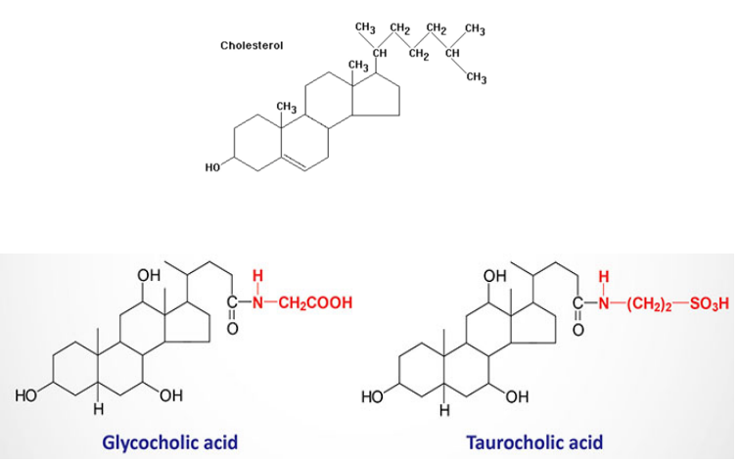
- Another physiological role of cholesterol is as the precursor of the various steroid hormones. for example, Progesterone is the C21 keto steroid sex hormone.
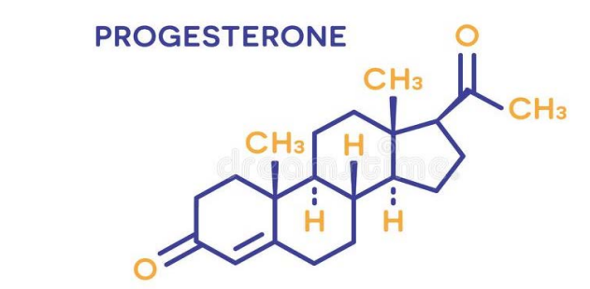
- Cholesterol is also the precursor of the female steroid hormones, the estrogens in the ovary and of the male steroids testosterone in the testis.
