Metabolism
The sum total of all the enzymatic reactions occurring in the cell that produce energy and basic materials needed for important life processes, is collectively called metabolism

Metabolism involves:
- Catabolism: Catabolic reactions that break down large, complex molecules to provide energy and smaller molecules.

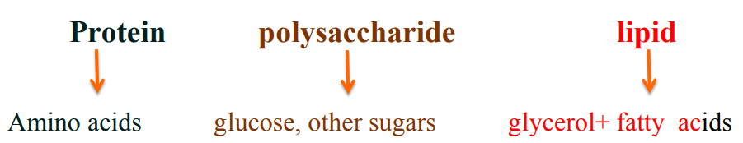

2- Anabolism: Anabolic reactions that use ATP energy to build larger molecules

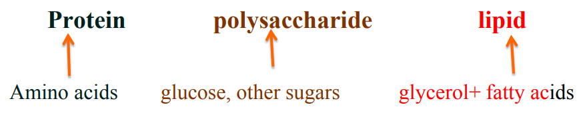

Stages of Metabolism
Stage 1: Digestion and hydrolysis
Hydrolysis is break down of large molecules to smaller ones (simpler forms) that enter the bloodstream.
Digestion is the process of hydrolysis of naturally occurring foodstuffs in to simpler forms.
They are absorbed only when they are hydrolyzed to simpler forms.

Stage 2: Degradation
Break down molecules to two-carbon and three-carbon compounds.

Stage 3: Oxidation
Oxidation of small molecules, electron transport, and provide ATP energy.

Adenosine triphosphate (ATP)
- Is the energy form stored in cells.
- Is obtained from the oxidation of food.
- Consists of adenine (nitrogen base), a ribose sugar, and three phosphate groups.

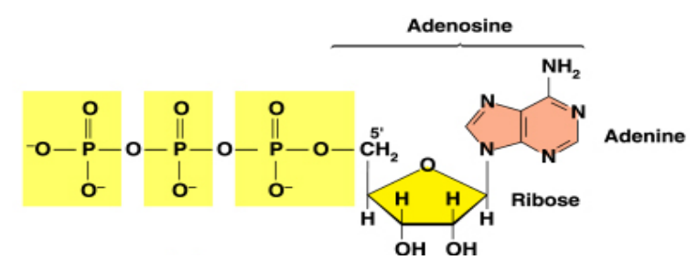

Coenzyme
- Coenzyme NAD+ (Nicotinamide Adenine Dinucleotide)
1 NADH = 3ATP
- Coenzyme FAD (Flavin Adenine Dinucleotide)
1 FADH = 2ATP
- Coenzyme GTP (Guanosine Tri Phosphate)
1 GPT = 1ATP
Carbohydrate Metabolism
Stage 1: Digestion of Carbohydrates
Stage 2: Glycolysis
Stage 3: Krebs cycle OR citric acid cycle
Stage 1: Digestion of Carbohydrates
- The principle sites of dietary carbohydrate digestion are the mouth and intestinal lumen
- The major carbohydrates of our diet are polysaccharides (starch and glycogen), these polysaccharides are hydrolyzed to maltose and glucose by the action of number of enzymes.
- Begins in the mouth where salivary α-amylase breaks down polysaccharides (breaking some α-(1-4) bonds) to smaller polysaccharides (dextrin), maltose, and some glucose.
- There are both α- and β-(1-4) endogulcosidases in the nature, but humans do not produce and secrete the enzyme (β-(1-4) endogulcosidases) in digestive juices. Therefore, they are not able to digest cellulose.
- Salivary α-amylase is not active in stomach due to high acidity (lower pH).
- When the acidic contents of reach the small intestine, they are neutralized by bicarbonate secreted by the pancreas, and pancreatic α-amylase continues the process starch digestion.
- Pancreatic α- amylase hydrolyze dextrin's to maltose and glucose.
- The final digestive process occurs at the mucosal cells where disaccharides digested to monosaccharide by different disaccharidases.
- Hydrolyzes maltose, lactose, and sucrose to monosaccharides, mostly glucose, which enter the blood stream for transport to the cells.
- Any defect in specific disaccharidase activity of the intestinal mucosa causes the passage of undigested carbohydrate into large intestine, and this leads to osmotic diarrhea.
- More than half of the world's adults are lactose intolerant. They are not able to metabolize lactose.
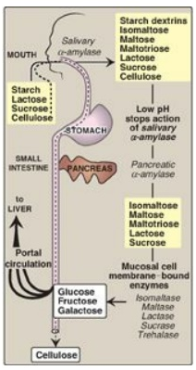
Stage 2: Glycolysis
- Is the sequence of 10 enzyme-catalyzed reactions that converts glucose (6 C) into two pyruvate (3 C)
- Takes place in the extra-mitochondrial part of the cell (cytoplasm).
- These reactions are grouped under 2 phases, phase I and II.
In phase I (reactions 1-5 of glycolysis)
Energy is required to converted Glucose (6 - carbon) to two (3 –carbon) molecules.
Energy consuming = 2 ATP

In phase II (reactions 6-10 of glycolysis)
Energy is generated to convert two Glyceralaldehyde 3-phosphate (3- carbon) to two pyruvate (3 –carbon) molecules.
Energy yielding = 4 ATP + 2 NADH
There are two types of glycolysis:
1- Aerobic glycolysis: site of occurrence cytoplasm in the presence of oxygen. Here glucose (6C) by two phases (10 reaction) is broken down to 2 pyruvate
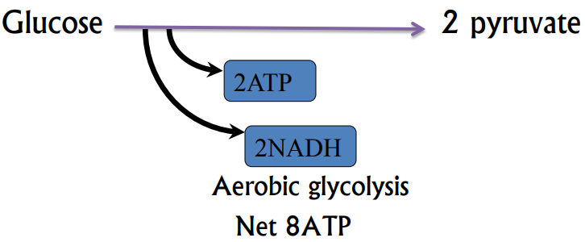
Input (energy consuming) = 2 ATP
Output energy = 4 ATP + 2 NADH
= 4ATP + 2× 3ATP
= 4ATP + 6ATP =10ATP
10ATP - 2 ATP = 8ATP

- Anaerobic glycolysis: occurs in cells under hypoxic conditions. Two molecular of lactate are formed from pyruvate by lactate dehydrogenase enzymes. In this type only 2 ATP are formed
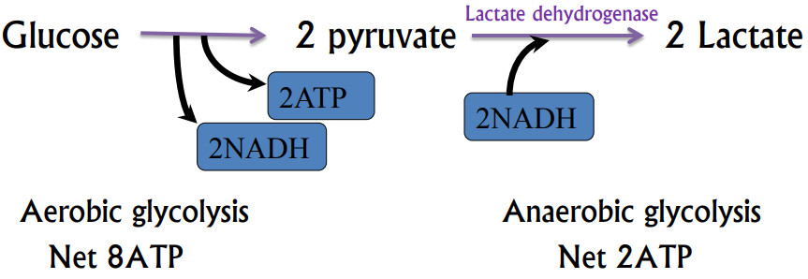
Input (energy consuming) = 2 ATP + 2 NADH
Output energy (yielding steps) = 4 ATP + 2 NADH
Net = 2 ATP

Fate of pyruvate
- Entry into the citric acid cycle
- Conversion to lactate
- Conversion to ethanol
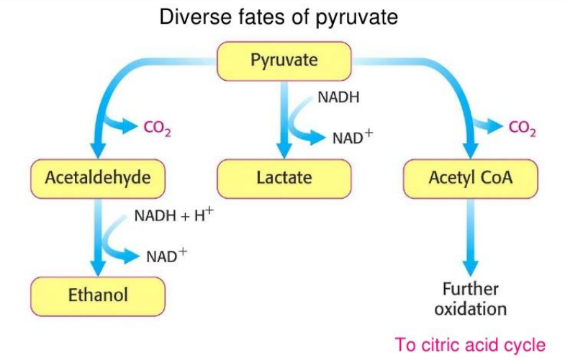

Stage 3: Krebs (citric acid) cycle
- The citric acid cycle (tricarboxylic acid cycle TCA) is the principal process for generating the reduced coenzymes NADH and FADH2, which are necessary for the reduction of oxygen and ATP synthesis in the electron transport chain.
- The citric acid cycle also functions as a source of intermediates for biosynthesis of other important molecules (e.g., some amino acids).
- The reactions of the citric acid cycle occur within the matrix of the mitochondria.
- There are eight reactions in the cycle. Of particular importance are the reactions where NADH (Steps 3, 4, and 8) and FADH2 (Step 6) are produced.

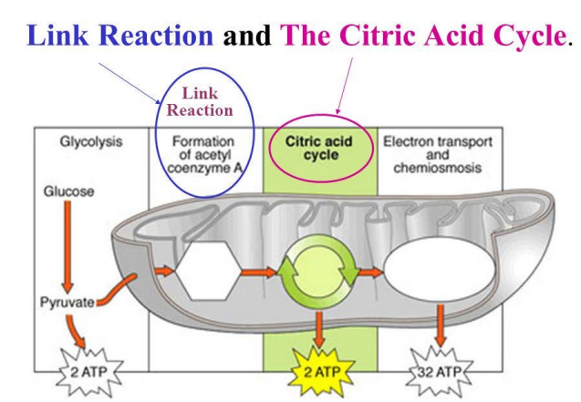

Reactions of TCA cycle: 8 reactions:
- Citrate synthase
- Aconitase
- Iso-citrate dehydrogenase
- ketoglutarate dehydrogenase
- Succinyl-Coenzyme A synthetase
- Succinate dehydrogenase
- Fumerase
- Malate dehydrogenase
Energy yield of Krebs cycle:
Input (energy consuming) = 0 ATP
Output energy = GTP + 3 NADH + FADH2
= ATP + 3× 3ATP + 2ATP
= ATP + 9ATP + 3ATP =12ATP
= 12ATP one molecular of Acetyl CoA
= 24 ATP two molecular of Acetyl CoA
Full Oxidation of Glucose
What is the maximum yield of high energy ATP in the aerobic catabolism of glucose?
Glycolysis Aerobic:
Glucose →2pyruvate + 2NADH+2ATP 8 ATPs
Pyruvate Dehydrogenase: 2pyruvate → 2 acetyl CoA + 2NADH 6 ATPs
TCA cycle: acetyl CoA→2CO2+3NADH+FADH2+GTP
2 x 12ATP = 24ATP
OVERALL yield from glucose 38 ATPs
