Amino acids and Proteins
Amino acids
Amino acids: are the simplest units of a protein molecule, they form the building blocks of protein structure, they are organic compounds made of carbon, hydrogen, oxygen, and nitrogen. Contains two functional groups an amino group (-NH2) and a carboxyl group (- COOH).
In all amino acids found in proteins, those groups (amino group, carboxyl group and a hydrogen atom) are attached to the carbon atom, called alpha α-carbon atom. (α- amino acids) In addition, the α-carbon atom binds a side chain group, named R.

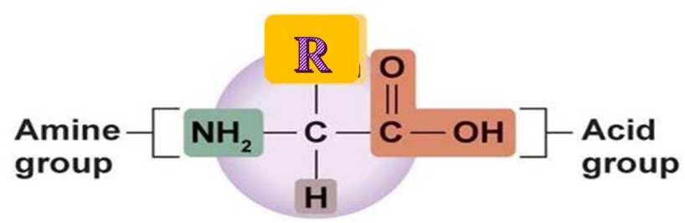

Zwitterions in simple amino acid
A zwitterion is a molecule that possesses both a positive and negative charge on the same molecule. An amino acid has both a basic amine group and an acidic carboxylic acid group. At neutral pH, the amino acids exist as zwitterions due to the negatively charged carboxyl group and a positively charged amino group (the amino groups pick up an H+ and become positively charged while carboxyl groups lose an H+ and are therefore negatively charged).
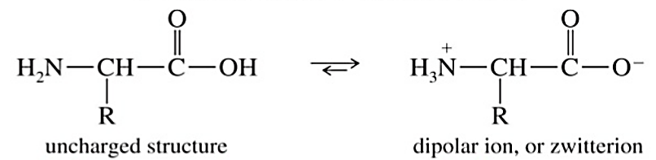

The net charge on any amino acid at a given pH is the total of the positive and negative charges on the molecule. In summary, at low pH, amino acids accept the maximum number of hydrogen ions and behave as positively charged (cations) as possible, and at high pH they accept the minimum number of hydrogen ions and behave as negatively charged (anions) as possible
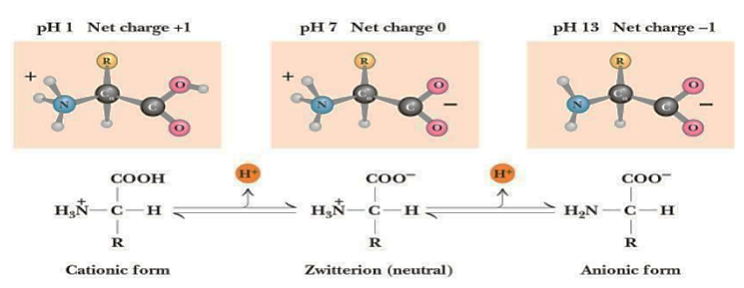

Isoelectric point (pI)
Isoelectric point is the pH at which the net charge of amino acids is zero. It means the exact pH at which an amino acid is electrically neutral and in its zwitterion form. At a solution pH less than the pI of the amino acid, the amino acid is positively charged. At a pH greater than the pI, the amino acid is negatively charged.

Optical properties of amino acids
- Based on the position of amino group on the asymmetric carbon atom, amino acids exist in two types, they are Dextro and Levo amino acids. The two forms in each pair are termed stereoisomers or enantiomers.
- The amino acid having the NH2 group on the right is called D-amino acid. The amino acid having the NH2 group on the left is called L-amino acid.

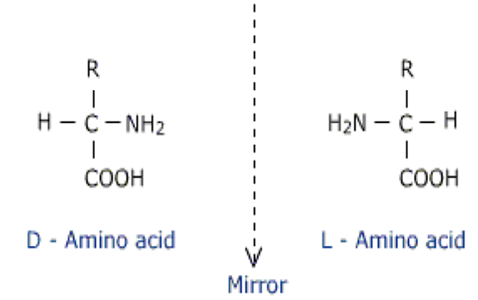

- Only L-Amino acid have been found in protein molecules. D-amino acids have been found only in small peptides bacterial cell walls and in some antibiotics, they are not found in proteins.
- A large number of amino acids are found in nature (> 300), but only (20) different α- amino acids as building blocks of proteins. (Involved in protein formation).
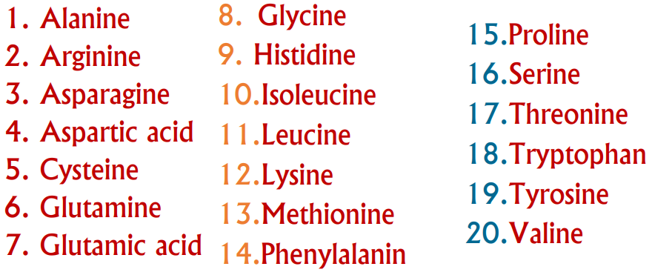

Classification of amino acids
- According to R groups
- Aliphatic amino acids

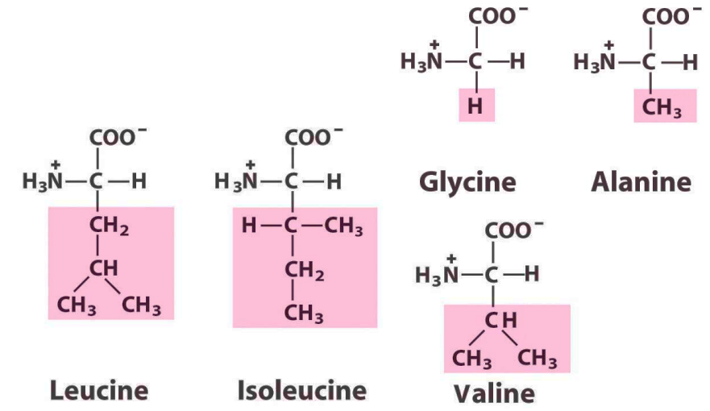

- Amino acids containing hydroxyl (-OH) group
- Serine
- Threonine

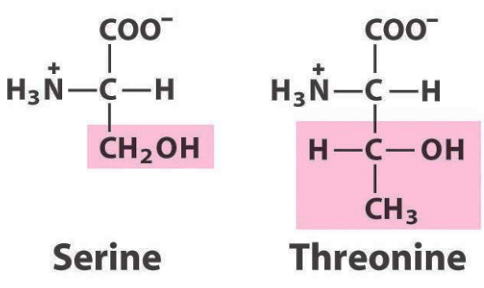

- Amino acids containing thiol or (- SH) group
- Cysteine
- Methionine
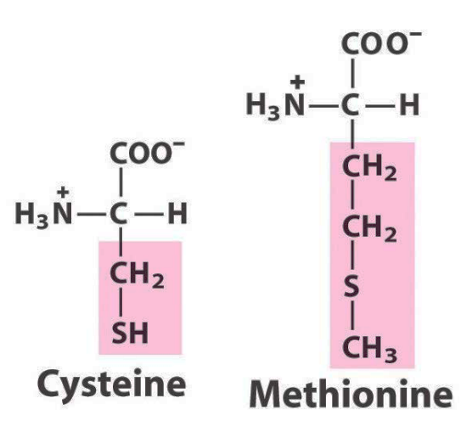
- Acidic amino acids and its amides
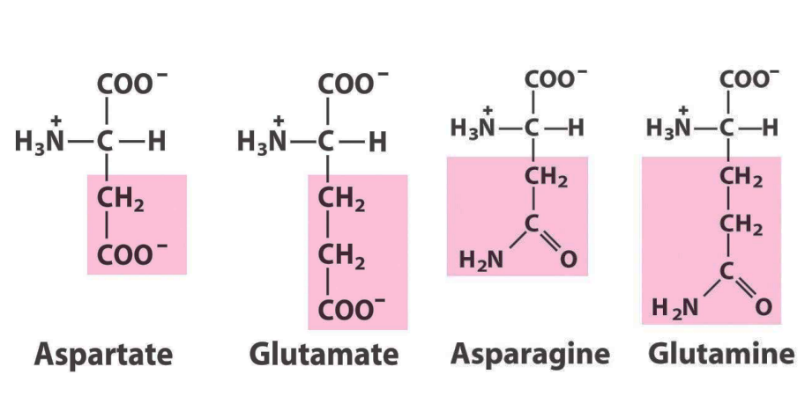

- Basic amino acids
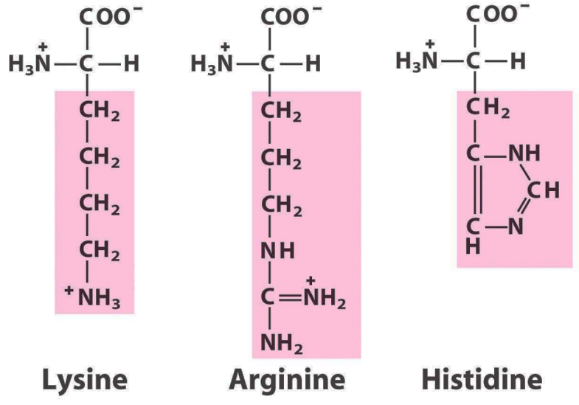
- Heterocyclic amino acids (Containing imino ‘ -NH-’ group)
- Proline
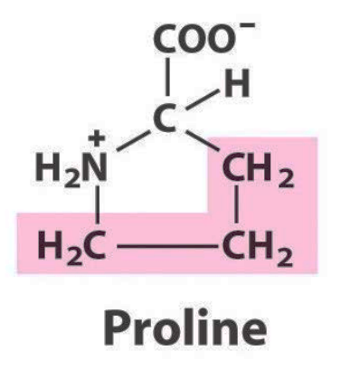
7-Aromatic amino acids
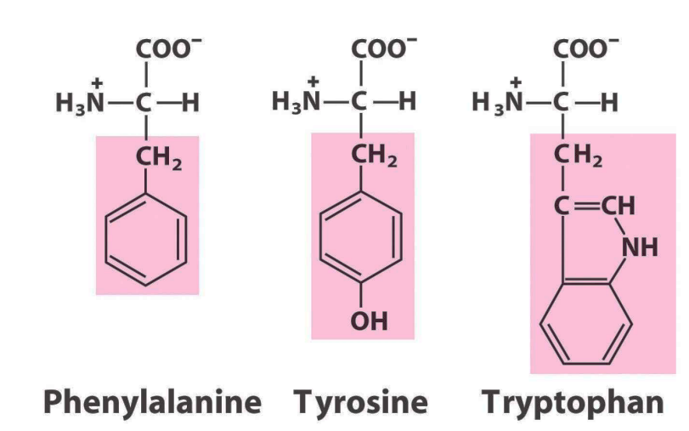

- Nutritionally amino acids are classified to:

- Essential amino acids: - Certain amino acids cannot be synthesized by our body and they must be included in the diet for normal health.
- Non-Essential amino acids: - Certain amino acids can be synthesized in the cells from essential amino acids or from other compounds. They are called non-essential amino acids.
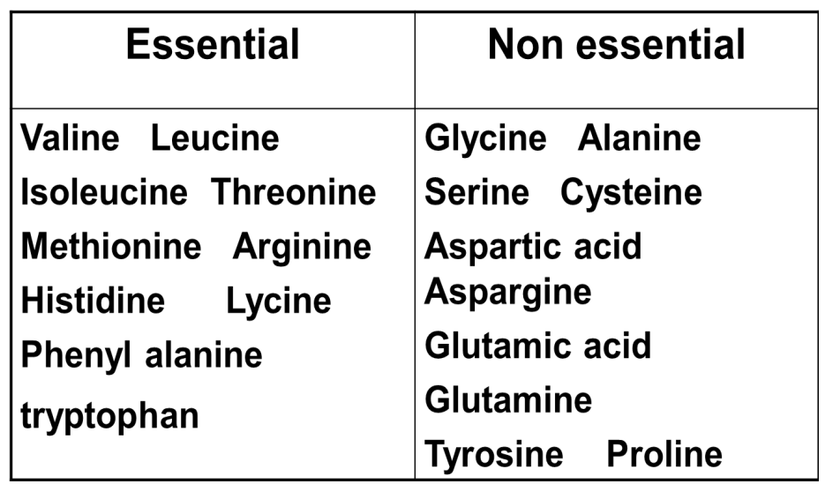

- Amino acids are depending on their reaction in solution to:-

- Neutral amino acids: The R-group in this class of amino acids are nonpolar (or) hydrophobic (‘water-fearing’), ex. glycine, alanine, valine, proline, leucine, isoleucine, methionine, phenylalanine, tyrosine and tryptophan, serine, threonine, cysteine, asparagine and glutamine.

- Acidic amino acids: The two amino acids having R groups with a net negative charge at pH 7.0 ex. Aspartic acid, glutamic acid.

- Basic amino acid: The amino acids in which the R groups have significant positive charges at pH 7.0 ex. Lysine, arginine and histidine.

