Academic Curriculum Vitae
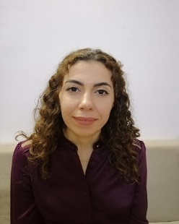
Personal Information:
Full Name: Noor Nadhir Polus
Academic Title: Assistant Lecturer
Email: noor.kunda@su.edu.krd
Mobile:07504676885

Education:
- State all educations accomplished
- BSc: 2007 college of agricultural engineering science
- MSc: 2014 college of agricultural engineering science
Employment:
- State employment starting from first employment
- 27/11/2008 Salahadin university /Erbil

Qualifications
- Teaching qualifications:
- IT qualifications: Microsoft word, excel, excess, power point
- Language qualifications
- English Very good
- Kurdish very good
- Arabic very good
- Any professional qualification: NONE
- You could put any professional courses you have attended:
- election course,
- general English course,

Teaching experience:
- State all teaching courses you delivered, stating undergraduate:
- Medical and veterinary insects
- insect ecology,
- stored product pests,
- horticulture insects
- forest insects.
- Field crop insects
Lab supervision
Lab of entomology / plant protection department

Research and publications
- 1- Description of onthophagus lucidus (sturm, 1800) (coleoptera: scarabaeidae) from Kurdistan region-Iraq.
- A survey on the prevelance of some ectoparasite species infesting sheep and goats in Kalar district,Kurdistan refion Iraq .
- description of common house Mosquito,Culex pipienes Linnaeus,1758(Diptra:Culicidae)from Erbil governarate Kurdisatn region -Iraq .

Conferences and courses attended
- Give details of any conferences you have attended, and those at which you have presented delivered poster presentations.

Funding and academic awards
None
Professional memberships
- List any membership you hold of any professional body or learned society relevant to your research or other life activities.

Professional Social Network Accounts:
profile links: https://academics.su.edu.krd/noor.kunda/

Research Gate: https://www.researchgate.net/profile/Noor-Kunda.

Google scholar https://scholar.google.com/citations?hl=en&user=IrdLDioAAAAJ&scilu=&scisig=AMD79ooAAAAAXOOjLaYxvnFZl3dt8s58gR4r_7kPmWpD&gmla=AJsN-F5Q9QAyvG2e9Q1ilE19J3aTD71MEauzHyh2QC68qzhDfjvCXoySUeUmYPp9W2S4ZLEuZe1cxigaE-5gbs7I9UC0znEd59kiKBrisRM56nwZJFrgyMc&sciund=16769517366618680108

.

