Ichthyology/ practical (2nd class) 6 th Lecture
Internal parts and organs in fish
Circulatory System

Fishes have closed circulatory systems with a heart that pumps blood around the body in a single loop from the heart to the gills, from the gills to the rest of the body, and then back to the heart.

Functions of circulatory system:
- Transport of materials:
- Gasses transported:
- Oxygen is transported from the gills to the cells.
- CO2 (a waste) is transported from the cells to the gills.
- Transport other nutrients to cells (from digestive system)
- Transport other wastes from cells.
- Transport hormones.
- Contains cells that fight infection.
- Helps stabilize the pH and ionic concentration of the body fluids.
- It helps maintain body temperature by transporting heat.

A fish’s circulatory system (1 loop system) is made up of:

Heart: pumps the blood

Arteries: carries blood away from heart

Veins: carries blood to the heart

Capillaries: connects arteries to the veins

-Heart:
The heart of fish is two chambered; Atrium (upper) and Ventricle (lower)

- Atrium.
As the heart relaxes, the blood passes through a valve into the thick-walled, muscular

- Ventricle.
- To Conus/Bulbus Arteriosus
- To Aorta (large artery) to body

Bulbus arteriosus.

The last chamber of the fish heart is called the bulbus arteriosus in the teleosts, but the cornus arteriosus in the elasmobranchs. The difference between these chambers is that the cornus arteriosus of sharks and rays contains many valves while the bulbus arteriosus of bony fish contains none. Both are alike in being primarily elastic and work to reduce the pulsed nature of the blood leaving the ventricle giving it a more even, constant flow.

Sinus venosus.

The first chamber is called the sinus venosus, it is the preliminary collecting chamber.
In teleosts it is filled from two major vein called the hepatic veins (left and right), the anterior cardinals and the posterior cardinals. However, in the elasmobranchs only one hepatic vein leads into it.

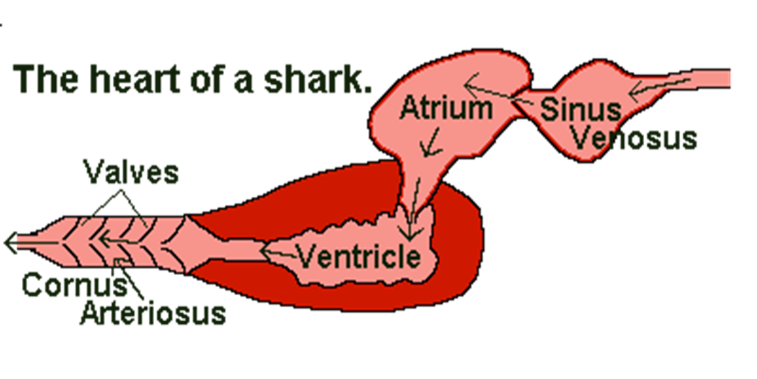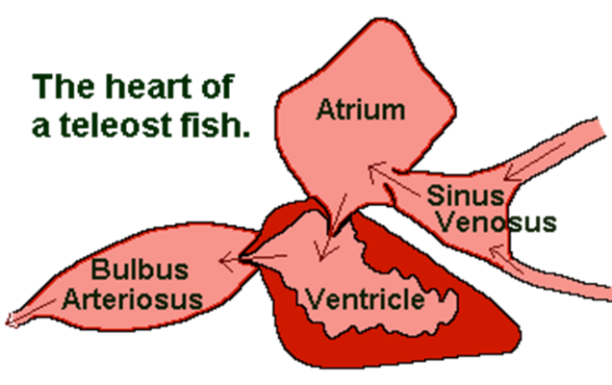
Fish Blood
- The blood of fish similar to that of any other vertebrates , But it differ to human blood that fish RBC are nucleated and avoided but human are not.
- Blood cells are formed primarily in the kidney and spleen and to a lesser extent in the liver, intestinal submucosa and thymus gland.
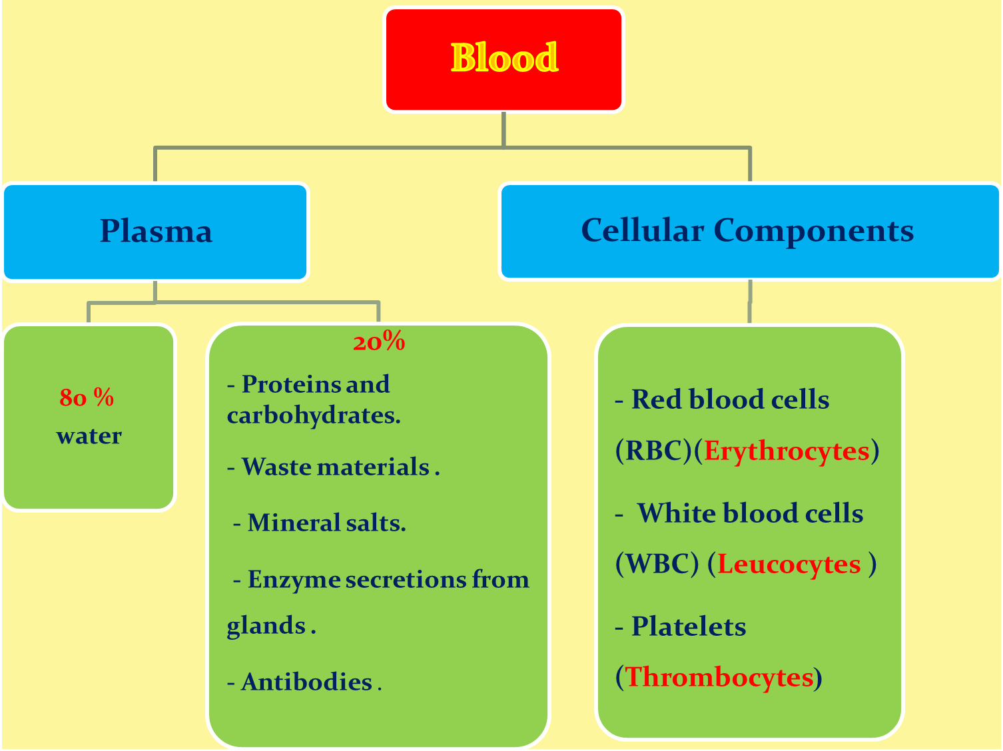

- Red Blood Cells (Erythrocytes) – The most abundant cells in blood; they are oval and nucleated , it is produced in the bone marrow and contain a protein called hemoglobin that carries oxygen to cells.
- White Blood Cells (Leucocytes) – They are part of the immune system and destroy infectious agents called pathogens.
- Platelets (Thrombocytes) – The clotting factors that are carried in the plasma; they clot together in a process called coagulation to seal a wound and prevent a loss of blood
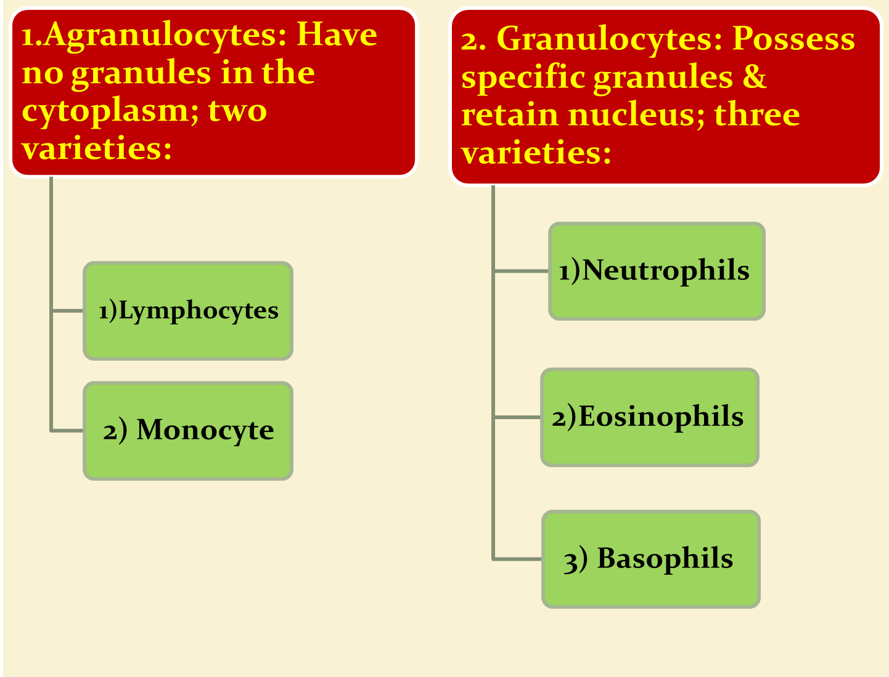

Functions of blood cells:
- Respiration- Transport of Oxygen
- Carries nutrient material (glucose, amino acid & fatty acids, vitamin)
- Excretory- Carries waste materials (urea, uric acid, creatine etc.)
- Exchange of electrolyte and other molecules
- Contains regulatory agent such as hormones
- Distribute body heat
