**Digestive system**

The digestion process is starting with mouth which is capturing food (or taking food) using the teeth from Jaws (some fish) or/and using the Gill rakers then sending the food to the Pharyngeal Cavity ,which contain Pharyngeal Teeth, the mechanical digestion will be done there by those teeth which called Pharyngeal Teeth.

**After ingestion of food, gut is responsible for:**

* **Digestion** - breaking down food into small, simple molecules.
* Involves use of acids, enzymes
* **Absorption** - taking molecules into blood

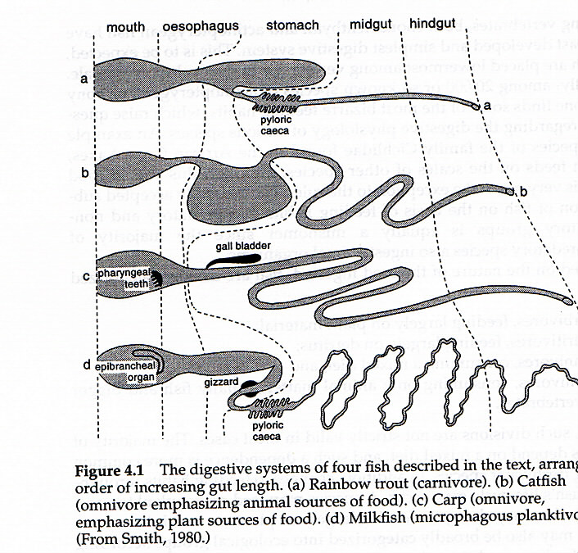

milkfish

planktivore

carp

Omnivore

catfish

Omnivore

trout

Carnivore

From the figure above, you can see the differences of digestive system between different types of fish according to their feeding (note that catfish is feeding animal sources of food while carp is feeding plant sources of food.)

**Carnivores :-** A fish that feed on animals such as **yellow perch** (*Perca flavescens*).

**Herbivores :-** A fish that feed on green plants **grass carp** (*Ctenopharyngodon idella*).

**Omnivores :-** A fish that feed on species (animal and plant). **common carp**(*Cyprinus carpio*).

* **Organs of the Digestive System**

**1- The Mouth**

Food is brought into the body via the mouth, However there is, as always a large variety in fish as a whole and the mouths are quite different in both form and function. The first parts of the digestive system, and their size varies depending on the size of food are small fish that feed on plankton in contrast to predatory fish have teeth jaw or teeth pharyngeal.

**2- The Pharynx**

Immediately behind the mouth is the pharynx which is the continuation of the tube started at the mouth and in which are found the gill clefts, through which water flows out of the alimentary canal and into the gills. It is short which leads to the esophagus.

**3- The Esophagus**

* After the pharynx comes the esophagus, a muscular tube that leads to the stomach.
* The esophagus in bony fishes is short
* A tube like organ that connect mouth to stomach.
* Expands easily, which allows the fish to swallow its food whole
* The esophagus walls are layered with muscle.

**4- The Stomach**

The stomach of fish is less well delineated than it is in the higher vertebrates, and in some cases it is considered to be absent. Where a true stomach is found to exist it is a muscular bag.

The acidity of the stomach changes depending on whether it is full or not. Secretion of Hydrochloric acid is stimulated by the stretching or expansion of the stomach walls caused by the presence of food, so the stomach is more acid when it is full that when it is empty. In most fish the pH of the stomach varies between 2 - 4. The main enzymes active in the stomach are Pepsins. Most species of bony fishes have a stomach. Usually the stomach is a bent muscular tube in a "U" shape. Gastric glands release substances that break down food to prepare it for digestion.

**5 - Pyloric caeca**

This organ with fingerlike projections is located near the junction of the stomach and the intestines many fish have some thin blind tubes called Pyloric caeca. The pyloric caeca are an adaptation for increasing the gut area; they digest food. The pyloric caeca secrete digestive enzymes and increase the surface area in the stomach for nutrient absorption.

**6- Intestines**

Site of food digestion and nutrient absorption. Most food absorption takes place in the intestine. The length of the intestine in bony fishes varies greatly.

**7- The Pancreas**

The Pancreas is well developed in the lungfish, sharks and rays and most juvenile fish; however in many teleosts it becomes quite reduced and diffuse in the adults. In sharks and rays it is quite distinct from the liver, but in those teleosts wherein it is found it is often partially embedded in the liver. The pancreas secretes enzymes such as trypsin (attacks proteins), amylases (attack carbohydrates) and lipases (attack fats) into the intestines either through sharing one of the hepatic ducts (those belonging to the liver), or through its own pancreatic duct.

**8- The Liver**

Is a large organ that play various roles in the fishes body, it is the site of glycogen storage, it produces a variety of substances, including enzymes that help with the digestion. The liver is often very large in some sharks and may extend along the body cavity to the cloaca. The liver usually has two separate lobes, but it may have only one (some members of the Salmonidae), the liver always has at least one, and sometimes as many as eight ducts leading into the first part of the intestines. In many cases the pancreas will share one of these ducts.

**9- The gall bladder**

Is usually found somewhere within the liver, it secretes substances that attack fats and help them to be broken down.

**10- The Rectum**

The rectum is the end of the intestines and through it faeces pass out of the fish's body and into the surrounding water. In the lungfish, sharks and rays the rectum opens into the **cloaca** which also receives wastes (urine) from the kidneys and material from the reproductive organs. In bony fish the rectum reaches the outside environment through the **anus**, which is normally situated just in front the urinary and reproductive openings.

