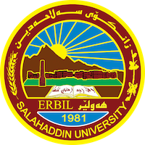
Academic Curriculum Vitae
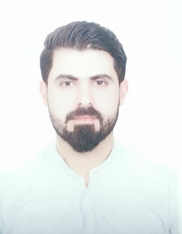
Personal Information:
Full Name: Omer Osman hassan
Academic Title: Assistant lecture
Email: (university email) omer.hassan@su.edu.krd
Mobile: 07504125250

Education:
- 2007-2011: (B.Sc. in Agriculture). Department of plant protection, College Agricultural Engineering Science, Salahaddin University-IRAQ
-I graduated from Salahaddin University college Agricultural Engineering Science in 2011 (Ranked First in Plant protection department).
-MSc degree in Acarology (Population Dynamics and Bio-Ecological study of Tetranychus urticae on Cucumber in Erbil province) in 2017.
-Now I am member of academic staff in college Agricultural Engineering Science plant protection department /Salahaddin University.

Employment:
- 2011-2014 Assist. Lab of Plant protection Department, College Agricultural Engineering Science / University of Salahaddin.
- 2017-2019 Register of college of Education of Makhmour.
- 2019-2020 Register of college Agricultural Engineering Science
- 2019 Assist. Lecturer of Plant protection Department, College Agricultural Engineering Science / University of Salahaddin.

Qualifications
- Teaching qualifications
- IT qualifications
- Language qualifications such as TOEFL, IELTS or any equivalent
- Any professional qualification

Teaching experience:
- Pesticides
- Vertebrates Pests
- Agricultural Extension
- Non Insect Animal Pests

Research and publications
- Population dynamic of Tetranychus urticae on cucumber in Erbil region with study of the effects three different miticides on T. urticae. (Journal of physics,2019).

- Molecular Identification and Morphological Study of European Hoverfly Eristalis pertinax (Scopoli, 1763)(Diptera: Syrphidae) from Erbil Governorate Kurdistan Region – Iraq.

- Molecular Identification and Morphological Study of Ground beetle, Cyminidis andrea, Menetris, 1982 (Coleoptera: Carabidae) from Erbil Governorate Kurdistan Region - Iraq

Funding and academic awards
- List any bursaries, scholarships, travel grants or other sources of funding that you were awarded for research projects or to attend meetings or conferences.

Professional memberships
- Kurdistan Agricultural Engineers Syndicate/Iraq 2011 till now.

Professional Social Network Accounts:
- http://academics.su.edu.krd/omarosman
- Omer HASSAN | Salahaddin University - Erbil, Erbil | SUH | College of Agriculture | Research profile (researchgate.net)
- https://www.linkedin.com/in/omer-hassan-872236214/ https://myaccount.google.com/?utm_source=account-marketing-page&utm_medium=go-to-account-button

