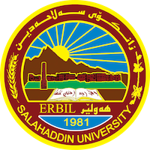
Academic Curriculum Vitae

Personal Information: 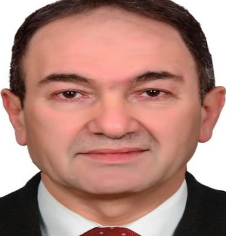
Full Name :D. Osman Abdullah Hama-Ameen
Academic Title: Lecture
Email: (osman.hamdamin@su.edu.krd)
Mobile:009647504925238

Education:
- Bachelor in sciences society in 6/7/2008/ Salahaddin University.
- Master of teaching methods history in 23/7/2012/Sulaimani University.
The title of thesis is:
فاعلية التدريس على وفق برنامج كورت(CORT)في تنمية التفكير الإبداعي والذكاء الوجداني لدى تلاميذ الصف السادس الأساسي في نادة التربية المدني

- Doctor of teaching methods history in 17/3/2022/ Salahaddin University.
The title of thesis is:

فاعلية برنامج تعليمي قائم على نظرية العبء المعرفي في تنمية التفكير الاستدلالي واتجاه طلبة الصف الثامن الأساسي نحو مادة الاجتماعيات.
Employment:
- I first started working as a primary school teacher in
- 2012, assistant lecturer /social Science Department, College of Basic Education/ Salahaddin University.
Qualifications
- Excel /2018/ College of Basic Education/ Salahaddin University.
- E-Learning and Moodle /2020/ College of Basic Education/ Salahaddin University.

Teaching experience:
- General psychology- First Year in 2013 -2018
- Developmental Psychology - Second Year in 2014-2015.
- Measurement and evaluation-Third year 2016.
- Management and supervision/2015-2016-2017-2018-2019-2020.
- Academic skill 2014 and 2022.
- Teaching methods- Fourth Year in 2016-till now.

Research and publications
- فاعلية برنامج تعليمي قائم على نظرية العبء المعرفي في تنمية التفكير الاستدلالي لدی طلبة الصف الثامن الأساسي فی مادة الاجتماعيات.
https://journal.uor.edu.krd/index.php/JUR/article/view/Vol%288%29.No%281%29.paper19

Conferences and courses attended
- Give details of any conferences you have attended, and those at which you have presented delivered poster presentations.

Funding and academic awards
- List any bursaries, scholarships, travel grants or other sources of funding that you were awarded for research projects or to attend meetings or conferences.

Professional memberships
- List any membership you hold of any professional body or learned society relevant to your research or other life activities.

Professional Social Network Accounts:

- List your profile links of ReserchGate, LinkedIn, etc.

It is also recommended to create an academic cover letter for your CV, for further information about the cover letter, please visit below link:
https://career-advice.jobs.ac.uk/cv-and-cover-letter-advice/academic-cover-letter/

