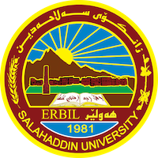
Academic Curriculum Vitae
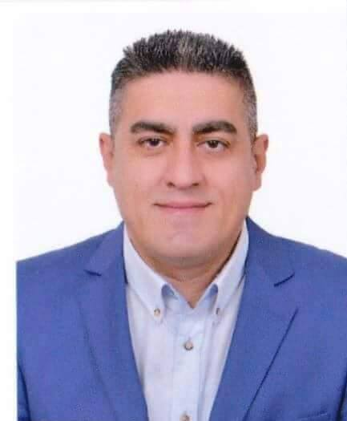
Personal Information:
Full Name: Ozer Sahdi Ismahil
Academic Title: University Professor
Email: (university email) ozer.ismahil@su.edu.krd
Mobile: 07504495711

Education:
- Bachelor Salahaddin University-Erbil Physical Education, Physical Education, 1996
- Master, Baghdad University, Physical Education, 2004
- PhD: University Poznan, physical Education, Poland, 2011
- The date I obtained the title of Assistant Professor is 2015
- The date of my obtaining the title of professor is 2022

Employment:
My first employment was at Salahaddin University-Erbil
Qualifications
- I got the scientific title of Assistant Lecturer in 2004.
- I got the scientific title of Lecturer in 2011.
- Experienced in microsoft office computer program.
- Experienced in IT.

Teaching experience:
- Giving lectures in methods of teaching sports in the College of Basic Education-University of Salahaddin in 2005 and 2006.
- Teaching volleyball in the college of Physical Education-University of Salahaddin from 20004 to 2006.
- Selected as the best ph d student in the Poznan college of Physical Education in Poland in 2009.
- Selected for solving the problems of ph d students in Poznan college of Physical Education in Poland in 2009 and 2010.
- Teaching sports management in the college of Physical Education- University of Salahaddin from 2011 to 2016.
- Teaching human resources management in the department of business management of management technology institute from 2011 to 2014.
- Participation in the committee of the discussion of many students of higher education in the college of Physical Education and department of business management.
- Supervising many scientific researches of the students of college of Physical Education and the department of business management in Management Technology Institute.
- Supervising an M A student.
- Teaching management in higher studies courses.
- Participation in the in many committees for the discussion of the theses of many M A students.

Research and publications
- The impact of studing physical education in the University of Salahaddin-Erbil-Iraq.
- A comparative study of the forms of solving organization conflicts of some of the managers of Erbil clubs.
- Certain Fitness Elements and its Relation to the Professional Performance of the Libro Volley Ball.
- Administration behaviors and their relation to some basic problems of the coach of volleyball.
- A comparative study of the status of anxiety in competions( scientific, physiological and self confidence) in the different lines of football games
- The impact of long- duration training of oxygen and without oxygen in some of blood anf physiological substitutions of football players.
- Types of leadership and their relation to the types of communication due to managers and the teaching staff views of the College of Physical Education -University of Salahaddin –Erbil
- Studying the difference in the types of leadership by the heads of the departments of the College of Physical Education-University of Salahaddin and teachers staff views.
- Understanding the role of organization by the coaches of the perfect sessions of Erbil.
- The Reality of sport marketing of the super league administration staff in Kurdistan region. Iraq

Conferences and courses attended
- Participation in the worldly scientific conference of College of Physical Education in Poznan-Poland in 2009.
- Participation in a management course in Poland sports union in 2010.
- Participation in the worldly scientific conference for the colleges of Physical Education in Mosul University in 2012.
- Participation in sports cultural week of Daratu youth centure in 2013.
- Participation in cultural week of the general directorate of culture and arts by putting plans for a number of teachers and coaches in 2013.
- Participation in an art’s guide in Tanin centurein Erbil in 2013.
- Gaining a refree certificate in football in Erbil in 1995.
- Gaining a refree certificate in volleyball in Baghdad in 2003.
- Gaining a certificate in training of volleyball in Baghdad in 2003.

