OPEN ACCESS PEER-REVIEWED CHAPTER
Response of Strawberry (Fragaria X ananassa Duch.) Flowering and Yield to Photoperiod
WRITTEN BY
Parween Muhammad K. Rozbiany and Shler Mahmud Taha
Submitted: January 8th, 2022 Reviewed: May 17th, 2022 Published: January 4th, 2023
DOI: 10.5772/intechopen.105442
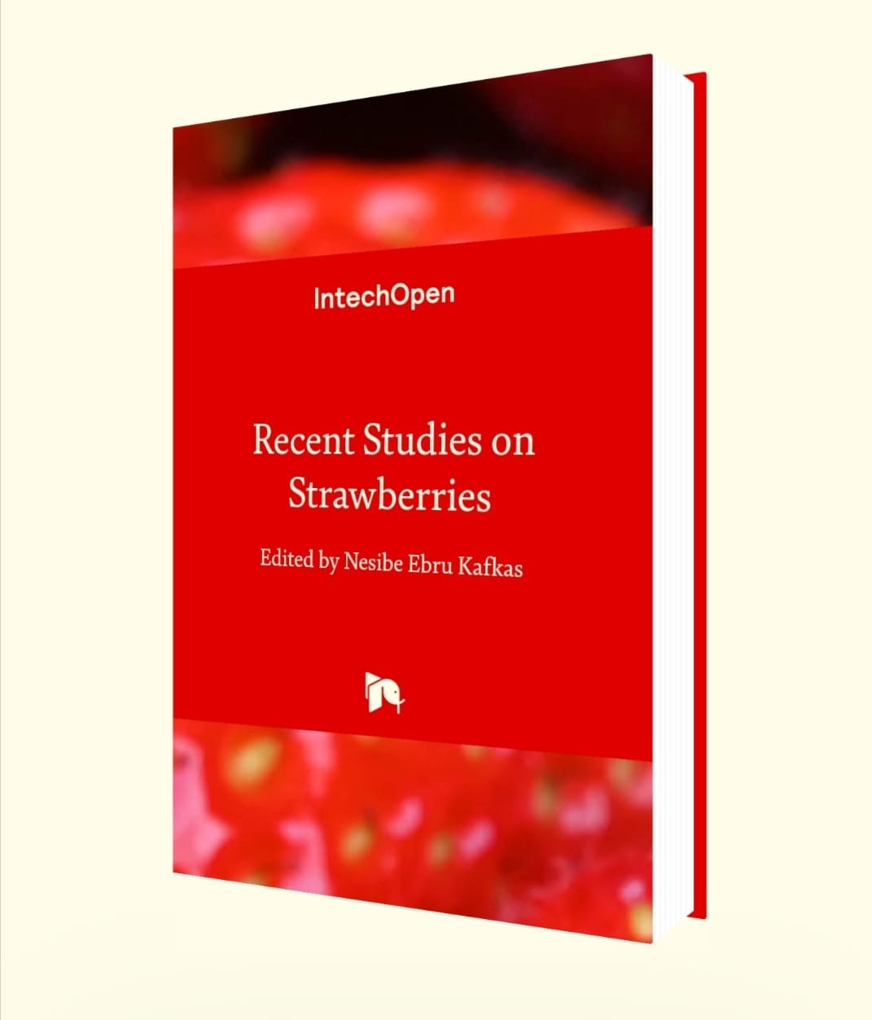
IntechOpen
Recent Studies on StrawberriesEdited by Nesibe Ebru Kafkas

FROM THE EDITED VOLUME
Recent Studies on Strawberries
Edited by Nesibe Ebru Kafkas
Book Details Order Print
CHAPTER METRICS OVERVIEW
19 Chapter Downloads
View Full Metrics
REGISTER TO DOWNLOAD FOR FREE
Abstract
The study was carried out during the growing seasons 2016-2018, collage of Agricultural Engineering Science—Salahaddin University—Erbil. For studying the effect of photoperiod on flowering and yield of two cultivars of strawberry, Festival and Albion were covered with black clothes for (0, 2 and 4 hours). The experiment was laid out in randomized complete block design with three replications for each treatment. Ten plants per experimental unit were arranged randomly in 54 plots. The data were analyzed using (SAS) program. As a result, when propagating the strawberry, the number of runners produced by the adult plants is an important consideration. Parameters significantly increased at photoperiod for 4 h included: for Festival in the first season, number of flowers, plant-1, viability pollen grain% and fruit set% in the first and the second seasons for Festival, (fruit dry weight and dry weight%) for Albion increased in the first season, (fruit fresh weight, fruit size and fruit length) for Albion in second season, (number of fruits. plant-1 and fruit diameter) for Festival in first season, marketable fruits% for Albion in second season, Yield. plant-1 (g) and yield, hectare-1 (Kg) significantly increased at photoperiod 4 h for Festival (100.591) in second season and (96.633) in first season.
Keywords
- photoperiod
- Fragaria X ananassa Duch.
- flowering
- yield
- Albion
- festival
Author Information
Show +
1. Introduction
1.1 Effect of photoperiod on the yield of strawberry plant
Young plants grown at 10 and 12 h photoperiod during 21 days at day temperatures between 12 and 18°C achieved complete flower emergence, while no flowers emerged at a photoperiod of 16 h. More detailed knowledge is required on the reaction of strawberry plants to photoperiods between 12 and 16 h. Greenhouse production provides the opportunity to optimize both day and night temperatures for flower production. Among the subset, the day and night time temperature had the greatest effect. Fruits, resulting from the primary flowers, especially those to the coolest day time temperature, were always the largest and required the most days from on thesis to harvest [1]. However, an interaction of photoperiod and temperature in the flower initiation of this plant has been demonstrated in many studies [2]. Different threshold photoperiods and temperatures have been reported for different strawberry cultivars [3, 4].
Le Mière et al. [2] studied the influence of photoperiod and temperature on inflorescence and flower initiation through the autumn in the strawberry cv. Elsanta. The percentage of flower initiation or final flower number in the primary, secondary, or tertiary inflorescences is not impacted by photoperiod. The final flower number in the primary inflorescence is slightly affected by temperature. For flowering bud initiation, the lowest number required of photoinductive cycles varied between 7 and 24 [5]. Darnell [6] reviewed and found the significant effect of interaction between temperature and photoperiod on the production of strawberry plant. Sønsteby and Nes [3] showed maximum flowering in “Korona” and “Elsanta” at 15°C and 24 days with 8 h photoperiod. However, for successful greenhouse production, more detailed knowledge is required about the effects of photoperiod and temperature and their interactions on flower and inflorescence emergence [7].
In June bearing strawberry cultivars, flowering is induced by short photoperiod, which also reduces vegetative growth. Plants were subjected to different photoperiods (12, 13.5, or 15 h) to be successful in 12 and 13.5 h photoperiod and number of flowers and yield were increased by lengthening the treatment [4]. The critical photoperiod for flower induction in “Korona” is in the range of 12 and 15 h. The confusion in the literature about the floral groups of the grown strawberry is actually caused by the strong interaction of the photoperiod and temperature; at one temperature checked, a cultivar may behave day-neutral, but it works out that it requires a photoperiod at any other temperature. The critical duration of the day depends heavily on temperature; in all photoperiods, flowering is prevented at high temperatures above 24°C, short days promote flowering at moderate temperatures between 14 and 20°C, while cooler temperatures induce flowering 14°C independently of photoperiod [7].
Nishiyama and Kanahama [8] examined the photoperiod and temperature impact on flower bud initiation (FBI) of ever-bearing and day-neutral strawberries (Fragaria x ananassa Duch. cv. “Hecker” and cv. “Summer berry”). Consequently, flower bud initiation (FBI) was totally limited by the 16th week. After that, under 24 or 8 h photoperiods at 20/15°C or 30/25°C, these plants were grown. The plants recommenced flower bud initiation (FBI) in these environments, excluding under the 8 h photoperiod at 30/25°C. The results demonstrated that the flowering response of these cultivars is quantitative under low temperature and qualitative under high temperature. Verheul et al. [6] investigated on strawberry cv. Korona. No flowers emerged in plants exposed to photoperiods of 16, 20, or 24 h or to an SD treatment for 14 days. An SD treatment (10 or 12 h photoperiod) of 28 days resulted in highest numbers of inflorescences and flowers per plant, while an SD treatment of 21 days resulted in the highest numbers of flowers per inflorescence.
The effects of photoperiod (12, 13, 14, 15, or 16 h) day (6, 9, or 12°C) and the interactions between flower and inflorescence emergence were investigated by exposing 4-week-old runner plants of strawberry cultivars Korona and Elsanta during a period of 3 weeks. A daily photoperiod of 12 or 13 h resulted in the highest number of plants with emerged flowers. A photoperiod of 14 h or more strongly reduced this number, while no flowers emergence at a photoperiod of 16 h [9]. Strawberry cv. Hecker and cv. Summer berry plants were grown at 30/25°C under an 8 h photoperiod from June to September (for 16 weeks). As a result, flower bud initiation was completely inhibited by the 16th weeks. Then, these plants were grown under 8 or 24 h photoperiod at 30/25°C, the plants resumed FBI. These results indicate that the flowering response of these cultivars is qualitative at high temperature and quantitative at low temperature [10].
Sønsteby and Heide [11] studied the perpetual-flowering F1-hybrid “Elan” that is propagated by seed. The results demonstrated a marked quantitative LD response across range of temperature from 9 to 27°C. Seedlings were response to LD stimulus at an early stage germination. The critical day length from early flowering strongly enhanced by short-day condition in combination with high temperature. In controlled environment, [12] investigated the environmental control of flowering in the ever-bearing (perpetual-flowering) diploid strawberry Fragaria vesca ssp. semperflorens cultivars “Rügen” and “Baron Solemacher.” At temperatures ranging between 9°C and 27°C, seed-propagated plants were exposed to 24 h LD and 10 h SD environments. There was a quantitative LD response of flowering. The formation of runner was occasionally monitored in short day at high temperature. The study found an evident interaction with temperature in both cases. Rising temperature causes an increase in the photoperiodic responses, in both cases.
Environmental control of flowering and runnering in three Constantin Fragaria chilonesis population with geographic origins in Alaska, Oregon, and Chile have been studied. All populations were short-day plants at intermediate temperature (15 and 21°C), while at low temperature 9°C, the Alaska and Chile populations were essentially day-neutral. At a day temperature of 18°C, flowering increased with increasing photoperiod (10, 16 or 20 h) had no effect on flower development at 18°C. [13] stated that flowering is substantially advanced and the number of leaves produced before flowering is reduced by night interruption (3 h light in the middle of a 14 h daily dark period). For SD strawberry cultivars in particular, high temperature (greater than 26°C) would suppress the effect of short photoperiod and retard flowering or reduce flower initiation ratio [14]. Strawberry LD plants can be further classified into four flowering scenarios, strong-day-neutral: cultivars flower at the same rate in a photoperiod from 12 to 24 h; intermediate day-neutral: cultivars have 100% flower under 12 h day length; weak day-neutral: cultivars have significant reduction in flower initiation when photoperiod is shorter that 12 h (Hamano et al., 2015); and some of the DN cultivars can show facultative LD response under lower temperatures (appr. 17°C) [15]. Sønsteby and Heide [16] demonstrated the capability of fractional induction. Berry yield varied in parallel with flowering in the field and was always higher in plants raised under SD conditions. After autumn planting, all studied cultivars flowered most abundantly in plants raised in SD and intermediate temperatures. Flowering was earliest in “Nobel” and “Rumba.”
1.2 Effect of photoperiod on the flowering of strawberry plant
Gast and Pollard [17] exhibited that leaf growth, mean temperature and inflorescence, and flower number increased in SD strawberry by applying row covers over plants from autumn to the beginning of bloom in spring. Fortuna showed a higher sensitivity of this genotype to light and the highest values of the TSS/TA ratio in exposed and nonexposed fruits [18]. The minimum temperature/maximum day length for flower bud initiation likely varies among cultivars [4]. Conversely, stolon or runner emergence generally occurs under days longer than 10 hand temperatures above 20°C. The decline in temperature and photoperiod with the decline in vegetative growth of some strawberry cultivars observed in the field was correlated for estimating this impact biometrically. Furthermore, no direct morphological observations can expose the effect of the growth potential change on vegetative growth since it happens throughout the decline of vegetative growth [18].
Kader [19] displays that yield is increased in the autumn by renovation immediately after harvest in short-day strawberry (postharvest defoliation) without a vernlazation period. On the other hand, the yield is reduced in the following year when the postharvest defoliation is declined in SD strawberry and discovered that highest yield is obtained when renovation occurred 14–28 days after last harvest in short-day strawberry. The development of flower bud is optimal at higher temperatures (19–27°C) [2]. The end dormancy strength differs with cultivar. Tehranifar and Battey [20] expressed that excessive chilling prevents and/or delays flower bud initiation. Therefore, yield is reduced and harvest is delayed in SD strawberry by excessive chilling. Inhibitory long-day process in the leaves regulates the flower bud initiation in short-day strawberry [21], as proven by the positive impact of postharvest defoliation in short-day cultivars on flower bud initiation [22] and the manipulation of phytochrome with FR and R light [23]. By the application of gibberellins, flowering inhibition can be mimicked. Le Mière et al. [2] indicated that there was no positive correlation between temperature and rate of progress to fruiting in “Elsanta.” However, while the size of crown correlated positively to yield, it was not related to fruiting time. Nonetheless, the yield is declined through a decrease in canopy size by warmer temperatures. Mori [24] discovered that the numbers of achenes per fruit (for all flower positions) and temperature through the ovule/pistil flowering bud initiation period were inversely related. When temperatures were 16/11°C (day/night during FBD), the maximum number of achenes per fruit was found.
Nishiyama and Kanahama [8, 21] explained that several cultivars in DN strawberry react as qualitative long-day plants at high temperatures (>27°C), quantitative long-day plants at lower temperatures (10 to 25°C), and DN at temperatures below 10°C. However, high temperatures decrease the flowering of DN types. Mochizuki et al. [25] investigated a forcing system for production of strawberries in winter in Japan. The study exposed nursery plants, which are grown in pots or plug trays, to slight nitrogen deficiency for promoting FBI. A petiole NO₃-N sap test was utilized for testing plant nitrogen status. For preconditioning nursery plants and promoting FBI, the plants were subjected to low temperature and SD treatments. For preventing heavy dormancy and promoting continued FBI, plants are kept at temperatures above 5°C. Strawberries are grown under long-day and mild temperatures for growth and continued flowering and fruit production. Throughout the early part of an SD night-chilling treatment, the application of fertilizer delayed FBI.
Sufficient plant nitrogen status is vital for increasing growth and FBI and FBD in strawberry grown on field. Nevertheless, there was no impact of spraying urea in short-day strawberry, in the autumn, through the FBI period, on yield the following summer in field grown plants. Nonetheless, the efficiency of utilized fertilizer enhanced and plant crowns production increased when granular fertilizer nitrogen was used at renovation in perennial, SD strawberry systems [26]. Serçe and Hancock [27] actively studied the genetic basis for remountainy. There is no basis for continuing to classify these plants as “day neutral” because of the variable response of flower bud initiation in remontane strawberry to temperature. Experiments on producing fruit during the winter on the short-day cultivar “Korona” in Norway have been effective utilizing SD treatments for inducing FBI [28] However, productivity was highly reliant on the quality plant; preconditioning plants to short-day escalated the formation of branch crown and subsequent yield. The temperature threshold is differed by cultivar. In addition, several cultivars in Nordic area have no flowering bud initiation under LD at temperatures as low as 9°C. Little flowering bud initiation happens below 10°C and above 25°C, the ideal temperature for flowering bud initiation is between 15 and 18°C under SD condition [9, 28].
Sønsteby and Heide [10] declared that these plants respond more like long-day plants at all temperatures excluding those below 10°C. The FBI is either directly affected by soil temperature or indirectly through its impact on vegetative growth. In comparison to plants that were not defoliated, early renovation resulted in yield escalation by up to 41%. Flower bud initiation is declined or postponed by the crowns treatment of SD strawberry with red light (600–702 nm). The application of fertilizer in the spring when further FBI and FBD happen has not been successful at rising the harvest while decent nutrition throughout the autumn period of FBI is required in SD strawberry [29, 30]. The manipulation of the growing and fruiting season of strawberry has been effective by the utilization of row covers and tunnels. If the tunnel or row cover offers an appropriate temperature and day length that is suitable for fruiting and flower bud initiation, remnant strawberries can have their fruiting season advanced or extended. For instance, once temperatures get too high under tunnels in the United Kingdom and in the continental United States of America, flowering in day-neutral strawberries stops [31]. Flowering was advanced by 1 week and flower number was raised to double, once the fertilization of the plants started 7 days after the beginning of the SD period although the number of crowns was not affected by the treatment. Even though high nitrogen status throughout the SD inductive period surges the FBI, in 201 strawberries, FBI is inhibited when plants are at a high nitrogen status directly prior to the SD flower inductive period [32]. The amount and period of flowering were impacted by time of the application of nitrogen fertilizer when groups of short-day strawberry with a low fertility system were fertilized with additional nitrogen for a period of time relative to 28 days’ SD floral induction period [13]. Antioxidant accumulation is a very important issue since these compounds have been extensively associated to antioxidant capacity and, therefore, to the healthy properties of strawberry fruits [33].
The effect of photoperiod (10, 12, 16, 20, or 24 h), day temperature (12, 15, 18, 24, or 39°C), the number of short days (14, 21, or 28) days plant age (4, 8, or 12 weeks) and their interactions on flower and inflorescence emergence were investigated in strawberry cv. Korona. No flower emerged in plant exposed to photoperiod of 16 h, 20, or 24 h or to short-day treatment for 14 days. All plants exposed to short days at daily photoperiod of 10 or 12 h for 21 days or longer emerged flower at treatments between 12 and 18°C [13]. Lately, it revealed that short-day cultivar “Honeoye” was insensitive to photoperiod at 14–20°C [34]. For stimulating long-day reactions in a naturally SD, day extension or night interruption can be utilized. The expression of reminting or repeat flowering is powerfully influenced by temperature and cultivar variation in rate of FBD. The DN cultivar “Tribute” was insensitive to photoperiod at 14–23°C, but required LD at higher temperatures (Bradford et al., 2010), similar to what has been observed by others [11].
Sønsteby and Heide [35] studied the impact of temperature and photoperiod on flowering, growth, and fruit yield in red raspberry cultivars (Rubus idaeus L.) “Autumn Treasure,” “Erika,” and “Polka.” The plants were grown in a controlled environment in various day-length conditions and temperature for 42 days. By raising temperature over the 15–25°C, “Erika” and “Polka” displayed an improved flowering, fruit maturation and yield, whereas photoperiod had no substantial impact on flowering and fruit yield in “Autumn Treasure,” flowering advanced and increased fruit yield resulted in the LD conditions 20 h at all temperatures in “Erika” and “Polka.” Via decreasing the number of nodes created prior to flowering in “Autumn Treasure,” a realization improved the transition to flowering with no impact fruit yield. In general, the higher the light exposure, the higher the antioxidant content and capacity [36]. Also, it has been reported that light intensity upregulates flavonoid biosynthesis in strawberry [32, 37] leading to the accumulation of anthocyanin, flavones, and total phenolic [38]. To regulate flowering in strawberry, temperature and photoperiod are the most vital environmental factors and their impacts have been comprehensively investigated [10]. Cervantes et al. [39] declared that at temperatures higher than 27°C with a critical photoperiod of 15 hours, “Elan” is a qualitative long-day plant. It is also suggested that all recurrent flowering (RF) cultivars are qualitative long-day plants at high temperatures of 27°C, quantitative long-day plants at intermediate temperatures (between 10 and 27°C), and DN at temperatures below 10°C. For affecting fruiting season and time of flowering, several berry crops are treated by changing growth and environment in commercial production systems. Also, [40] established that light incidence affects strawberry fruit quality (flavor and antioxidant content) and that strawberry fruit response to light conditions (as measured by the plasticity index) is genotype-dependent. Any cultural methods that allow fruit to be exposed to light may result in enhanced fruit quality in strawberry cultivars such as Fortuna [41, 42, 43, 44, 45].
Advertisement
2. Result and discussion
Some blooming characteristics for Festival cv. rose dramatically at photoperiod 4 h, such as blossom number. Similar to (Hidaka et al., 2014), plant-1 (32.200) in the second season, viability pollen grain percentage (80.156%) in the first season, and fruit set percentage (86.120%) in the second season (Figure 1).
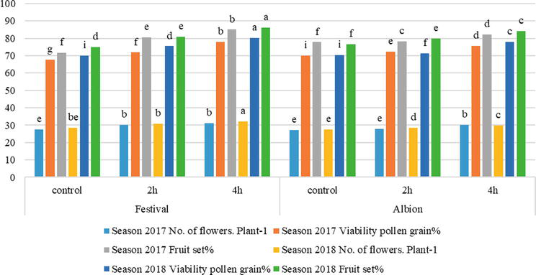
Figure 1.
Effect of photoperiod on some flowering parameters of two cultivars in two seasons 2017–2018.
Some fruit parameters increased significantly at photoperiod 4 h, such as fresh weight of strawberry fruit (13.782 g) in the second season and dry weight of strawberry fruit (3.467 g) in the first season; dry weight percentage recorded the highest value (29.515%) for Albion cv. in the first season, while Festival cv. recorded the lowest value (7.357%), Number of fruits. Plant-1 significantly increased (27.943) for Festival cv. at photoperiod 4 h in the first season and the lowest value recorded (11.111) for Albion cv. at control treatment in the first season. Finally, fruit fall percentage recorded the highest value (21.942%) for Albion cv. at control treatment in the second season and the lowest value (10.108%) for Festival cv. at photoperiod 4 h in (Figure 2).
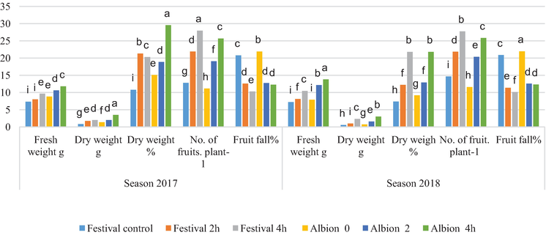
Figure 2.
Effect of photoperiod on some fruit parameters of two cultivars in two seasons 2017–2018.
Strawberry fruit diameter increased significantly to 3.984 cm for Festival cv. at photoperiod 4 h in the first season of planting, while fruit length increased dramatically to 4.688 cm in the second season for Albion cv. at photoperiod 4 h, and fruit size recorded the highest value (4.307 cm³) in the second season for Albion cv. at photoperiod 4 h and the lowest value recorded (1.321 cm³) for Festival cv. at (Figure 3).
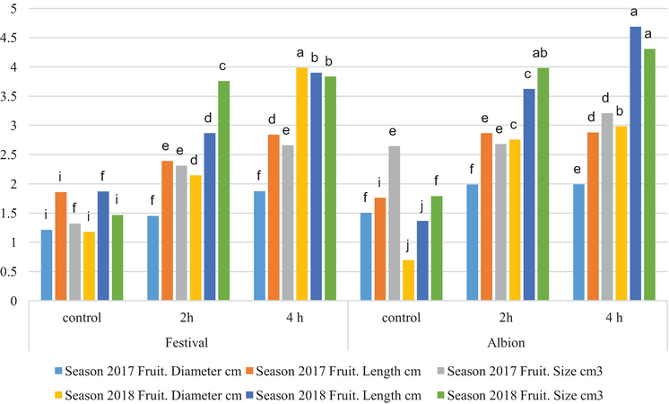
Figure 3.
Effect of photoperiod on some fruit parameters of two cultivars in two seasons 2017–2018.
Yield per plant-1 (g) and yield per hectare-1 (Kg) rose considerably at photoperiod 4 h for Festival cv. (100.591) in the second season and (96.633) in the first season, respectively (Figure 4).
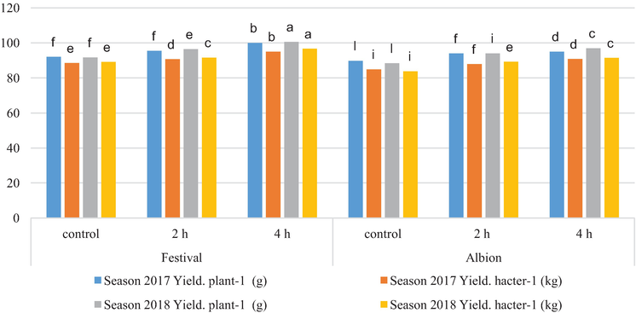
Figure 4.
Effect of photoperiod on yield of two cultivars in two seasons 2017–2018.
Strawberry marketable fruits percentage increased significantly (89.344%) for Albion cv. in the second season at photoperiod 4 hours, while unmarketable fruits recorded the highest value (17.932%) for Festival cv. at control treatment in the first season and the lowest value (9.769%) for Albion cv. in the second season at photoperiod 4 hours (Figure 5).
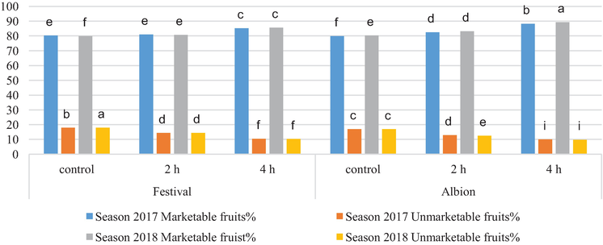
Figure 5.
Effect of photoperiod on marketable fruits% and unmarketable fruits% of two cultivars in two seasons 2017–2018.
Advertisement
3. Conclusions
The results confirm our previous finding [38] that flowering and fruiting in the strawberry plant are promoted and advanced by SD during early stages of plant growth and development. Photoperiod is one of the primary factors eliciting hormonal changes that stimulate flowering and fruit set. Covered plants for 4 h in day had a significant effect on most vegetative growth, flowering, and yield parameters. Generally, photoperiod via shorting day had significant effect on the studied parameters of the two (Festival and Albion) cultivars of strawberry plant. Festival cultivar responded to photoperiod more than Albion cultivar in fruit and yield parameter and that index to tolerance and good response of Festival cultivar.
Advertisement
Acknowledgments
All praise and thanks are due to the Lord of universe Allah for giving me inspiration, patience, time, strength and knowledge to complete this study. I am deeply indebted to Prof. Dr. Shler Mahmood Taha for her excellent advice, support, motivation, encouragement and patience that extended to me in the success of this study. I would also like to thank IntechOpen for their kind assistant. Extracted search from A Dissertation “Effect of Photoperiod and Foliar of Calcium on Growth, Flowering and Yield Quality Storage of Two Strawberry Cultivars (Fragaria X ananassa -Duch)” By Parween Muhammad Kareem Rozbiany and Prof. Dr. Shler Mahmud Taha. Erbil-Iraq. May 2020.
References
- 1.Kumakura H, Shishido Y. Effects of temperatures and leaf position on the translocation and distribution of 14C-photosynthatcs in fruiting strawberry cv. Morioka-16. Journal of Japan Society of Horticultural Science. 1994;62:833-838
- 2.Le Mière P, Hadley P, Darby J, Battey NH. The effect of temperature and photoperiod on the rate of flower initiation and the onset of dormancy in the strawberry (Fragaria x ananassa Duch.). Journal of Horticultural Science. 1996;71:361-371. (2)
- 3.Sønsteby A, NES A. Short days and temperature effects on growth and flowering in strawberry (Fragaria× ananassa Duch.). The Journal of Horticultural Science and Biotechnology. 1998;73:730-736
- 4.Konsin M, Voipio I, Palonen P. Influence of photo-period and duration of short-day treatment on vegetative growth and flowering of strawberry (Fragaria × ananassa Duch.). The Journal of Horticultural Science and Biotechnology. 2001;76:77-82
- 5.Hancock JF. Strawberries. New York: CAB International; 1999
- 6.Darnell RL. The Strawberry: A Book for Growers. Gainesville, FL: Dr. Norman F. Childers Publications; 2003. pp. 3-10
- 7.Verheul MJ, Sonsteby A, Grimstad SO. Interactions of photoperiod, temperature, duration of short-day treatment and plant age on flowering on Fragaria × ananassa Duch. cv. Korona. Scientia Horticulture. 2006;107:164-170
- 8.Konsin M, Voipio I, Palonen P. Influence of photo-period and duration of short-day treatment on vegetative growth and flowering of strawberry (Fragaria × ananassa Duch.). The Journal of Horticultural Science and Biotechnology. 2001;76:77-82
- 9.Manakasem Y, Goodwin PB. Responses of day neutral and June bearing strawberries to temperature and day length. The Journal of Horticultural Science and Biotechnology. 2001;76:629-635
- 10.Nishiyama M, Kanahama K. Effects of temperature and photoperiod on flower bud initiation of day-neutral and ever bearing strawberries. Acta Horticulturae. 2002;567:253-255
- 11.Verheul MJ, Sønsteby A, Grimstad SO. Influence of day and night temperature on flowering of Fragaria x ananassa Duch. cvs. Korona and Elsanta. Science Horticulture. 2007;112:200-206
- 12.Sønsteby A, Heide OM. Long-day control of flowering in ever bearing strawberries. The Journal of Horticultural Science and Biotechnology. 2007a;82:875-884
- 13.Sønsteby A, Heide OM. Quantitative long-day flowering response in the perpetual-flowering F1 strawberry cultivar Elan. The Journal of Horticultural Science and Biotechnology. 2007b;82:266-274
- 14.Sønsteby A, Heide OM. Temperature responses, flowering and fruit yield of the June-bearing strawberry cultivars Florence, Frida and Korona. Scientia Horticulturae. 2008;119:49-54
- 15.Sønsteby A, Opstad N, Myrheim U, Heide OM. Interaction of short day and timing of nitrogen fertilization on growth and flowering of ‘Korona’ strawberry (Fragaria× ananassa Duch.). Scientia Horticulturae. 2009;123:204-209
- 16.Sønsteby A, Solhaug KA, Heide OM. Functional growth analysis of ‘Sonata’ strawberry plants grown under controlled temperature and day length conditions. Scientia Horticulturae. 2016;211:26-33
- 17.Garcia KP. Physiology of flowering and diurnal net photosynthetic response in American strawberry cultivars under controlled environment. Journal of Agricultural and Food Chemistry. 2016;43:1489-1492
- 18.Sønsteby A, Heide OM. Flowering performance and yield of established and recent strawberry cultivars (Fragaria × ananassa) as affected by raising temperature and photoperiod. The Journal of Horticultural Science and Biotechnology. 2017;25:367-375. (18)
- 19.Gast KLB, Pollard JE. Row covers enhance reproductive and vegetative yield components in strawberries. HortScience. 1991;26:1467-1469
- 20.Robert F, Risser G, Petel G. Photoperiod and temperature effect on growth of strawberry plant (Fragaria × ananassa Duch.): Development of a morphological test to assess the dormancy induction. Scientia Horticulturae. 1999;82:217-226
- 21.Kader AA. Quality and its maintenance in relation to the postharvest physiology of strawberry. In: Quality and Its Maintenance in Relation to the Post-harvest Physiology of Strawberry. Portland: Timber Press; 1991;21: 145-152
- 22.Tehranifar A, Battey NH. Comparison of the effects of GA3 and chilling on vegetative vigor and fruit set in strawberry. Acta Horticulturae. 1997;409:629-630
- 23.Zhang L, Strik BC, Martin LW. Date of renovation affects fall and summer fruiting of June-bearing strawberry. Advanced Strawberry Research. 1992;11:47-50
- 24.Guttridge CG. Fragaria ananassa. In: Halevy AH, editor. Handbook of Flowering. Boca Raton , FL: CRC Press; 1985;3:16-33
- 25.Vince-Prue D, Guttridge CG. Floral initiation in strawberry: Spectral evidence for the regulation of flowering by long-day inhibition. Planta. 1973;110:165-172
- 26.Le Mière P, Hadley P, Darby J, Battey NH. The effect of temperature and photoperiod on the rate of flower initiation and the onset of dormancy in the strawberry (Fragaria x ananassa Duch.). Journal of Horticultural Science. 1996;71:361-371
- 27.Mori T. Effect of temperature during flower bud formation on Achene number and fresh weight of strawberries. Journal of the Japanese Society for Horticultural Science. 1998;9:396-399
- 28.Nishiyama, M. & Kanahama, K. (2000). Effects of temperature and photoperiod on flower bud initiation of day-neutral and ever bearing strawberries. IV International Strawberry Symposium 567.
- 29.Mochizuki T, Yoshida Y, Yanagi T, Okimura M, Yamasaki A, Takahashi H. Forcing culture of strawberry in Japan – production technology and cultivars. Acta Horticulturae. 2009;842:107-109
- 30.Strik B, Buller G, Righetti T. Influence of rate, timing and method of nitrogen fertilizer application on uptake and use of fertilizer nitrogen, growth, and yield of June-bearing strawberry. Journal of American Society of Horticultural Science. 2004;129:165-174
- 31.Serçe S, Hancock JF. Inheritance of day-neutrality in octoploid species of Fragaria. Journal of American Society of Horticultural Science. 2005;130:580-584
- 32.Sønsteby A, Heide OM. Environmental control of flowering and runnering in three contrasting populations of Fragaria chiloensis. The Journal of Horticultural Science and Biotechnology. 2009;84:267-272
- 33.Sønsteby A, Heide OM. Dormancy relations and flowering of the strawberry cultivars Korona and Elsanta as influenced by photoperiod and temperature. Scientia Horticulturae. 2006;110:57-67
- 34.Verheul MJ, Sønsteby A, Grimstad SO. Influence of day and night temperature on flowering of Fragaria x ananassa Duch. cvs. Korona and Elsanta. Science Horticulture. 2007;112:200-206
- 35.Lieten P. The effect of nutrition prior to and during flower differentiation on phyllody and plant performance of short day strawberry Elsanta. Acta Horticulturae. 2002;567:345-348
- 36.Opstad N, Sønsteby A. Flowering and fruit development in in a field experiment with two fertilizer strategies. Acta Agriculture Scandinavian Section B. 2008;58:297-304
- 37.Dale A, Luby JJ, Hancock JF. Breeding day neutral strawberries for Northern North America. Acta Horticulturae. 2002;567:133-136
- 38.Atmani D, Chaher N, Atmani D, Berbouc M, Debbache N, Boudaoud H. Flavonoids in human health: From to biological activity. Current Nutrition & Food Science. 2009;5:225-237
- 39.Bradford E, HAncock, J.F. & Warner, R.M. Interactions of temperature and photoperiod determine expression of repeat flowering in strawberry. Journal of the American Society for Horticultural Science. 2010;135:102-107
- 40.Sønsteby A, Heide OM. Effects of photoperiod and temperature on growth, flowering and fruit yield in annual-fruiting red raspberry cultivars (R. idaeus L.). European Journal of Horticultural Science. 2012;77:97-108
- 41.Li P, Ma F, Cheng L. Primary and secondary metabolism in the sun exposed peel and the shaded peel of apple fruit. Physiologia Plantarum. 2013;148:9-24
- 42.Kadomura-Ishikawa Y, Miyawaki K, Takahashi A, Masuda T, Noji S. Light and abscisic acid independently regulated FaMYB10 in Fragaria x ananassa fruit. Planta. 2015a;241:953-965
- 43.Feng F, Li M, Ma F, Cheng L. Phenylpropanoid metabolites and expression of key genes involved in anthocyanin biosynthesis in the shaded peel of apple fruit in response to sun exposure. Plant Physiology and Biochemistry. 2013;69:54-61
- 44.Heide OM, Stavang JA, Sønsteby A. Physiology and genetics of flowering in cultivated and wild strawberries–a review. The Journal of Horticultural Science and Biotechnology. 2013;88:1-18
- 45.Cervantes L, Ariza MT, Gómez-Mora JA, Miranda L, Medina JJ, Soria C, et al. Light exposure affects fruit quality in different strawberry cultivars under field conditions. Scientia Horticulturae. 2019;252:291-297

