**FIG** **TREE**

(Ficus carica), [plant](https://www.britannica.com/plant/plant) of the [mulberry family](https://www.britannica.com/plant/Moraceae) (Moraceae) and its edible [fruit](https://www.britannica.com/science/fruit-plant-reproductive-body). The common fig is [indigenous](https://www.merriam-webster.com/dictionary/indigenous) to an area extending from Asiatic [Turkey](https://www.britannica.com/place/Turkey) to northern [India](https://www.britannica.com/place/India), but natural seedlings grow in most Mediterranean countries; it is [cultivated](https://www.merriam-webster.com/dictionary/cultivated) in warm climates. In the Mediterranean region the fig is so widely used, both fresh and dried, that it is called “the poor man’s food.” The fruit contains significant that it is called “the poor man’s food.” The fruit contains significant amounts of [calcium](https://www.britannica.com/science/calcium), [potassium](https://www.britannica.com/science/potassium), [phosphorus](https://www.britannica.com/science/phosphorus-chemical-element), and [iron](https://www.britannica.com/science/iron-chemical-element).

The fig was one of the earliest fruit trees to be cultivated, and its cultivation spread in remote ages over all the districts around the [Aegean Sea](https://www.britannica.com/place/Aegean-Sea) and throughout the Levant. The [Greeks](https://www.britannica.com/place/ancient-Greece) are said to have received it from Caria (hence the specific name); Attic figs became celebrated in the East, and special laws were made to regulate their exportation. The fig was one of the principal articles of sustenance among the Greeks; the Spartans especially used it at their public tables.

**Physical description**

The fig plant is a bush or small [tree](https://www.britannica.com/plant/tree), from 1 meter (3 feet) to 10 to 12 meters (33 to 39 feet) high, with broad, rough, deciduous [leaves](https://www.britannica.com/science/leaf-plant-anatomy) that are deeply lobed or sometimes nearly entire. The leaves and stems exude a white latex when broken.

Fig fruits, known as [syconia](https://www.britannica.com/science/syconium), are borne singly or in pairs above the scars of fallen leaves or in axils of leaves of the present season. [Flowers](https://www.britannica.com/science/flower) are staminate (male) or pistillate (female) and enclosed within the [inflorescence](https://www.britannica.com/science/inflorescence) structure. Long-styled female flowers are characteristic of the edible fruits of most garden and orchard fig trees. Another type of tree, known as a [caprifig](https://www.britannica.com/plant/caprifig), produces inedible figs that house the fig wasp young. It has short-styled female flowers that are adapted to the egg-laying habits of the [fig wasp](https://www.britannica.com/animal/fig-wasp) (Blastophaga) and also contains male flowers near the apex. Pollen from the caprifigs is carried by the fig wasps to pollinate both the edible and inedible figs.

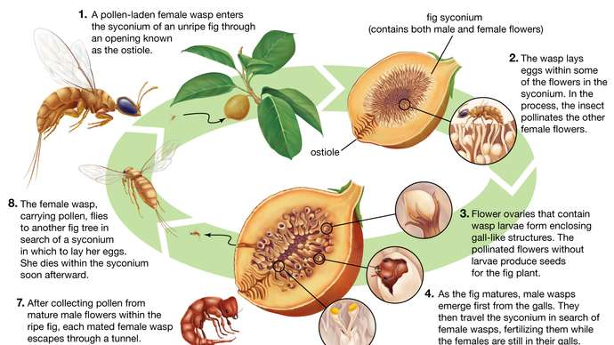

**Types and cultivation**

In addition to the caprifig, there are three other horticultural types of figs: [Smyrna](https://www.britannica.com/plant/Smyrna-fig), White San Pedro, and Common. Smyrna-type figs develop only when fertile seeds are present, and these seeds account for the generally excellent quality and nutty flavour of the fruit. Figs of the White San Pedro type combine the characteristics of both the Smyrna and the Common type on one tree. First-crop figs develop without flower [pollination](https://www.britannica.com/science/pollination), while second-crop figs in axils of leaves require it. Common figs such as the Dottato, Fraga, and Brown Turkey do not require pollination of flowers of either crop, the seeds in the mature fruit usually being hollow. The flowers of such figs were once regarded as incapable of fecundation and were therefore designated as mule flowers, but it has been proved that all common figs can produce fertile seeds if the flowers are pollinated.

The varieties of figs grown in various parts of the world run into the hundreds. Their [nomenclature](https://www.merriam-webster.com/dictionary/nomenclature) is very much confused, since the same fig is often grown in neighboring provinces under entirely different names. When a fig is introduced into other countries, a new name is commonly coined. Thus, Lob Injir of Smyrna became Calimyrna in California, and Dottato of Italy became Kadota. The Italian San Piero is known in England as Negro Largo, in France as Aubique Noire, and in California as San Pedro Black, Brown Turkey, or Black Spanish.

Fig trees are [propagated](https://www.merriam-webster.com/dictionary/propagated) from cuttings of dormant wood taken in February in the Northern Hemisphere and planted in nursery rows. These grow in one season to a height of 1 meter (3 feet) and are ready to transplant at the end of the [growing season](https://www.britannica.com/topic/growing-season). The trees thrive in a wide range of [soil](https://www.britannica.com/science/soil) types and in most Mediterranean countries receive water only from the natural rainfall. Some varieties produce only one crop, in summer or fall. Some bear two crops, the first maturing in June or July on wood of the previous growth and the second ripening in summer or fall in the axils of the leaves of the same season. In cool climates such as those of England and central France, most varieties mature only the first crop. Pot [culture](https://www.merriam-webster.com/dictionary/culture) of figs in greenhouses has long been practiced in England and other countries.

In most districts, figs are gathered when they fall and placed on trays for drying. Turning and manipulating during the drying process improves the texture and quality of the product. In the Old World, figs are grown commercially in Italy, Turkey, [Algeria](https://www.britannica.com/place/Algeria), Greece, [Portugal](https://www.britannica.com/place/Portugal), and Spain.