**Dormancy of trees**

**Bud endodormancy in deciduous fruit trees:**

**Dormancy** refers to a temporary suspension of visible growth of any plant structure containing a meristem[1](https://www.nature.com/articles/s41438-021-00575-2#ref-CR1) and is a biological characteristic of higher plants adapted to seasonal environmental changes through long-term natural selection. Bud dormancy is an important physiological process that helps plants survive harsh winter weather and determines growth resumption and flowering in the following spring.

Dormancy is similar to hibernation in that all the parts and processes of the plant, including the metabolism and energy consumption, slow down.

Bud dormancy is an important physiological process that helps plants survive harsh winter weather and determines growth resumption (return) and flowering in the following spring. Bud dormancy is generally divided into three types:

1. Para-dormancy
2. Endo-dormancy
3. Eco-dormancy

According to various factors that cause dormancy. This classification has been widely accepted by researchers in the study of bud dormancy.

1. **Para-dormancy**

In autumn, with decreased temperature and/or day length, buds (both terminal buds and axillary buds) are encouraging to enter endodormancy. In this stage, the buds cannot sprout, even under favourable conditions. Trees enter the first stage of para-dormancy during seasonal [temperature and day-length](https://www.americanforests.org/blog/the-legend-of-sleepy-trees/) changes. These environmental signals ultimately cause deciduous trees to lose their leaves. Leaves, flowers, and fruit require energy to maintain, which is why they shed (get rid of) them in colder months.

1. **Endo-dormancy.**

Is a type of dormancy where the buds are dormant because of an internal plant inhibitor system that prevents growth even under ideal external growing conditions. Once a plant has entered endodormancy, it will not grow again until it has received enough cold to overcome the dormancy).

After the fulfilment (investigation) of a certain period of chilling accumulation (termed chilling requirement, CR), endodormancy is released, and buds acquire the potential capability to resume (begin again) growth. Because the release of endodormancy generally occurs at the depth of winter, buds cannot break immediately because of unfavourable conditions and are forced into Eco dormancy.

After growth cessation (stopping) and bud set, low temperatures and/or the short-day photoperiod induces trees to enter endodormancy. When the chilling requirement is satisfied (contented), endodormancy is released and trees enter the Eco dormancy stage. Endodormancy is divided into three stages: induction (establishment), maintenance, and release.

1. **Eco-dormancy:**

Dependent on heat accumulation in phenological phases close to flowering. according to various factors that cause dormancy. This classification has been widely accepted by researchers in the study of bud dormancy. Deciduous fruit trees need a certain amount of winter chilling to break down gro.th inhibitors in flower and vegetative buds.

The chilling requirement (also called chill hours) needed for the tree to be success in a given climate. Varieties vary by chilling requirement and varieties are recommended based on the average number of winter chill hours a given area receives over the years.

[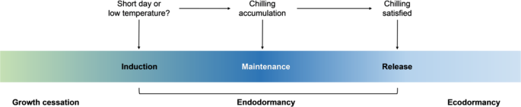](https://www.nature.com/articles/s41438-021-00575-2/figures/1)**Fig. 1: Dormancy–growth cycle**

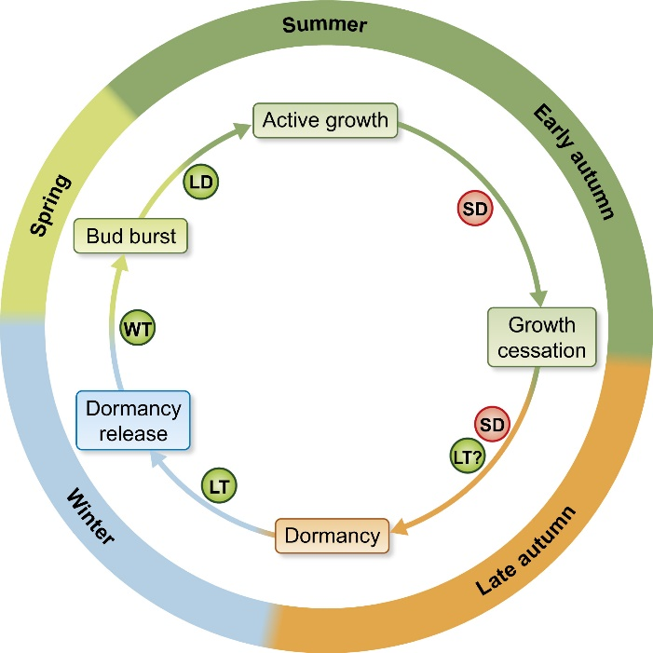

Fig. 2 Photoperiod‐ and temperature‐mediated control of phenology in trees – a molecular perspective

**Chilling requirement**

“Chill hours are the number of cold hours that a deciduous fruit tree (or nut tree) requires for flowering and fruit production each year. Every fruit tree variety has its own number of hours of chill needed for fruit production. Some fruit trees need as few as 100 chill hours, others need as many as 1,000 chill hours or more. *“*

The definition of chilling hours requirement is:

(**The number of hours of temperature is between 0-7 degrees C. more recently**).

**Chilling Hours**

Many deciduous trees (trees that lose their leaves in winter), require a period of dormancy and the accumulation of chilling to produce flowers and fruit. **A chill hour is the amount of chilling received by a plant at** 7 0C. The chilling requirement is the total number of hours required during the winter for a particular cultivar to induce the tree to break dormancy and produce flowers. **The chilling hours or chilling units (CU) represent one hour of exposure to temperatures adequate to bring the plant out of dormancy.** The amounts of chilling required vary by species and variety

When the trees lose their leaves, a chemical called abscisic acid (ABA) is produced in terminal buds—the part at the tip of the stem that connects to the leaf. ABA is produced in both deciduous and coniferous trees. It suspends growth and prevents cells from dividing—another key component of dormancy. It also saves a lot of energy to stall growth during the winter.

.

**The effect of lack accumulation of cold hours on deciduous fruit trees**

The lack of accumulation of cold hours generates multiple and varied imbalances in the physiological self-regulation and phenological calendar of sprouting, flowering and fruiting of the plant, such as:

* Delay in production.
* Increased vegetative growth.
* Less “darts or shoots” in stone fruit trees.
* Poor leaf development.
* Delayed sprouting.
* Dormant vegetative buds.
* Weakness in outbreaks.
* Vertical development due to lack of open lateral buds.
* Flowers Delayed and uneven flowering.
* Lower fruit set due to difference in flowering times.
* Weak flowers fall. Decreased pollen viability.
* Bud fall on susceptible trees.
* Fruit Uneven ripening.
* Lower productions.
* Lower fruit quality: size, colouring
* Growth Stages: (1) dormant, (2) swollen bud, (3) bud burst, (4) white bud, (5) bloom, (6) petal fall, and (7) fruit set.

**Dormancy and Chilling Requirement**

The shortening days of fall triggers the production of abscisic acid, which impedes growth, and causes dormancy in trees. For a full description of the onset of dormancy in trees, see our previous article “[Dormancy Onset In Trees](https://www.fortheloveoftrees.com/dormancy-onset-in-trees/)”. Over the winter, cold temperatures deplete the abscisic acid. When the concentration of the growth-impeding hormone is low enough, cellular activity and growth can begin when conditions allow. The amount of cold time required to deplete the abscise acid enough for growth to occur in spring is called the chilling requirement, and is a different amount of time for every species.

**Growth Hormones**

Once the chilling requirement is met, warmer temperatures and increased day length trigger the production of growth-stimulating hormones. Gibberellins stimulate stem growth, cytokinins regulate root growth and cell division, and auxins trigger tip elongation while inhibiting side shoot growth.

**Bud Formation**

While the long Portland summer days provide the trees with ample sunlight to make sugars, the trees are already preparing for the winter ahead. Plant buds are where new growth will occur. Buds are formed during the summer and fall prior to the spring in which we see them develop into new structures. This schedule of bud formation allows the tree to develop these important structures when there is ample energy available.

**Why do trees go dormant?**

The primary reason why trees go dormant is for their survival. The best way to think about this is just like a bear hibernates over the winter to survive, so do plants. This period of dormancy allows the plant to regroup and conserve energy while the outside conditions are not conducive to growing. Of course, not all plants go dormant, just like not all animals need to hibernate to survive.

**Which trees go dormant?**

Deciduous trees go dormant. The easiest way to know if a plant is deciduous is if the leaves all fall off in the wintertime and return in spring. Evergreen trees are the opposite of deciduous trees and will not go dormant. Evergreens often have thicker leaves that are waxy in texture. This waxy texture allows them to survive during the winter and last multiple seasons.

**Why is the tree I just bought losing leaves?**

This can be for various reasons, but the leading cause is transition. If your seasons change or transition to another season, like fall, you will see your tree missing or actively losing leaves. Consider the time of year and where the plant is traveling from. Our farm is in South Carolina, so if you experience fall at a different time than where the plant grew, your plant will need a little extra time to adjust to the new schedule. Just like if you traveled a long way and are recovering from jet lag.

**What can dormancy look like?**

Dormancy varies depending on the kind of tree that you have, but in general, you will notice the leaves gradually changing color and falling off the tree. There will be no flowers or fruit at this time, and if there are flowers and fruit, they will naturally fall off the tree as well. Expect the plant not to grow and go on "standby mode" during dormancy.

**What should I be concerned about in dormancy?**

The first step is knowing if your tree goes dormant or not. You should expect leaves on a deciduous tree to look worn out. they might have spots or some tears on it. This is normal as the tree is no longer putting energy into the leaves and instead switching gears internally. Red flags are any injury, oozing or pests that you see on the tree. This could be on the stems and the trunk so as the leaves fall off take the opportunity to check the overall health of your tree.

**How do I know if my tree is alive or is just dormant?**

Dormancy can be deceiving especially if your tree is lagging behind. A scratch test is a simple way to test your tree to see if its dormant or dead. To do this gently scratch of the outer layer of bark with a coin towards the base of your tree. This should reveal a wet green-white looking tissue. This means your tree is alive and healthy, just dormant. If you see dry, black-brown tissue then your tree is dead.

**Can I make my tree go dormant faster?**

As much as we would like to try and control nature, it is just not in our ability. There is no way to artificially trigger dormancy unless you control all the factors like temperature, light, and day length. Dormancy is a necessary part of the tree's cycle and allows it to have the energy for flowers and fruits so it is well worth the wait. As your tree ages and matures, its dormancy window will start to become more predictable.

**Do all trees go dormant at the same time?**

No, dormancy is an internal process that is individual to that tree. Some trees enter dormancy late, while other trees enter dormancy earlier. The rate at which trees go dormant also varies, while some go dormant overnight and others are slow to transition. Even trees of the same kind and variety might act differently! As long as your trees that should go dormant are going dormant, that is all that you should be concerned about.

**What triggers dormancy in trees?**

Nature gives cues to plants via environmental factors that let them know when to go dormant. These cues are shorter days, less light, cooler temperatures, and pollinator changes. All of these factors work in tandem to let the tree know that fall is here, to go dormant, and when it is time to exit dormancy.

**How will I know if my tree is coming out of dormancy?**

Look closely at the stems. You should start to see tiny buds begin to emerge and grow. These buds can be for flowers, leaves, or both. These buds are a sure sign that dormancy is over! Another great way to know if your tree is coming out of dormancy is to look around at nature. Often, plants around you will start to emerge that tell you winter is over and spring is here, aka. The end of dormancy!

**What is Dormancy?**

The best way to think of a tree in dormancy is to compare it to a bear in hibernation. Just as the bear needs rest during the winter and wakes up in spring, so does the tree. The process of dormancy is equally about survival as it is about energy conservation when wintertime resources are scarce. The bear is conserving energy and protecting itself when the weather conditions are too harsh in a similar way that the tree does. It just looks a bit different.

Trees spend spring and summer harvesting energy and expending that energy to grow shoots, leaves, flowers and fruits. As the days get shorter and the sunlight dwindles, trees enter into dormancy or an “energy saving mode.” There are changes internally and externally that happen to the tree when this time comes.

Internal changes

Internal changes during dormancy are occurring at the same time that the external changes are. Just because you can’t see the internal changes doesn't mean they aren't as important–they might even be more important than the external changes!

**Here are some internal changes that occur:**

* Growth dramatically slows or stops
* Signals are sent to the leaves to stop harvesting energy
* Sap will continue to flow, acting like antifreeze inside the tree & preventing damage

External changes

External changes are the most obvious to us when checking to see if a tree is entering dormancy or not. These are the visible changes we see on the outside of a tree.

**Here are some external changes that occur:**

* The green pigment responsible for energy production from the sun will start to fade, revealing the red and purple pigments underneath that give us bright fall colors.
* Left-over fruit is dropped and ready for harvest
* Evergreen trees (ones that don’t drop all their leaves) will stop growing and drop some of their inner needles or leaves

[Deciduous trees](https://www.fast-growing-trees.com/collections/shadetrees) are the showiest when entering dormancy. The leaves on deciduous trees are meant to be seasonal and typically last for one year. They are usually on the thinner side and aren’t waxy like a holly leaf is. As a deciduous tree enters dormancy, expect its leaves to change color and drop completely, leaving the tree bare.

**Entering and Exiting Dormancy**

**Entering dormancy**

The timing will vary depending on where you live, the weather patterns that year, and of course, the specific plants you have. For most, expect dormancy to gradually occur for your trees when the temperatures start to drop. In northern climates like Minnesota, this might be as soon as early October. In Southern states like North Carolina, expect to see color change in late to mid -November.

The best thing you can do during this transition to dormancy is to be consistent. Don’t stop watering altogether now that your trees are dropping leaves. Instead, water until the ground freezes in your area. While you might need to water less, you’ll still need to support your living plant. Be consistent with your [fall care](https://www.fast-growing-trees.com/pages/fall-planting-tips-by-region?_pos=1&_sid=baf81c167&_ss=r), and it will only help your garden come springtime!

**Exiting dormancy**

Just like entering dormancy, exiting dormancy won’t happen overnight. When your plants do emerge from dormancy, expect a burst of growth. This might be a flower bud on a redbud tree or some new leaves emerging from your apple tree.

**Dormancy** is the mechanism that plants use to protect sensitive tissue from unfavourable climatic conditions. In a changing global environment, temperate fruit crop adaptation might be at risk due to changes in temperature cues. This description is completed by the variability that climatic change might induce in plants through direct or indirect changes in dormancy.

* **A brief introduction to dormancy**
* Dormancy in temperate-zone deciduous fruit trees is a phase of development that allows trees to survive unfavourable conditions during the winter (Faust et al., 1997). Diverse factors can lead to meristem inactivity. For example, unfavourable environmental conditions, such as chilling temperatures or short photoperiod, generally induce this inactivity. Temperatures or day lengths below a certain threshold impede the processes that lead to growth and prevent any external indication of activity.

**Dormancy and fruit production**

The productivity problems derived from dormancy are not restricted to fruit production. Other activities, such as silviculture, can also be affected. Nonetheless, the focus of this study will be on the problems associated with fruit production. Most of the species and cultivars of temperate areas originated were originally cultivated between the latitudes 34° and 48°N (Faust, 2000). Independent of the climatic latitude and continentality, the climatic origin of these species play an important

* Deciduous species differ from other species in that they have a period of dormancy in winter. In practical terms, it can be observed that in late autumn the trees begin to show yellow leaves, which fall off, leaving the tree completely bare in winter.
* 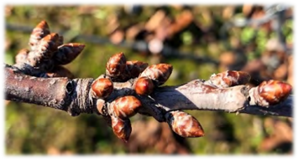Dormancy is therefore a physiological reaction of self-protection for meristems (growth structure for the new crop cycle), located inside the buds.
* Several authors have pointed out that dormancy occurs in response to a decline in day length towards the end of summer and in temperature towards the end of autumn. This suggests that the plant may respond to environmental cues that promote the accumulation of reserves to protect against winter cold.

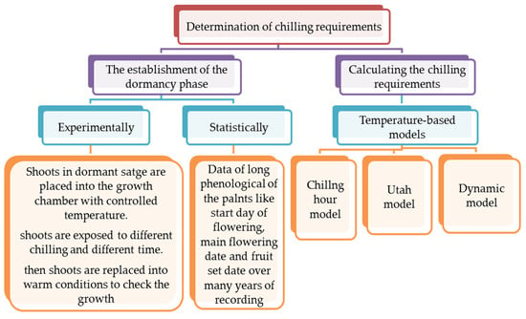

* Figure 2. A chart flow for determination of chilling requirements for deciduous fruit trees.