**Fruit Tree Growth Stages During Lifetime**

**Cultivation of** fruittreesand stagingduring lifetime for the growth ofthesetreesand their **development is special important and the most important of these stages:  
1 -** the start ofvegetativegrowthphase(**juvenile):** fruit trees at this stage be young and small in the beginning stages of growth where start seedlings after planting in orchard composition branches of very strong growth, long length up to 120 cm or more. It contains branch on the side separating leafy buds including long internodes, these branches grow and growth stands vertically sharp angle with the main stem either or early fruiting varieties grafted on rootstock were carrying floral buds, but the increase may be few.

2 - Continued vegetative growth stage and start produce (**Early bearing stage**):

Characterized this period to increase the number of Lateral branches and the formation of branches and one-year-old branched into short- branches bearing  
Floral buds while new growing makes sharp angle branches with the main stem,  
and in most cases made up the vegetative buds.

3 - The stage of the yield (**Full bearing orchards**):

In this stage, the tree structure has been completed and composition of growth by way of special breeding with type and varieties may be intensive tree branches , short-and long-branched and tend lateral branches present parties to the structure. Tree leaning gradually cause the less of the main stem growth and trees Growth may be was completed and began giving good yields and continuously depending on the age of the tree, types and methods of pruning and then begins to fall after yield.

4 - **The stage of low and lack of yields**:

At this stage less, annual vegetative growth Branches and tree branches are short and a few fruit trees tend to phenomenon of alter bearing and droop outdoor branches from tree crown to bottom, at this stage, need to pruning the trees to renew action on the bay cut Old branches and renewal branches by pruning procedure new branches.

5 - The stage of the pyramid (aging or Senile):

The annual tree growth is very weak not exceeding a few centimeters and the trees Formation a small and few fruits prepare and thus become Planting and breeding is not economic, therefore prefers uprooting and replaced by other trees. The cause and severity of pruning an important role in shortening this stage.

**Fruit Tree Stages of Growth & Development** **during the year**

Deciduous fruit such as apple, pear, peach and plum undergo a series of distinct stages during the annual cycle of fruit production. Although specific stages vary, depending on the type of tree, most fruit trees follow a similar pattern of growth and development. Fruit growers use these stages to evaluate the progress to prune and apply pesticides and fungicides.

**1 - Dormancy**

In autumn, deciduous fruit trees lose their leaves and store energy in the trunk and roots to sustain (bear) them during winter dormancy. developing buds become inactive in preparation for winter survivalالبقاء. Dormancy prevents buds from opening prematurely during short warm periods. Fruit trees require a certain number of chill hours, hours when temperatures remain between 0 to 7 degrees, to achieve optimal fruit production. Chill requirements vary, depending on the variety of tree. Correct **pruning during dormancy produces** vigorous spring growth; **however, heavy pruning causes excessiveزائد** growth of leaves and stems but **little fruit production**. Pruning too early in the winter makes trees **more susceptible to winter injury. Application of oil-based pesticide and fungicide sprays during dormancy prevent problems before new growth begins**.

**2- Budding**

The swelling of flower buds in early spring start the budding stage. Buds that have received the correct number of chill hours emerge from dormancy, ready to begin growing when temperatures warm in springtime. Insufficient chill hour accumulation leads to delayed growth and reduced fruit production. Budding occurs in as many as 13 stages (Separate stages). The exact number and name for each budding stage is varies by type of tree. Typical budding stages include **swollen bud, bud explosion, green tip, tight cluster and pink or white bud.** Knowledge of these stages helps a grower determine whether crop has been injured by cold weather or is progressing normally.

**3 - Blossoming**

Blossoming begins with the opening of the first flower buds and lasts until the petal-fall stage, when about 75 percent of blossoms have fallen from the tree. During this stage, Blooms are particularly sensitive to damage from late spring frosts. Pollination is crucial (vital)during blossoming to ensure optimal production of well-formed fruit. Most fruit trees depend on insects such as honey bees to transfer pollen from the male to the female flower parts. **Avoid using insecticides during** the blossom stage to prevent killing beneficial pollinator insects. **Full bloom** occurs when approximately (nearly) 80 percent of a tree's flower buds are opened.

**4 - Fruit Set**

Depending on the type of tree, fruit set typically occurs sometime between March and May; about 4 to 10 days after blossoms appear. Fruit set is the transition from non-growing ovaries to rapidly developing fruits. It normally requires the full completion of fertilization, although in some plant’s fertilization can be bypassed leading to the formation of a seedless fruit, a process referred to as parthenocarpy

**5- Fruit growth and Development**

changes commonly follow a sigmoid curve. Fruit development can be divided into four major phases, fruit set, rapid cell division, cell enlargement, and maturation and ripening. Added to this, changes in storage products (oil, starch and sugar) and structural carbohydrate (endocarp thickening) influence dry matter content. Fruit ripens over the summer months until harvest time, usually about 60 to 150 days after blooming. Fruit can increase in mass or volume from fertilization to maturity.

Hand-thinning the crop produces larger, better-formed fruit and prevent breakage of tree parts. During the fruit development stage, growers often apply chemical treatments to prevent and control pest.

**improve flowering and fruit set**

complex biochemical interactions occur inside the plant to induce both flowering and fruit set.

**1. No or few flower buds or flowers develop**

There can be many reasons for this but, there are three the most common:

**i. Too little sunlight/too much shade:** Plants require a certain minimum number of sunlight hours to induce flower bud **formation**, and this amount **varies with species, and even with different cultivars or varieties of the same species**. And it’s not only the light provided by sunlight, **but its heat that has an effect,** which is why there can be **differences depending on whether the sunlight is morning or afternoon, or in summer or winter**. Day (or night) **length also** has an impact. Most researches recommend that vegetables **require a minimum of six hours direct sun daily,** but it’s possible to harvest modest but worthwhile crops with less than that, **though fewer flowers – and hence fruit – are produced**. Of course, everything else – soil fertility, moisture etc. – needs to be ideal in this situation.

[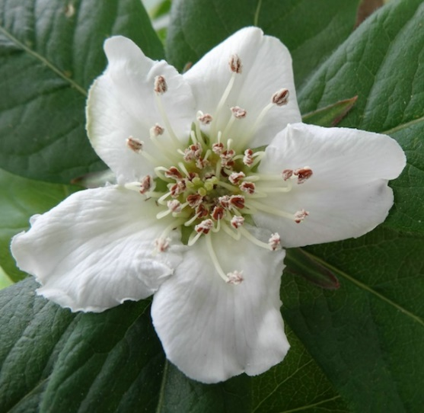](https://gardendrum.com/wp-content/uploads/2013/02/Medlar-flower-pre-pollination.jpg)

flower pre-pollination

flower after pollination[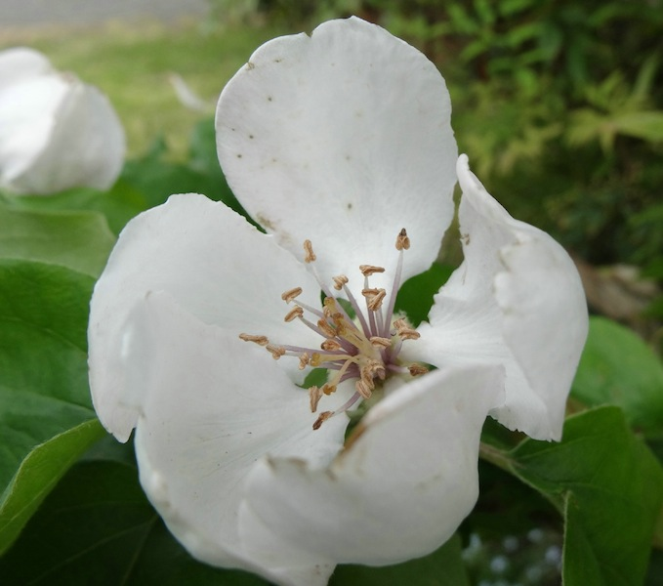](https://gardendrum.com/wp-content/uploads/2013/02/Medlar-flower-after-pollination.jpg)

**ii. Nutrient imbalances**, notably too much nitrogen. Improving soil with sufficiently of organic manures and composts produces rich, friable soil… but plants with sufficiently of vegetative growth, but no flowers

potassium redresses the imbalance and stimulates flowering Once again, the biochemistry is complex, although the author acknowledges that potassium may **affect flowering indirectly by promoting overall plant health.**.. The author does suggest that potassium can improve fruit set in some plants, and I have no doubt I’ve seen it improve my crops of bush currants and tomatoes. You can add potash in the form sulphate of potash, liquid fertilisers such as Thrive Flower and Fruit, and certain seaweed fertilisers or rock dusts.

**iii. Plant immaturity:** Some fruit trees such as figs, peaches, nectarines and apples produce fruit very early, often bearing in the nursery when you purchase potted specimens, whereas others, such as pistachio, avocado and walnuts, need several seasons or longer to establish and develop cells that give increase to flower buds.

**2. Flowers develop, but fruit does not.**

Lack of sun, nutrient imbalances and plant immaturity can also limit fruit set, with three more common causes.

**i. Lack of pollination:**Lack of pollination is usually for two reasons. The first is a lack of bees. Perhaps flowers have appeared, but a subsequent cold period has dropped the temperature to below 13-15 C, when most bees cease flying.

If your garden lacks bees, you can encourage them by planting a wide variety of long-flowering, bee-attracting plants such as lavender, thyme, Nepeta, lemon balm, salvias and oregano, and plants that flower successively throughout the year so there’s always pollen available.

Lack of **pollination may also be because the trees requires** a cross-pollinator. Most almonds, cherries, plums, and apples require a cross-pollinator nearby, and even those which are promoted as self-fertile generally produce bigger crops near a compatible pollinator.

When bees aren’t doing their job, you can pick the male flowers and hand-pollinate the female ones, gardeners pollinating each female flower with two different male flowers; remember too that the female flowers are viable for only a day, so pollinate them daily, early in the morning when they first open.

**ii. Irregular watering:**Both flowers and tiny fruit may drop when plants dry out, even with just one missed watering. You don’t need to flood them, but regularity with a constancy of moisture levels is the key.

**iii. Temperature:**Extreme heat can cause flower drop

**Causes and control of flower drop in fruit trees**

Flower drop is having a serious impact on crop yield as loss in flower cause loss of fruit which directly result in yield loss cause serve economic loss in the horticulture industry.

Flowers are dropped due to many reasons which include internal and external factors such as wounding(hurtful) in plant or invasion of pathogen, fluctuate or unbalanced environmental conditions Flowers are also discarded by plants after pollination.

Dropping of reproductive organs male flowers or bisexual flowers is common in various species most time’s petals fall but varying in species cause variation in floral part drops such as styles, sepals, styles and stamen.

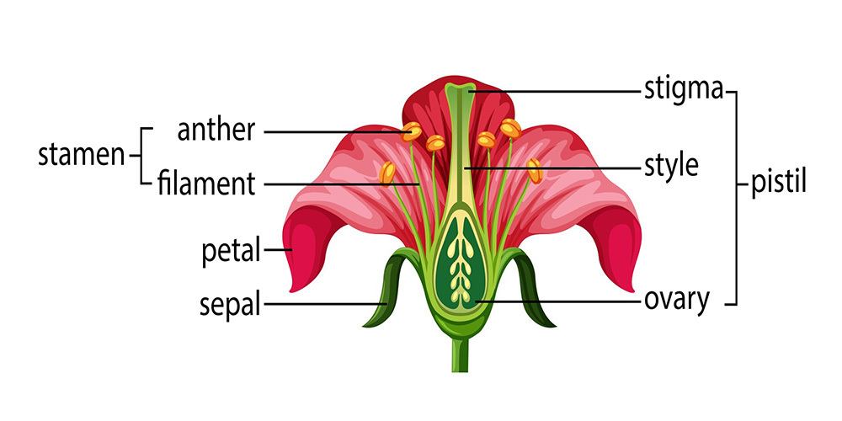

There are numerous main factors of flower drop and techniques Causes of flower drop in fruit trees

♣ Application of irregular Nitrogen,

♣ Poor fertilization,

♣ Climatic factors (wind, rainfall etc.)

♣ Abundant crop load,

♣ Irregular ripening

♣ Internal auxin deficient

**Fruit Drop:**

Fruit trees usually bear a large number of flowers and only small percentage of which are enough to give a normal yield. When the fruit set is much more than the tree can normally carry to maturity, there will be drop of fruits at various stages of fruit development as an adjustment of tree to its resources. Such drop is natural and beneficial to the trees and it will prevent exhaustion (consumption) of the resources and breaking of branches by over bearing.

The flower or fruit drop are preceded by the **formation of layer or several layers of cells at the base of petiole pedicle or punned and at the right angles to this axis.** These cells are more or less **rectangular** in shape and are not cemented together hardy **and not crossed by fibrous or vascular tissues** Consequently breakage or abscission is at that point. The formation of this **abscission layer of cells is a natural phenomenon ordinarily taking place as** natural maturity is reached. It may be speeded by certain environmental conditions.

**The fruit drop usually takes place in definite, waves or at definite stage and those are**

1) Pre-setting

2) Post setting

3) Jun drop

4) Pre-harvest drop.

The first drop presetting occurs shortly after flower opening. Usually flowers with aborted pistil drop off at’ this stage.

Second drop post setting occurs a fortnight (two weeks) later than the first, drop. This drop includes unfertilized flowers and some fertilized flowers also drop off at this stage as a result of adjustment in the trees between nutritional factors arid fruit set.

Third drop June drop occurs when the fruits are marble size due to the formation of abscission layers in the young fruit stalks. This drop usually occurs in most deciduous fruits in the month of June.

These three drops are supposed to be natural one and thinning of fruits hopes the trees to produce remaining fruits with good size.

**Pre-harvest Drop:**

In addition to the fruit drop like presetting post setting and June drop rare is a another drops pre – harvest drop which causes financial loss to grower as it takes place just before the harvest of fruits. At this stage 1/2 developed and 3/4 developed fruits are shed drops to many causes.

**Major reasons for fruit drop**

**1) Mechanical Causes:**

Wind and hail

storm cause’s fruit drop.

**2) Climatic Factor:**

Climatic factors such as **high temperature low humidity very low temperature, hasten the formation of abscission layer in the fruit stalk**. The formation and growth of **buds, flowers, and fruits can all be dramatically impacted by temperature variations**. Stressed plants may respond by losing their buds, blooms, and fruits

**3) Physiological Factors:**

Lack of available nitrogen and similar other nutritional factors may cause fruit drop. **Fruit drops from weak shoots is more than from strong ones**.nutrient deficiency causes flower dropping (especially calcium and boron) deficiency. A calcium deficiency can abort flower buds of different kinds of fruit trees. **hormonal influence on control of flower and fruit drop.** Auxin, gibberellins, and ethylene are hormones that are directly related to the process of flowers and fruit drop. **Complex hormonal interactions occur during fruit development**. Gibberellins and cytokines **stimulate fruit growth** and auxin as a **growth stimulator** and also as a fruit drop agent.

**4)** **Insufficient Pollination:**

Young fruit that has not received enough pollination will be drop. **This may be because of an absence of pollinating insects like bees and butterflies during flowering time**. To increase their numbers by planting roses, among other garden plants that will **attract bees and other beneficial insects**

**5) Pathological Factors:**

Attack of pest and diseases will increase fruit drop.Severe injury of mites, leaf miners, and other insects or diseases that great quantity lower the amount of photosynthate produced by plant leaves pre-harvest decline severity. **It has been found that severe mite and leaf miner lower the photosynthetic capability of plant leaves**, limiting the **availability of carbohydrates to the fruits in the late stages of the growing season**. However, the **severity** of the pre-harvest losses can be increased if significant insect or mite damage is combined with extreme pruning, low Mg, or drought stress.

**6) Poor fertilization and Cultural Practices:**

Nutrient insufficiency is a prevalent issue. It may be caused by a lack of both major and minor nutrients. It differs from one plant to another. The issue can be resolved by giving your plant a balanced fertilizer that contains all these components. **Pre-harvest fruit drop is often more severe in orchards with low fertility soils, as well as orchards with low magnesium (Mg), high potassium (K), and high boron (B).** It is advised that orchards receive yearly maintenance sprays of Mg (Epsom salts) at the first and third cover sprays to reduce the preharvest drop in,excessive irrigation resulting bad aeration in soils lead to drop of fruits.

**7) Extreme pruning:**

Pre-harvest fruit drop is frequently significant in orchards that get heavy summer trimming. When an excessive number of leaves are removed, older, less functional plant leaves remain, which may cause a constraint in the availability of carbohydrates. Fruit drop will rise if summer pruning lowers the leaf-fruit ratio below 20:1. If summer pruning is required, it is advised to keep it moderate and remove just a small portion of the functional leaves

**8) Water stress:**

Improper watering places a lot of strain on trees. Plants can experience this stress from both overwatering and underwatering. Underwatering may lead plants to divert water from growing buds to food-producing sections of the plant, which causes buds, flowers, and fruits to weaken and finally dry out and fall off. The plant is defending itself in this way. Excessive watering also results in root rot or other fungal infections, which may destroy the fruit.

**9) Other Factors:**

The shed is more of seedless fruits than of seeded ones. It is also said that cross pollinated fruits keep better on the tree than self-pollinated fruits.

Younger plant shed more fruits than older ones probably owing to lack of nutritional reserves. Within a kind of fruit, the varieties differ among themselves in the extent of fruit drop.

**Extreme pruning:**

Pre-harvest fruit drop is frequently significant in orchards that get heavy summer trimming. When an excessive number of leaves are removed, older, less functional plant leaves remain, which may cause a constraint in the availability of carbohydrates. Fruit drop will rise if summer pruning lowers the leaf-fruit ratio below 20:1. If summer pruning is required, it is advised to keep it moderate and remove just a small portion of the functional leaves.Extreme pruning

.

**Ways to prevent fruit drop**

. The best techniques to [prevent fruit drop](https://fasalblogin.wordpress.com/how-to-prevent-fruit-drop-in-citrus/)are as follows:

1. **Windbreak and shelterbelt planting:**

Intense wind speeds damage the fruits and branches mechanically and cause desiccation due to excessive water loss during transpiration. To protect against hot and cold winds and decrease fruit drop, windbreaks made of quickly growing, deeply rooted trees should be placed all around the orchard.

1. **Management of Water and Moisture:**

Most fruit crops experience significant fruit drops due to moisture stress during fruit set and development. In an [irrigated system](https://fasalblogin.wordpress.com/things-to-know-about-drip-irrigation-system/), water application should be based on properly timed evapotranspiration deficiencies. The scheduling of irrigation based on plant water content should be appropriate for deep-rooted perennial fruit crops.

[Mulching](https://fasalblogin.wordpress.com/how-mulching-can-protect-crops-from-the-summer-heat/) reduces soil evaporation from the surface by reducing the supply of heat energy to the evaporating site and decreasing the soil’s thermal conductivity, which helps conserve soil moisture and increase water efficiency. As a result of this method, fruit drop is decreased. Sawdust, wheat, rice straw, and black or white polyethene are common mulching materials.

1. **Nutritional Management:**

Fertility management for reducing fruit drop should be done in a way that the intercrop residues primarily supply the fruit plants with nutritional supplements. Nonetheless, it is advantageous to apply manures and fertilizers annually close to the areas where root activity is at its highest and where rainfall incidence is most significant. Treating nutritional deficiencies involves foliar feeding of micronutrients in the required quantities.

1. **Pest and Disease Management:**

The perennial nature of fruit trees generates a reasonably stable agroecosystem that is conducive to the growth and spread of pests and diseases. The spread of various diseases and pests should be closely monitored, and effective management measures should be implemented to minimise any adverse effects.

1. **Growth regulator use:**

Several growth regulators are suggested for preventing fruit loss in various fruit crops. When preparing the solution, however, extreme caution should be exercised. It is important to strictly adhere to the specified dose for decreasing fruit drop; for instance, 2, 4-D operates as a hormone at low concentrations but as a weedicide at high quantities.

**Major Factors Responsible for the Unfruitfulness in Fruit Crops**

The conditions under which fruit trees do not set fruit to a desired extent are known as unfruitfulness. These conditions may be external or internal. External factors are not related to the fruit trees. Internal factors are specific to the fruit plant.

**A. External Factors:**

The environmental conditions govern the life cycle of a fruit plant. These conditions greatly influence the flowering and fruit setting in the fruit plant. Factors like nutrition, pruning, water supply, rootstock used, temperature, insect pests and diseases affect the fruiting in fruit trees.

**1. Climate:**

**I. Temperature**:

This is one of the most important factors, which directs the flowering, fruiting and fruit development. Temperature requirements are species specific. Variation in day and night temperature or extreme variations, or continuously hot temperature adversely (badly) affects the pollination and fruit set in most of the fruits. Temperature affects the bee activity in an orchard. Bees help in the pollination and fruit setting.

**II. Rainfall:**

Rainfall is very important to maintain the underground level of water. It also helps in improving the quality of fruits. Rain at full bloom washes away the pollen, **stigmatic fluid** and keeps the pollinizers away, hence affecting the fruit set.

**III. Winds:**

There are many fruits which get pollinated through wind (Anemophily). For these plants movement of air at the time of flowering is necessary to affect pollination. Most of the fruit plants are insect-pollinated (entomophilous). In such plants, wind hinders rather than helping in pollination.

**IV. Frost/Freeze**:

It is the most important factor for deciding the fruitfulness in an orchard. Frost injury can convert (transform) a regular bearing cultivar into an irregular bearing. Even orchards may not produce any fruit for two to three years continuously due to killing of branches caused by severe frost.

**V. Hail Storm:**

Hail storm has been found to be very harmful in hilly areas. Most of the apple crop was damaged by hails at fruit set. Hails kill flower buds and blossoms. There are areas which are prone to hails and freezes every year. Some areas are almost free from these hazards in the same zone.

**VI. Cloudy Weather:**

Cloudy weather is more dangerous than hails. The humidity makes the conditions most favorable to spread fungal diseases.

**VII. Intensity of Light:**

Light also plays a major role in the fruitfulness of an orchard. Strawberry plants develop pistils only when these are exposed to specific light intensity.

**2. Disturbed Moisture in Soil:**

Soil moisture is one of the key factors to production of fruits. The excess soil moisture as well as low soil moisture conditions at the time of flowering and fruit set encourage abscission layer formation, leading flower and fruit drop. Growing cover crops or mulching the basins can overcome the low soil moisture. Flooding of the orchards at flowering time should be avoided.

**3. Nutrition:**

When balanced nutrition is not given the plant’s growth and development is affected. The practice of application of fertilizers at the time of flowering/fruit set should be avoided. The manures and fertilizers need to be applied one to two months before flowering and in split doses after fruit setting.

Imbalance in the nutrients certainly cause unfruitfulness or flower drop. Higher does of fertilizers render many kinds of fruit plants more vegetative and without flowers or produce abnormalities in the flowers. Excess of nitrogenous fertilization induces barrenness in plants.

**4. Rootstocks:**

Rootstocks affect the scion cultivars physiologically. Quince rootstock induces dwarfing in pear due to formation of inverted bottleneck, whereas D-4 produces very vigorous pear plants. Trifoliate orange and its hybrids Troyer and Carrizo produced dwarf citrus plants than on Jatti Khatti and Kharna Khatta. The grafted plants produce early crops than those raised through seeds, this way fruiting is affected by the rootstocks. Use of inter-stock reduced the juverule period by two years in ‘Leconte’ and other soft pears. Patharnakh (Pyrus pyrifolia) inter-stock was better than root suckers (Pyrus calleryana).

**5. Pruning:**

The deciduous trees are judiciously pruned each year. Un-pruned grapes bear little crop with small bunches as compared to pruned vines. Un-pruned peaches bear little fruit and are prone to limb breakage. To improve fruiting, right pruning is given every year. Similarly, summer dormant bear is pruned in May-June to get more fruit. The intensity of prurning varies from cultivar to cultivar and species to species.

**6. Plant Age:**

Some fruit plants have long juvenile period than others. These plants cannot be made to bear fruit early. The Citrus medical and C. jambhiri plants bear only male flowers in the first few years. Slowly hermaphrodite flowers appear with age. Young grape vines produce less pollen than the aged vines of the same cultivar. Very healthy plants bearless flowers than semi- healthy plants. Declining plants bear profusely than healthy trees.

**7. Chilling Requirements:**

Some fruit trees need desired chilling hours requirement for spur formation and flowering. Bartlette and conference pears do not flower in plains; whereas low chilling requiring ‘Leconte’ and other pears bear heavy fruit. Apple remains vegetative for long in lower hills than higher altitudes. Southern cultivars of mango shoots get killed due to frost or low temperature in north hence no fruiting. In ‘Leconte’ pear profuse flowering is observed every year but fruit set is irregular due to change in season.

**8. Spraying at Full-bloom:**

Normally insecticide sprays at flowering time are not recommended. However, sometimes due to prolonged flowering particularly in litchi, mango and pear, it becomes necessary to control aphids, etc. Hence, insecticide is sprayed, which adversely affect the fruit set. In mango a disease ‘Jhumka’ has surfaced due to poor pollination. Fungicides normally do not affect pollination. **Insecticide sprays should be avoided on full- bloom. Spray may be advanced or delayed for a week or so.**

**B. Internal Factors:**

Some fruit species produce abundant flowers arid set little fruit. Sometimes there may not be any fruit on a tree. Pollination failure, sterility or deficiency of nutrients may be the major cause of unfruitfulness.

**The internal factors are:**

(1) Impotency, (2) Incompatibility, and (3) embryo abortion. Some other factors are related to flower structure and form.**These are:**

**1. Dicliny or Uni-sexuality:**

The stamens and carpels lie in separate flowers. Male or female flowers borne on same or different trees. (a) Male and female flowers on the same plants are called monoecious, e.g., walnut, pecan nut, chestnut, banana and coconut.

**(b) Dioecious:**

The male and female flowers are borne on two different plants. Hence, to set more fruit male flowers from male plants are placed close to female flowers on the other plant, e.g. Date palm and papaya.

.

**2.****Dichogamy:**

In many bisexual flowers the anthers and stigma mature on different times. This condition is known as dichogamy. It acts as a barrier to self-pollination hence; unfruitfulness in such plants is the result. When the gynoecium matures earlier than the anthers of the same flower the condition of the flower is protogyny.

On the other hand, when the anthers mature first and discharge their pollen earlier than the stigma of the same flower, the condition is protandry. Avocado flowers are protogynous in nature and in mango stigma are receptive for two hours but pollen is available for longer period hence such a situation is termed as protandry. Coconut can be another such example.

**3. Self-sterility:**

In such flowers the pollen does not fertilize the ovule of the same flower through stigma; this leads to unfruitfulness in many fruits. This can also be termed as **incompatibility**. In incompatibility, both pollen and ovule are fertile but fail to unite due to some reason. The self-sterility has been found in pear, apple, plum, almond citrus and mango cultivars. **Bartlett pear is self-steri**le. Commercial cultivars of loquat are self- incompatible. In plum cultivars pollinizer Kala Amritsari have been recommended due to self-incompatibility.

**4. Heterostyly:**

In this condition the flowers have short styles and long filaments (stamens) and other flowers on the same tree or species have long style and short stamens/filaments. This is known as dimorphic heterostyly. Similarly there can be trim-orphic heterostyly, i.e., stamens and styles of three different lengths, example pomegranate, litchi, sapota and almond. Hence, poor fruit set may be due to heterostyly.

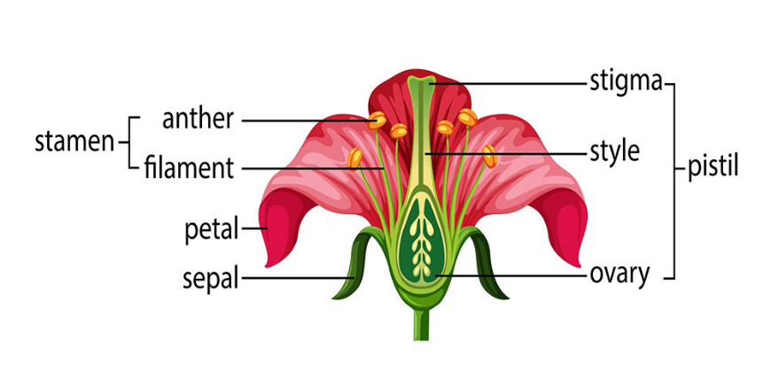

**C. Physiological Reasons Factors Responsible for the Unfruitfulness in Fruit Crops:**

It is difficult to assign the particular reason for unfruitfulness in some of the situations.

**These physiological factors are:**

**1. Pollen Tube Growth:**

The rate of pollen tube growth through the style is so slow that it does not reach the ovule. It is usually so in heterostyly condition. Poor rate of pollen tube growth has been found in pear and mandarin.

**2. Poor Pollen Germination:**

Sometimes due to physiological reasons pollen does not germinate on the stigmatic surface. This situation may bring unfruitfulness.

**3. Delayed Pollination:**

Sometimes flowers abscise because of delay in pollination, for example, if kangji kalan lemon flowers are not pollinated from outside source, all flowers fall down due to self-incompatibility. Hence, to get good crop synchronizing in pollen cultivar with that of lemon cultivars should be included as pollinator.

**4. Nutrition:**

When fruit plants over-bear in one season and get depleted(tired) in nutrition, there may be no crop in the coming year. Nutrition affects the pistils and pollen productivity both. For example, plums and peaches may not produce any crop in one year after a heavy crop in the previous year. Carbohydrate deficiency has been reported for coulure or blossom abortion and flower drop in grapes. Twenty percent sucrose spray at full bloom stage improves fruit set in soft pears.

**Major Factors Responsible for the Unfruitfulness in Fruit Crops**

**A. External Factors:**

**1. Climate:**

**I. Temperature**:

**II. Rainfall:**

**III. Winds:**

**IV. Frost/Freeze**:

**V. Hail Storm:**

**VI. Cloudy Weather:**

**VII. Intensity of Light:**

**2. Disturbed Moisture in Soil:**

**3. Nutrition:**

**4. Rootstocks:**

**5. Pruning:**

**6. Plant Age:**

**7. Chilling Requirements:**

**8. Spraying at Full-bloom:**

**B. Internal Factors:**

**The internal factors are:**

(1) Impotency, (2) Incompatibility, and (3) embryo abortion. Some other factors are related to flower structure and form.**These are:**

**1. Dicliny or Uni-sexuality:**

**2. Dichogamy:**

**3. Self-sterility:**

**4. Heterostyly:**

**C. Physiological Reasons:**

**These physiological factors are:**

**1. Pollen Tube Growth:**

**2. Poor Pollen Germination:**

**3. Delayed Pollination:**

**4. Nutrition:**

**Why Fruit Trees Fail to Bear**

Fruit tree normally will begin to bear fruit soon after it has become old enough to blossom, the health of tree, its environment, fruiting habits, and the cultural practices you use can influence its ability to produce fruit. Pollination is also essential to fruit yield.

If just one of these conditions is unfavorable, yields may be reduced. Perhaps the tree will not bear fruit at all. The factors contributing(المساهمة) to fruit production.

**1 - Bearing Age**

The length of time from planting to fruit bearing varies with the type of fruit. Trees that grow at a moderate rate generally bear fruit sooner.

Dwarf apple and dwarf pear trees usually begin to bear 1 to 2 years earlier than standard-size trees.

**2 - Tree health**

Healthy trees produce good quality fruit. Weak or diseased trees produce fruit of poor quality or no fruit at all.

Pest problems involving insects and diseases if not detectedتكشف early and managed properly can influence fruit production and weaken a fruit tree's overall health.

When fruit trees are not sprayed properly or left untreated, diseases and insects may effect on the size and quality of the yield, although the tree itself usually continues to bear fruit.

**3 - Climate and Weather**

Most hardy fruit trees need a certain amount of cold winter weather to end their dormancy and to promote spring growth. When winters are too mild, spring growth is delayed, irregular, and slow. These factors extend the period of blooming, thereby increasing the possibility of frost injury.

On the other hand, extreme cold during winter dormancy may kill the fruit buds. As the fruit buds grow and open, they become more sensitive to injury from frost.

When a heavy frost is expected, covering the trees will sometimes prevent bud or blossom injury.

During spring frosts, some commercial growers heat their orchard. Overhead irrigation provides effective frost protection when temperatures drop to zero C°.

**4 – Pollination** °

Most fruit trees need to be pollinated. Pollination is affected by cold weather and reduced pollinating insect activity. Without sufficient pollination, trees may blossom but will not bear fruit.

Some species of fruit trees have "perfect" flowers. Both the anthers, which contain pollen, and the pistils, which develop into fruit, are located in the same blossom. Trees that bear fruit through self-pollination, or set fruit without pollination, are called "self-fruitful."

However, many types of fruit trees that have perfect flowers cannot produce fruit from their own pollen. These require pollen from another variety and are called "self-unfruitful.”

**5 - Biennial bearing or Alternate bearing**

Sometimes, certain fruit trees such as apples bear heavily one year and low the next. This is called "biennial bearing." The spring-flowering buds of most fruit trees have actually been formed during the previous summer. Therefore, an especially heavy crop one year may prevent adequate bud formation for the following year.

Biennial bearing is difficult to alter or correct. However, you can induce a return to normal yearly fruit production by early and heavy thinning during the year in which the trees are producing their large yield.

About 30 to 40 healthy leaves per single fruit are needed to produce good quality. Within 30 days after bloom, thin remaining fruit to leave a single fruit every 6 to 8 inches along the branches.

**6 - Cultural Practices**

Fruit trees need full sunlight for best production. Leave space for fruit tree root systems.

A good watering and fertility program is also essential to fruiting at its best and good water fruit trees deeply. Do not over fertilize, especially with nitrogen, since over applications can cause so much growth at the expense of fruit production.

Reduce competition from weeds or grass by cultivation, mulching, or weed product application around the base of the tree. Do not spray the trunk wood.

Good pruning practices are important. upright growth will delay fruit bearing and reduce the quantity of fruit produced.