Scientific name: *Pyrus communis*

Family: Rosaceae

Pears are deciduous, but one or two species in are evergreen. Most are cold-hardy, withstanding temperatures between -25°C and -40°C in winter, except for the evergreen species, which only tolerate temperatures down to about -15°C. Common pear is a small to medium sized tree about 15m in height with a broad crown, a straight trunk and arching branches. Pear tree size is heavily dependent on rootstock and training system. Growing on a tree and harvested in late summer into mid-autumn. Several species of pears are valued for their edible fruit and juices, while others are cultivated as trees. Most pears require high chilling hours to break dormancy, but some cultivars exist that have lower chill requirements.

Pear types can be classified in to two groups, European types and Asian types:

1-(European pears): The most popular tree for commercial production, at least in the west is *Pyrus communis*. among this species, the most popular Varieties are Bartlett, Bosc, Comice, Seckel, and Winter Nelis.European pears are sweeter and softer than apples and easily damaged when ripe they are generally picked when still hard, which unlike most fruit, improves the texture and flavor.

2-Asian pear (*Pyrus serotina*):

Are also known as Japanese pear and Oriental pear. The Asian pear are more like Apples, with hard,crisp,less juicy flesh and they are ripen fully on trees.Hosui,large,yellowish-brown,yellowish- brown, russet fruit with prominent lenticels and excellent quality. The most popular varieties are Kosui, Olympio, and shineseiki.

Description of pear fruit trees

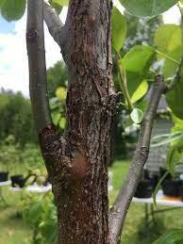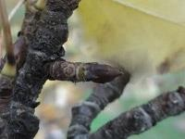Bark:Is dark brown with small rectangular scales. Twigs are hairless and redish or olive-brown with yellow porse (lenticels).Terminal buds are about 8 mm long.

# 

# Leaves:

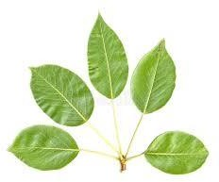Leaves are 4 to 7.5 cm long, oval, tapering to a pointed tip, borne on long leaf stalks. Leaves are thick and shiny with fine teeth along the edges the leaves are light green in spring, turning to yellow and then orange in autumn.

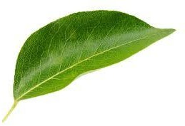 Flowers:

### Pears are most flower parties on terminal(apical) on the spurs and little carries laterally on branches one year old of mixed buds emerge in early spring with the leaves. Flowers, borne in clusters, are pink in bud, white when open. Flowers are fragrant, about 2.5 - 3.5 cm wide, with 5 white and purple petals they are hermaphrodite (each flower has both male and female flower).

### C:\Users\hp\Desktop\pear\concorde-pear-tree-p154-3648_medium.jpgC:\Users\hp\Desktop\pear\pink-buds-blossoming-pear-tree-flowers_810125-1210.jpg

# Fruits:

## the fruit is called pomo of variable shape and color, Fruits are green pears,2 - 12 cm long. Like many pears, they are widest toward the tip and narrow toward the stalk. Fruits hang from the tips of short shoots.

## 

Pears pollination:

Most pear trees need cross-pollination from nearby pollen sources of common tress, but some pear trees usually do not need cross-pollination to produce fruit because they are self-fruitful. All pear fruit tress are pollinated by insects such as bee.

# Planting:

* Plant pear trees in late winter or early spring.
* Pear trees need full sun for best fruit set and fertile, well drained soil as well as good air movement.
* Plant to plant at least two varieties of pear trees as they will need to be cross-pollinated to produce fruit.
* Space standard-size trees 5 to 6m apart. Space dwarf trees 3 to 4m apart.

# Soil:

# The most suitable soil for pear is medium texture, deep good drainage and aeration, free of alkaline. The pear tress can be grown in soils having PH up to (8.7).

Propagation:

Pear tree is commonly propagated by grafting or budding and rooting hardwood cuttings.

# Irrigation:

Is one of the most important processes affecting the production of pear trees and water requirements vary depending on the old trees and the growing season and the type of soil and weather conditions and the cultivated area and the irrigation system. Irrigated land in the beginning of season in late February and early March heavy irrigation push a floral buds open, without irrigation during the flowering period.

# Climate:

# • Pear trees can be grown in wide range of climates. They can be grown at an altitude of 1000 to 200 meter above sea level

# • The pear trees can tolerate as low as -25°C when dormant and as high as 44°C during its growing period.

# • Pear trees need chilling of 1,200 hr. below 7°C during winter for flowering and fruit set.

# • The chilling requirements vary from variety to variety.

# • An average annual rain-fall of 1600 to 2000 mm is more than enough for growing pear trees.

# Thinning and pruning:

Pear trees prune late in the dormant season to minimize cold injury. On many pear varieties the fruit sets heavily and require thinning to ensure adequate fruit size and to prevent overloading of trees, Bartlett varieties should be thinned by removing the small fruitlets in June.

### Harvesting:

harvested pear trees about 110-115 days after full bloom, Harvest season begins from late summer to autumn (August to October) depending on the variety and location. The pear varieties should be harvested while still green. If pears are left on the tress until the skin color has changed to yellow they will break down internally and will be unfit for consumption look for a change in the skin color from grass green to lighter green.

Common Pests & Diseases:

Common pests include aphids, codling moths, and pear psylla. Diseases to watch for include fire blight, pear scab, and pear rust.

