**Physiology and Classification of Fruits**

Various classification systems have been applied to fruits to meet various objectives. Physiological and morphological characteristics of a given fruit species or even a given cultivar affect its postharvest life and processing quality.

Botanically, a fruit is the reproductive structure of a flowering plant in which seeds form and develop. In cooking arts, fruit normally refers to an edible, juicy, and sweet object derived from a flower on any flowering plant. Among so many species of flowering plants with so much anatomical variety, only a relatively small group of species and fruit types are common in human diet. Nevertheless, the physiological and morphological characteristics of a given fruit species or even a given cultivar affect its postharvest life and process-understanding on **how a fruit develops in the field and how fruits are categorized in modern society.**

**DEVELOPMENT OF A FRUIT**

A fruit is developed from a flower and its associate tissues. The onset of fruit development begins as early as the differentiation of flower by which the apical meristem on a shoot forms a flower or inflorescence instead of a leaf or a shoot.

Anatomical changes begin at the end of the meristem, first generating the calyx and the corolla, and later the androecium (male) and the gynoecium (female) tissues. The process of flower differentiation can be completed within nearly less a year in deciduous trees.

The differentiation of **gynoecium** continues to form the carpel or pistil in which the ovule is formed. A gynoecium may consist of a single carpel, multiple different carpels, or multiple natural carpels. Inside gynoecia ovules, within one or more ovaries develop and later become seeds onto fertilization. When mature, gynoecia may function to **attract pollinators through aroma or nectar.**

At bloom or in some instances prior to bloom, gynoecia receive pollen grains on their specialized surface structure called a stigma and, in some cases, actively select **genetically different pollen grains** so as to avoid inbreeding. Gynoecia may enable the growth of pollen tube to the ovule and the delivery of sperm to the egg.

The gynoecium forms the pericarp. The pericarp in most fruits differentiates into three different layers.

The outer layer is called **exocarp** and normally becomes the peel of the fruit. The middle layer is the **mesocarp**, the major edible part of most fleshy fruits. The inner layer is the **endocarp**, which directly surrounds the ovary and the seed

**Pollination and Fertilization**

Most flowering plants will not set fruit without pollination or fertilization. Pollination is the process of transferring pollen grains from anthers to stigmas. Pollination in some species occurs automatically at bloom due to their special structure of the flower or the specialized arrangement of their stigmas and stamens, in same species. Pollination in most other species usually will not be completed without natural vectors, i.e., wind or insects.

The majority of common fruit crops require insect for pollination, and the pollination efficiency is usually improved by introducing bee hives to the orchard during blooming season.

Instead, their major pollinators are native flies. In commercial production, their pollination can be benefited by introducing the oriental latrine fly to the orchard during bloom. Some fruits are dioecious, and pollen grains must be transferred from a male flower in a male plant to a female flower in a female plant to complete the pollination process.

Fertilization takes place after the germination of poll grains on the stigma. A pollen grain after successful germination contains two sperm cells. Upon entering the ovule, one sperm cell fertilizes the egg cell and the other unites

with the **two polar nuclei of the embryo sac**.

The sperm and **haploid egg combine to form a diploid zygote and later**

**the embryo of the seed**. The other sperm and the two haploid polar nuclei form a triploid nucleus and **later the endosperm**, a nutrient-rich tissue nutritious the developing embryo. The ovary, which includes the ovule, develops into the pericarp of the fruit and helps to protect and disperse the seeds.

In self-fertilized fruit crops, for example, in most peach and nectarine cultivars, successful fertilization can occur within one flower, and pollen grains from other flowers or from other cultivars are not necessary. On the other hand, fertilization in cross-pollinated fruit crops, for example, in most apple, pear and

cultivars, will not succeed with pollen grains from flowers of same cultivars or other cultivars with incompatible genetic background. Therefore, it requires the mixed planting of two genetically compatible cultivars in an orchard block to achieve a satisfactory yield.

In some fruit crops, although self-pollination is possible to set fruit, cross-pollination by mixed planting two cultivars will increase the fruit size and quality.

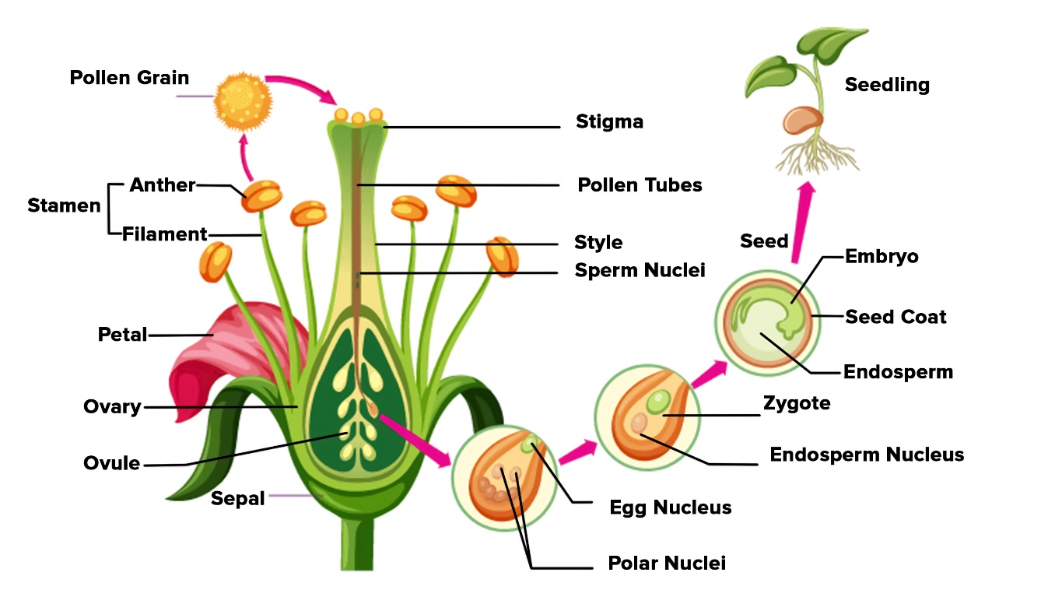

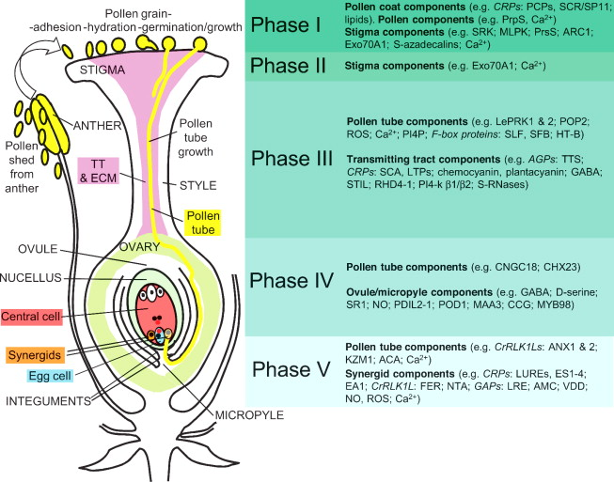

**Peach, nectarine, and apricot**

Most peach varieties are self-fruitful. However, ‘J.H. Hale’, ‘Earlihale’, ‘Candoka’, or ‘Mikado’ (‘June Elberta’), need to plant another variety to ensure adequate pollination. Most other peach varieties will pollinate those self-unfruitful varieties.

The lack of fuzz on the fruit is the main difference between a nectarine and a peach. Nectarines are usually smaller and have a special, somewhat sharp flavor. Nectarines do not need pollinators.

Nectarine flowers are more susceptible to frost injury than peaches, and the fruit is frequently scarred from injury by insects.

Leading varieties of apricot trees are self-fruitful. However, a pollinator will increase production. ‘Goldrich’ and ‘Perfection’ varieties must be cross-pollinated to bear fruit.

**Plums**

Japanese plums bloom earlier than European plums, and for this reason Japanese and European plums will not usually pollinate each other. ‘Stanley’, the number one European type, is self-fruitful. ‘Blue Fire’ and ‘Stanley’ are the most common pollinators for European plums. ‘Redheart’ is one of the best pollinators for Japanese plums. ‘Santa Rosa’, one of the most widely planted Japanese plums, and ‘Methley’ are self-fruitful.

**Sour cherry and sweet cherry**

All **sour cherries are self-fruitful, such** as ‘Montmorency’, ‘Balaton’, ‘Danube’, bush cherry, and Nanking cherry. They are hardier and bloom later than sweet cherries. For sweet cherries, most old varieties (‘Bing’, ‘Lambert’, and ‘Napoleon’) **are self-unfruitful,** but a lot of varieties after ‘Stella’ (the first self-fruitful sweet cherry variety) are self-fruitful, such as ‘Compact Stella’, ‘Lapins’, ‘Blackgold’, ‘Whitegold’, ‘Sweetheart’, and ‘Skeena’. These self-fruitful v

**How to ensure flowering and fruit setting, improve quality and achieve optimum production**

* Flowering and fruit setting processes are key physiological stages for good crop production. In agriculture, flowering and fruit setting are prerequisites for crop production whenever fruit is harvested.
* In order to have an optimum percentage of fruit setting after a good flowering, appropriate conditions between the crop physiological conditions and the climatic conditions during this stage must be met. **Physiological factors that promote optimal fruit setting include the production of viable pollen and the speed of pollen tube growth. On the other hand, dry wind, rain, cloudiness and extreme temperatures —whether high or low— are climatic factors that will negatively impact fruit setting**.
* At the nutritional level, in the case of fruit trees, a factor that **will determine flowering will be the post-harvest fertilization in the previous season**. If the necessary nutrients have not been provided after harvest, the plant will not accumulate the necessary reserve substances after winter dormancy, as the reserve substances will be the source of nutrients for the plant until the beginning of plant development, when photosynthesis will produce the necessary nutrition once the plant has sprouted vegetative.
* At these flowering and fruit setting stages, in any crop, whether fruit or vegetable, the crop will require higher **concentrations of micronutrients and calcium in addition to standard nutrition**. Flower buds and subsequent flowering require **zinc, boron, molybdenum and other nutrients in much higher amounts**. It is essential that these elements are available for use at this stage, as they **play a key role during flowering** and fruit setting, because their deficiency causes physiological disorders in the crop, reducing the number of fruits per tree.
* For example, boron participates actively in pollen germination and its viability, pollen tube growth and the development of seeds, fruits and dried fruits. Together with molybdenum, they have a synergistic action on the terminal buds of the plant, which is the tissue responsible for the growth and differentiation of all plant structures such as flowers, reproductive structures and fruits.
* On the other hand, zinc is involved in the **production of auxins**, which are phytohormones involved in the growth of tissues during fruit formation, contributing to prevent fruit drop, as well as participating in the synthesis **of amino acids** through the **enzymatic metabolism and the chlorophyll synthesis**.
* Phosphorus is a macronutrient of vital importance in the flowering period, as it is directly involved in the formation of flowers, **that is essential for cell division and meristematic growth**, being an essential of nucleic acids and energy molecules, as well as of **cell membranes**. If there is not enough phosphorus, this meristematic growth cannot take place and the plant will not be able to develop properly.
* After pollination, when pollen reaches the stigma, the pollen tubes begin to grow through the pistil and reach the ovule, where fertilization occurs. After pollination there is a period of rapid cell division with a high energy demand. **Calcium is also essential** during this period and frequently, if its concentration is poor, it can limit the development of strong cell walls, being critical in the quality of most fruits.

**How Can Ensure Good Flowering and Fruit Setting**

* It is important that plants receive sufficient water during flowering and fruiting. Both water stress and excessive irrigation can reduce pollen viability, leading to poor fruit setting, so it is recommended to follow an irrigation plan through irrigation management, although this may vary between crops.
* Fertilization at these stages is essential, as sufficient nutrients such as boron, zinc and molybdenum, as well as phosphorus, need to be available during flowering and fruit setting, which as we have seen are very important in the development of these stages. Getting ahead of any “hidden hunger” (e.g., leaf analysis) is highly recommended, as well as applications of calcium and appropriate nutrients on the leaf to correct deficiencies before they become a problem.
* During this stage the crop shows extremely high energy consumption, so an intake of

**bio stimulants** will help as a contribution (role) to these special requirements in the stages of flowering and fruit setting, while helping to lessen or mitigate the negative impact of climatic stress that the crop may suffer during these stages.

* With the application of [**Complete nutritional solution,**](https://herograespeciales.com/en/) these stages will be improved and maximized in the crops. Bio stimulants that achieve very good results, maximizing yield and crop production.

**Growing stone fruits in the orchard**

* Stone fruit trees need full sun to produce the most fruit.
* Space trees 4 to 6 m apart.
* Plant two different, compatible varieties to ensure fruit.
* Prune annually to maintain tree shape and a healthy, open canopy.
* Expect to get fruit 2 to 5 years after planting if you plant a 1 or 2-year-old tree.

All stone fruits bloom very early in the spring. If flowers are damaged by freezing temperatures, you'll get no fruit that year, but you'll probably get fruit the following year.

**Caring for stone fruit trees through the seasons**

* **March**: For existing trees, prune before growth begins, after the coldest weather has passed.
* **April**, May: If last year's growth was less than 12 inches, apply compost around the base of trees. Plant bare root trees as soon as the soil can be worked.
* **May**, June: Plant potted trees after the threat of frost has passed.
* May through October: Water trees as you would any other tree in yard, particularly during dry spells.
* June, July: Cut to the ground any root suckers near the tree; they look like good seedlings and have similar leaves to the tree.
* June through August: Place netting over trees as fruit ripens to prevent bird damage. Harvest ripe fruit.
* October, November: Rake and compost fallen leaves and fruit. Apply tree wrap in late fall to prevent winter injury.
* November through March: Watch for deer and vole damage; put fencing around trees if needed.

**Peach Tree Growth Stages: How Fast Do Peach Trees Grow?**

Not sure what to expect out of your peach trees once they've been planted? Find out everything you need to know about each growth stage of peach trees, including how quickly they should start producing fruit in orchard.

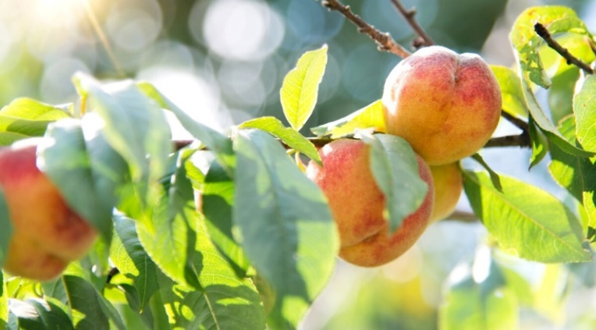

Peach fruits, the sweet taste of a fresh, juicy peach, and sunny yard, can grow peach tree. But first, must understand a peach tree’s size, needs, and growth stages.

There are dwarf varieties that can be grown in Close distances and standard. Peach trees require regular attention and maintenance.

Peach trees originated in China and have been cultivated for their delicious fruits for thousands of years. Today there are hundreds of cultivars of peaches and nectarines, and it’s quite possible that you could grow one of these in your own yard.

Peaches and nectarines are both the same species, *Prunus persica*. The only difference is that **peaches have fuzzy skin, and nectarines have smooth skin**. The other major peach category defines how the fruit separates from the pit:

* **Freestone peaches** have fruit that separates very easily from the pit.
* In **clingstone peaches**, the fruit and pit are difficult to separate from each other.

**Chill Hours**

Peach trees need 500-1000 chill hours to break dormancy.Depending on the variety, peach trees need between 500 and 1000 chill hours. [Chill hours](https://www.epicgardening.com/fruit-tree-chill-hours/) refers to the number of hours where temperatures are below 7°C.

During this time, a fruit tree is dormant, and **after receiving enough chill hours, the tree will break dormancy** and enter another growing season. You may need to contact your local agricultural extension agent to help you determine your average regional chill hours.

Chill hours are important to understand:

* If a tree breaks dormancy too soon, it will flower too early.
* An early end to dormancy means flowers and fruits can be damaged or killed by frosts.
* If a tree doesn’t receive enough chill hours, it may not flower or fruit properly.
* Lack of chill hours can delay the bloom period and interrupt or halt fruit production.

Because weather patterns are changeable, chill hours vary from year to year. When in doubt, and if you have enough space, plant a couple of different cultivars with slightly different requirements to increase your chances of having peaches yearly.

**Choose a Growing Site**

Choose an ideal site with ample sunlight, consistently moist soil, and adequate space for growing peach trees.

One very important step you need to make before you buy a peach tree is to choose a great site for it. Peach trees have some basic growing conditions that need to be met. Make sure you have a growing site that meets these basic needs.

**Sun**

Peach trees need a minimum of 8 hours of sunlight per day. Try to avoid growing trees in a location that receives less than this amount.

**Water**

**The soil for** your tree should stay consistently moist but never soggy. Ideally, it should receive water in a circular diameter as wide as the tree’s canopy; this gives the best chance that all of the root system will receive water.

**Soil**

The ideal soil for peaches is loose, well-drained, loamy, and rich in organic matter.

**Space**

Provide enough room for your peaches to grow without direct competition from other trees. Try to avoid planting your tree over pipes, as the roots may grow around the pipes making maintenance difficult and may puncture older pipes. Ideally, place your tree at least 20 feet from buildings or walls to prevent structural damage if roots grow along the surface of the soil.