Q/
A/ Write the function of:
- Crop
- Proventriculus
- Liver
- Pancreas
B/ What are the factors that have an effect on the nutritional value of plant sources of proteins. Also write tree of most of important and common plant Sources of protein
Q/ If you have a flock in production period. Egg weight 62 g, weekly increase in body weight 28 g, the body weight 2300 gram, the rate of egg production 75% and the breeding on the ground. How much net energy needs for these birds?
Q/ A
- Why the corn is the main components in the poultry diet?
- Why Soybean meal is the most important plant protein that used in poultry feeds?
- Are you suggesting using the blood powder in poultry diet or not? Why?
B/. What are the important tests, these are doing for the ingredient in the laboratory of Erbil feed factory for manufacturing poultry diet before inserting it to the factory?
Q/ Calculate the daily requirement of protein with the feed consumption for Broiler flock consists of 5000 birds if you knew that the weight of bird 2500 g and the rate of weekly body weight increasing 595 g, the proportion of protein in the diet 19 %.

Q/
- Define the (Digestion, and Absorpsion).
- What are the most Raw material types these are used in the poultry diet as an ingredient?
Q/
In the Flock of Chicken to egg production, the rate of weight is 2200 g/ bird. The average weight of the egg production 61.2 g with a standard deviation 5.12 g, daily growth rate 10 g and a standard deviation 0.21g with daily feed intake 120g. Calculate the bird's need of Lysine, Histidine, Leucine, tyrosine, Theronine and Valine.
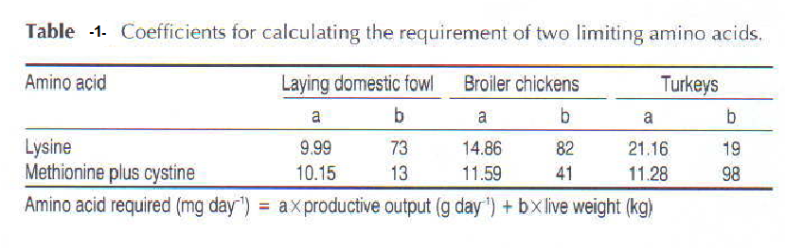
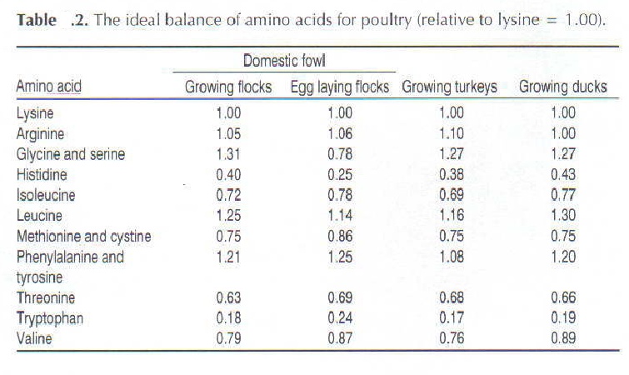
Q/
- What are the factors that have an effect on the nutritional value of plant sources for proteins ?

- If the weight of chicken (2) kg , the average of daily increase 5 g , the rate of egg weight (62) g , production rate(80)% and the breeding in cages. calculate the net energy for birds.
Q/
- / Define the (Digestion, and Absorpsion) also write the function of (Liver and Crop)
- / Answer the following question
- Why the corn are the main components in the poultry diet?
- Why Soybean meal is the most important plant protein that used in poultry feeds?
- Are you suggesting using the blood powder in poultry diet or not? Why?
Q/
If you have a flock in production period. Egg weight 62 g, weekly increase in body weight 28 g, the body weight 2300 gram, the rate of egg production 75% and the breeding on the ground. How much energy is needed to these birds?
Q1/
A/ Define the digestion and write the parts of the digestion system gradually with the function of each one of them.
B/what are the important tests, these are doing for the ingredient in the laboratory of Erbil feed factory for manufacturing poultry diet before inserting them to the factory?
Q/
A/. What are the raw material types that use in pthe oultry diet? And write two examples for each one.
B/. Why using of barley in the poultry diet limited? And write the ratio of protein and fibre in barley. What is the allow ratio of it in poultry diets?
C/. What's the gossypol? And which plant seed meals contain it?

