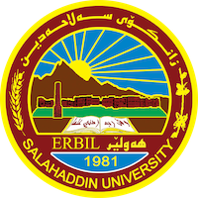
Academic Curriculum Vitae

Personal Information:
Full Name: Pherset Zuber Mohammed Rosbeiani
Academic Title: Assistant Professor
Email: (pherset.rosbeiani@su.edu.krd)
Mobile:0750 4402479

Education:
Bachelor Study Course, University Mossul | 1987 – 1991
History Teacher at Shorish grammer school, Arbil / Iraq | 1991 – 1994
Study Course Islamic History, University Mossul, M.A. | 2007
PhD Course, Doctoral Degree Humboldt, University Berlin | 2011
2015-2016

Employment:
Assistant Professor, Historical Department, College of Arts, Salahaddin University Erbil / Iraq since | 2012

Guest lecturer in the University of Potsdam/ Germany
Qualifications
- I have six years teaching experience.
- Word, Exile, Power Point,
- Kurdish native, Arabic, Germany, English Advance.

Teaching experience:
I have six years teaching experience since (2012 – currently).
Research and publications
- State all researches, publication you made.

Conferences and courses attended
- Give details of any conferences you have attended, and those at which you have presented delivered poster presentations.

Funding and academic awards
Guest lecturer in the University of Potsdam/ Germany 2015-2016

Professional memberships
Salahaddin University-Erbil, Academic Staff. –
Kurdistan Historical Cultural Association Member.
Professional Social Network Accounts:
https://scholar.google.com/citations?user=RD-XfbsAAAAJ&hl=de&oi=sra

