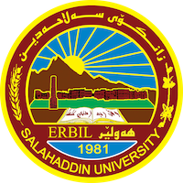
Academic Curriculum Vitae
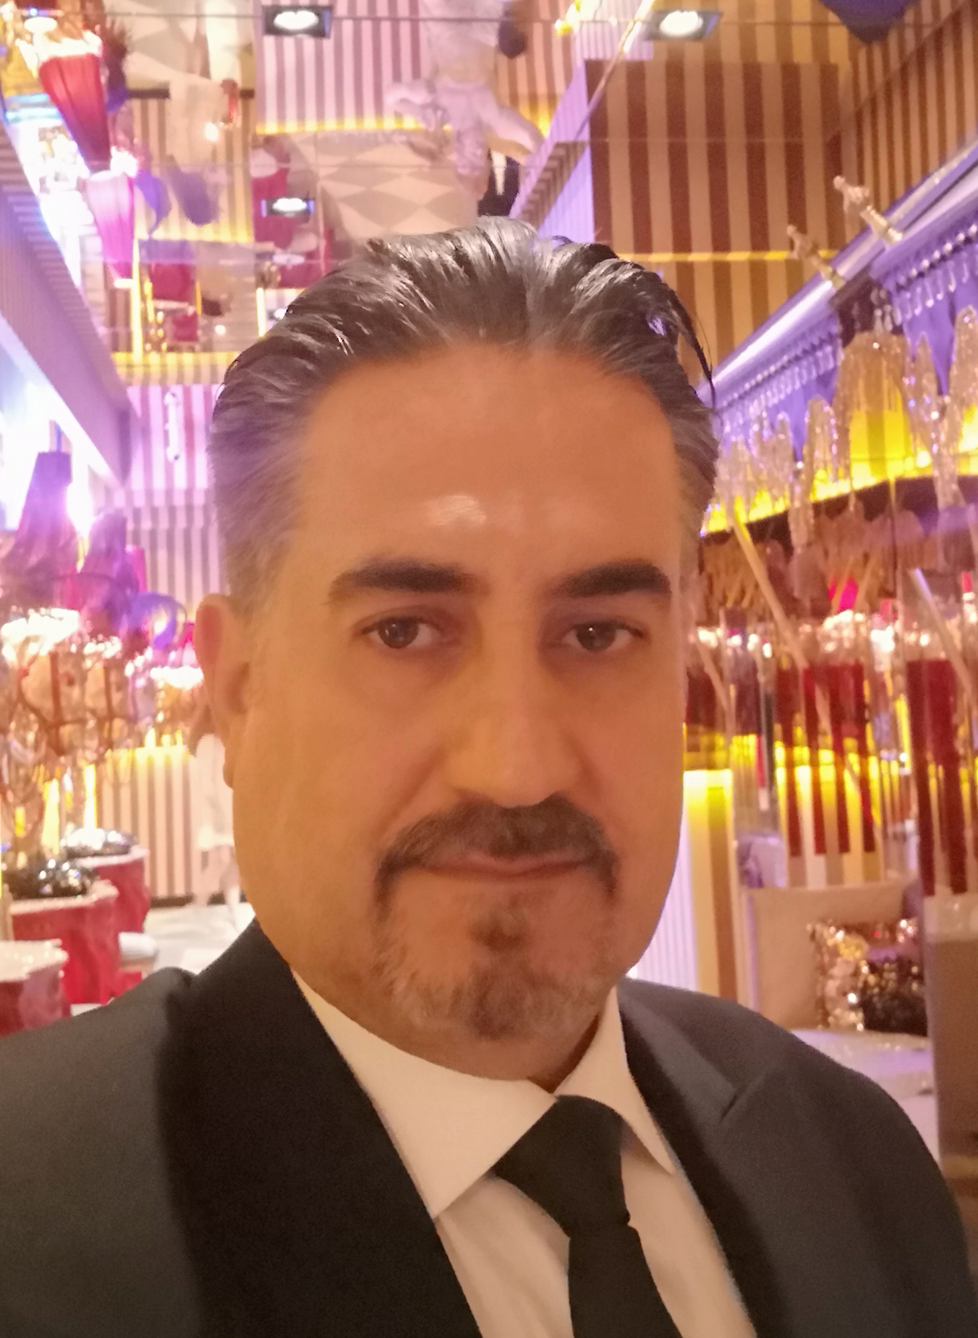
Personal Information:
Full Name:PIROT JAWDAT ABDULRAHMAN BAZZAZ
Academic Title: Assistant lecturer
Email: (pirot.bazzaz@su.edu.krd)
Mobile:+9647504617975

Education:
Degrees | University | College | Department | Country | Date of Completion
Bachelor | mosul | Agriculture | Horticulture | Mosul/ Iraq | 1995
Master | Salahaddin University-Erbil | Agriculture | Plant production | Kurdistan Region/ Iraq | 2010

Employment:
Date of Employment | University | College | Department
1\10\2000 | Salahaddin University-Erbil | Agriculture | Plant production

Qualifications
- Participate in train the proficiency English language course (160 hours listening, speaking, reading comprehension, vocabulary, grammar and essay writing.
- Participate in Computer Training Course Which started from 15\7\2007 to 30\8\2007
Participate in Teaching Methods Course No.

Teaching experience:

No | Teaching Courses | Level
 | Principle of Horticulture  (theory &practical) | Undergraduate
 | Agricultuer extension(theory &practical) | Undergraduate
 | Horticultuer seed production  (theory &practical) | Undergraduate
 | Vegetable production (practical) | Undergraduate
 | Ornamental plant (practical) | Undergraduate
 | Plant Biotecnology (practical) | Undergraduate
 | Principle of Fruit Production(practical) | Undergraduate
 | Turfgrass (practical) | Undergraduate

Research and publications
- State all researches, publication you made.

Conferences and courses attended
No | Conferences title | Conference Place | Participation Type | Date
 | 6th International Conference and WorkShops on Basic  and Aplied Sciences | Salahaddin University-Erbil | Participate as guest | 18-19\3\2017
 | 1st International Conference of Agri Sciences | Salahaddin University-Erbil | Participate as guest | 6-7\11\2023
No | Conferences title | Conference Place | Participation Type | Date
3 | Academic Symposium of Islamic  Medicine (NASIM), | Salahaddin University-Erbil | Participate as guest | 22/09/2022
4 | EPU SYMPOSIM | Salahaddin University-Erbil | Participate as guest | 2-3\5\2017
Funding and academic awards
- List any bursaries, scholarships, travel grants or other sources of funding that you were awarded for research projects or to attend meetings or conferences.

Professional memberships
- Kurdistan Agricultural Engineers Syndicate Iraq
- Kurdistan Teacher Union
3-Iraq Agricultural Engineers Syndicate .

Professional Social Network Accounts:
Profile link | Social Account | No.
https://academics.su.edu.krd/pirot.bazzaz | Academic profile
https://orcid.org/my-orcid?orcid=0009-0002-1553-0103 | Orcid

