College of Agricultural Engineering Sciences Department of Horticulture
------------------------------------------------------------------------------------

Plant Biotechnology Unit Guide
Second Year - First Semester, 2022 - 2023

Course Book

1. Course name | Plant Biotechnology
2. Lecturer in charge | Dr Noura Masseh Ellya Kka
3. Department / College | Horticulture / Agricultural Engineering Sciences
4. Contact | Email: noura.kka@su.edu.krd
5. Time (in hours) per week | Theory 2 h, Practical 3 h
6. Office hours | I am usually available after class (Sunday 10:30 am – 12:00 pm) or you can arrange an appointment. It is best to email me to set up a meeting  time. Please use my direct email address for this purpose.
7. Course code | AgH1201
8. Teacher's academic profile | Dr Noura Kka https://academics.su.edu.krd/noura.kka  Mr. Pirot Jawdat Bazzaz https://academics.su.edu.krd/pirot.bazzaz
9. Keywords | Plant Genomes, Functional Genomics, Genetically Modified Crops
10. Course overview:
The basic principles of plant biotechnology will span the concepts of molecular biology. This unit will cover structure, function and replication of DNA, gene expression, molecular basis of mutation, selection and regeneration of transgenic plants, plant biotechnology data collection and management, developments and
issues in plant biotechnology.
- Course objective:
This unit has been specifically designed to introduce students to:
  - The principles, practices and application of plant transformation, agriculture and industry.
  - To expose students to issues in plant biotechnology.
12. Student's obligation Attendance
Attendance for this class is mandatory. Attendance will be confirmed with evaluation sheets. Each unexcused absence will result in the lowering of your final grade by one grade.
Academic Honesty and Integrity
Cheating of any kind will not be tolerated. Copying of others’ work, use of disallowed material, plagiarism in assignments, or cheating in any other form as defined by the instructor will result in a grade of zero for that assignment. Multiple infractions will result in a grade of ‘Fail’ for the course.
Student Conduct
Students are expected to respect the rights of others in the class. Cell phones and other electronic equipment should be turned off prior to the beginning of class. Use of these items during class time, or any other unwarranted classroom disruption, will result in your immediate excusal from class for the remainder of the period.
You may bring drinks to class. Please finish any meals before class begins. The use of tobacco products during class time is strictly prohibited.
13. Forms of teaching
Lectures (Teaching by presentation), classroom teaching (class discussion), Integrating Technology (electronic mail) and LMS (Moodle)
English is the main language for teaching in addition to Arabic and Kurdish.

Google classroom: This course will be enhanced using Google classroom. Students are required to download
PowerPoint presentations and other important class material from Google classroom for the course
For Google classroom you only need to login with university account (example@student.su.edu.krd) and password.
Google classroom applications is available in play store.
14. Assessment scheme
Theory Percentage of Overall Mark
10 x pre-quizzes 5%
First midterm test 5%
Thursday October 14, 2021 at 9:00 -10:15 am Covers topics (Week 1 to Week 4).
Second midterm test 5%
Thursday November 18, 2021 9:00 -10:15 am Covers topics up (Week 5 to Week 8).

Practical
12 x quizzes 5%
Presentation 5%
First midterm test 15%
Second midterm test 10%
Final exam
Theory (Week 1 – Week 12) 50%

TOTAL 100%
- Student learning outcome:
Students will be able to learn about:
  - Shifting genes from one thing to another (Gene technologies)
  - How a plant reacts to what is going on. (Functional genomics)
  - Developing new crops (Molecular biology).
  - Bioinformatics
  - Ethical issues involved in biotechnology.
16. Course Reading List and References:
Lecture notes, class notes provided or recommended by the lecturers will be sufficient for the course.
- Although there are prescribed text books, the students can refer to the following books.

- Ricroch, A., S. Chopra, and S.J. Fleischer, Plant biotechnology: experience and future prospects. 2014: Springer.
- Altman, A. and P.M. Hasegawa, Plant biotechnology and agriculture: prospects for the 21st century. 2011: Academic press.
- Stewart Jr, C.N., Plant biotechnology and genetics: principles, techniques, and applications. 2016: John Wiley & Sons.
- Reece, J.B., L.A. Urry, M.L. Cain, S.A. Wasserman, P.V. Minorsky, and R.B. Jackson, Campbell biology. Vol. 9. 2011: Pearson Boston.
- Becker J M. , Caldwell G A. ZEA Biotechnology: A Laboratory Course. (1996)

- Fletcher L, Goss E, Phelps P, Grady SO Introduction to Biotechnology Laboratory Manual. (2011)

- Slater, A., Scott, N. and Fowler, M., 2008. Plant biotechnology: the genetic manipulation of plants. OUP Oxford.
17. The Topics: | Lecturer's name
Unit weekly activities
Theory

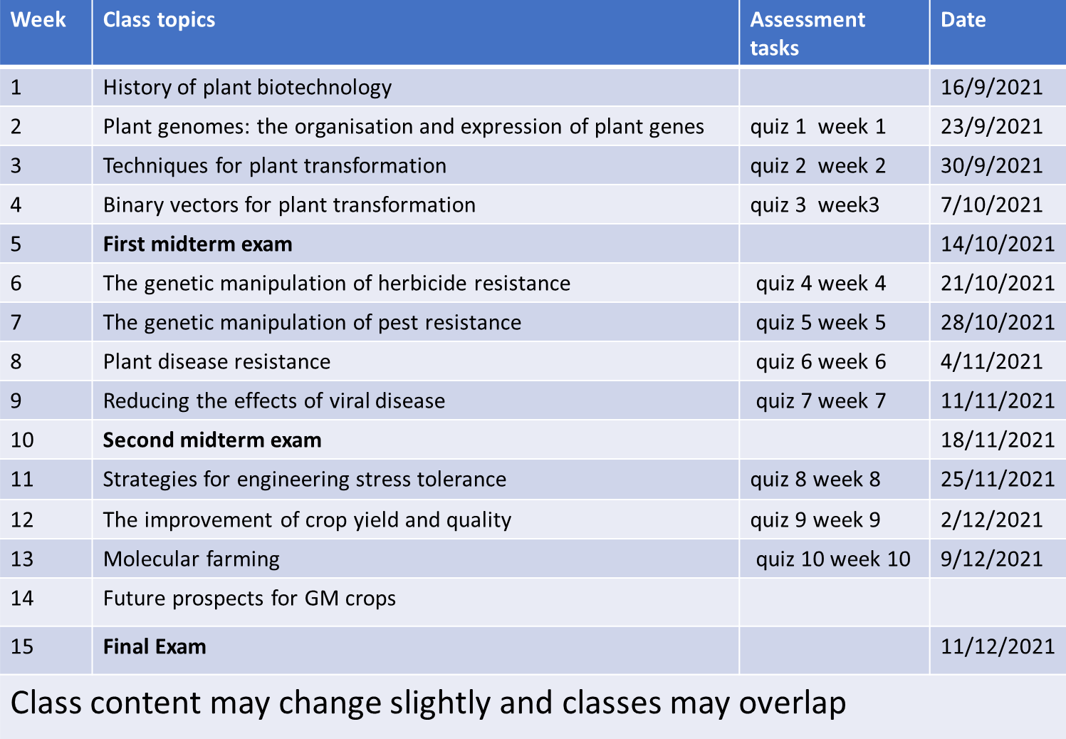

Practice
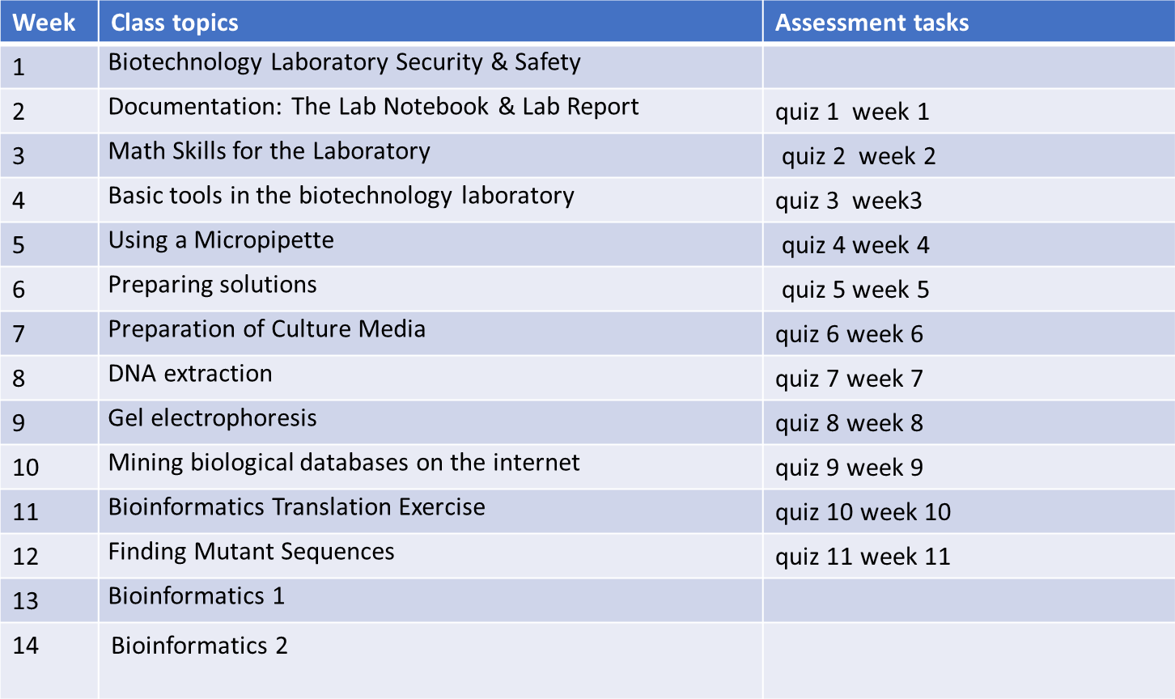
Class content may change slightly, and classes may overlap.
- Examinations:
Questions and Answers template
  - When biotechnology has revolutionized plant agriculture?
Since the first stably transgenic plant produced in the early 1980s and the first commercialized transgenic plant in 1994, biotechnology has revolutionized plant agriculture.
  - How much transgenic cropland has been planted worldwide?
More than a billion acres of transgenic cropland has been planted worldwide.

  - How many transgenic plants grown? And for what reason the transgenic crops were produced in the United States alone?
Over 50 trillion transgenic plants grown in the United States alone. In the United States, over half of the corn and cotton and three-quarters of soybean produced are transgenic for insect resistance, herbicide resistance, or both.
Bt transgenic crops are designed to: A) Make crops cold resistant B) Provide resistance to insects
C) Make crops heat resistant D) Improve nutritional value of crops E) Increase vitamin B content

20. Extra notes:
Please feel free to come and talk to me to get helpful feedback on your progress, or if you are struggling in any way.
This course book provides you with the key information about Plant biotechnology.
For the best chance of success, you should read it very carefully and refer to it frequently throughout the semester.
- Peer review
Standard guidelines were followed and it is clear.
  - There are sufficient topics and examples.
  - References are relevant, recent and available.

