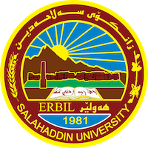

**Academic Curriculum Vitae**

**Personal Information :** 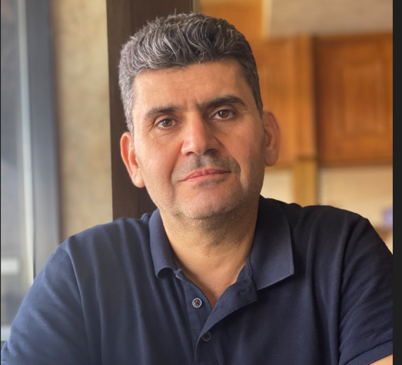

Full Name: Pshtiwan Abdullah Yousif

Academic Title: Assistant Lecture

Email: [pshtiwan.yousif@su.edu.krd](mailto:pshtiwan.yousif@su.edu.krd)

Mobile:00967504993242

**Education:**

-B.Sc. in Biology (1995–1996), College of Education, Salahaddin University-Erbil

- M.Sc. in Clinical biochemistry 2015-03-03 , Near east University-Cyprus-Turkey

**Employment:**

-Demonstrator (14-Jun 1998) at President of Salahaddin University-Erbil

-Director assistant president office 1998-2005

- Assistant Lecturer ((2015-08-28) at Department of Chemistry, College of Education, Salahaddin University-Erbil

-The decider of the Chemistry Department (September 2015- September 2017).

- Member of the Examination Committee of the College of Education (2015, 2020-2021, and 2022-2023).

**Qualifications**

-Microsoft Windows Training Course (September 2014).

-Teaching Methods Course (November 2014 – May 2015).

-Elementary, pre- intermediate and Intermediate levels (English course) at Language and Translation center- Salahaddin University Erbil

**Teaching experience:**

* Clinical biochemistry (3 rd Class, Department of Chem.).
* Option (Chemotherapy) (4 th Class, Department of Chem.).
* Option (Food chemistry) (4 th Class, Department of Chem.).
* Clinical biochemistry(2 nd Class, Department of Biology)
* Analytical chemistry (1 st Class, Department of Chem.).

**Research and publications**

* [Evaluation of Free Radicals and Some Other Biochemical Parameters in Leukemia and Β-Thalassemia in Erbil City](https://lupinepublishers.com/contact.php)(2019).
* [Essential Constituents of Truffle in Kurdistan Region](http://dx.doi.org/10.21271/ZJPAS.32.5.15)(2020)
* [Green Synthesis, Characterization, and Investigation Antibacterial Activity of Silver Nanoparticles Using Pistacia atlantica Leaf Extract open_in_new](https://link.springer.com/article/10.1007/s12668-019-0606-z)(2021)
* [Association between some serum oxidative stress biomarkers and lipid profile in type 2 diabetic patients in Erbil City](https://zancojournals.su.edu.krd/index.php/JPAS/article/view/3758).(2021)
* A[ssociation between Serum Levels of Vitamin D, Vitamin B12 and Folate with Oxidative Biomarkers in Diabetic Type 2 Patients in People in Erbil City: A Case-Control Study](http://djm.uodiyala.edu.iq/index.php/djm/article/view/661/528).(2021)
* The Role of procollagen type 1 amino-terminal propertied (P1NP) Cytochrome P450 (CYPs) and Osteoprotegerin (OPG) as Potential Bone function markers in Prostate Cancer Bone Metastasis(2023)
* Estimation of the Levels of UDP Glucuronosyltransferase 2 Activity and Some Vitamins (B12, B17, C and D) for Patients with Colon Cancer (2023)
* Estimation of the Levels of UDP Glucuronosyltransferase 2 Activity and Some Vitamins (B12, B17, C and D) for Patients with Colon Cancer. (2023)

**Conferences and courses attended**

* Give details of any conferences you have attended, and those at which you have presented delivered poster presentations.

**Funding and academic awards**

* No

**Professional memberships**

Kurdistan Chemistry Syndicate (2004 – Present).

- Kurdistan Teachers Union (2005 – Present).

**Professional Social Network Accounts:**

- ReserchGate:

- Google Scholar:

- LinkedIn:

- Academia:

- ORCID