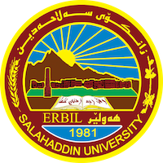
Academic Curriculum Vitae

Personal Information: 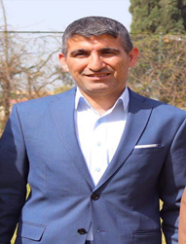
Full Name: Qahar Ali Ahmed
Academic Title: Assistant professor
Email: qahar.ahmed@su.edu.krd
Mobile: 009647504536769

Education:
- Bachelor in Physical Education / Salahaddin University – Erbil 2005.
- Master degree in Physical Education / Salahaddin University – Erbil 2009.
- Ph.D. degree in Physical Education / Salahaddin University – Erbil 2014.

Employment:
- Employed in Physical Education / Salahaddin University – Erbil 2009 until present.
- Registration administrator from 2010 until 2011.
- Head of individual games department from 2017 until 2023.

Qualifications
- Teaching method qualification at Salahaddin University in 2011.
- English language qualification at Salahaddin University language center (pre-intermediate) level 2013.

Teaching experience:
- Taught the following undergraduate courses (track and field- second grade) and (Exercise science – fourth grade).

Research and publications
- The effectiveness of competition-style exercises in developing the performance of some basic soccer skills.
- The Effect of Dynamic Style in Developing Legs and Arms Muscle Strength in Performing Javelin Throw for Physical Education College Students.
- The effect of plyometric exercises on some physical variables and the achievement of a 200-meter run.
Conferences and courses attended
- Physical Education and Sport Science conference ……….2019

Professional Social Network Accounts:

- https://scholar.google.com/citations?user=MPHT_MkAAAAJ&hl=en
- https://www.researchgate.net/profile/Qahar-Ahmed
- https://www.facebook.com/Dr.Qahar
- https://orcid.org/my-orcid?orcid=0009-0002-4533-6950

