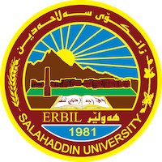
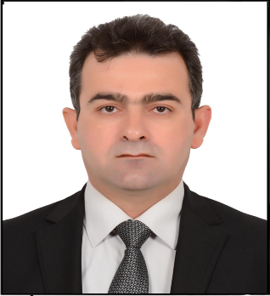
Academic Curriculum Vitae
Personal Information
Full Name:Qaraman Haidar Rahman
Academic Title: lecturer
Email: qaraman.rahman@su.edu.krd
Mobile: 0750 441 2349

Education:
- Holds a Bachelor's degree in History (2008)
- Holds a master's degree in Modern and Contemporary History (2014).
- Graduate student / PhD in Modern and Contemporary History (2021).
Employment:
- Ministry of Peshmerga (1991-2009)
- Ministry of Education and Scientific Research (2009…)
Qualifications
- He holds a graduation certificate from the Language Center, Salahaddin University - Erbil (2022).

Teaching experience:
- Participated in a computer education course (2009) in the College of Education, Salahaddin University - Erbil.
- Participated in two language courses at the Language Center at Salah Al-Din University in (2010) and (2022).
Research and publications
- بارودۆخی کۆمەڵایەتی شاری هەولێر لەماوەی نیوان سالانی (١٩٧٥-١٩٩١)
- بارودۆخی ئابووری شاری هەولێر لەماوەی نێوان ساڵانی (١٩٨٠-١٩٨٨)
- کاریگەریی دەستووری ئەنجوومەنی سەرکردایەتی شۆڕشی کوردستانی عێراق لەسەر ڕەوشی ناوچە ئازادکراوەکان(١٩٦٤-١٩٧٠).
- ئاراستە و شوناسی نیشتمانی لە بیری سیاسی مستەفا بارزانی (١٩٤٥-١٩٧٥).
- ڕۆڵی مستەفا بارزانی لە پێکهێنان و سەرکردایەتیکردنی رێکخرا و دامەزراوە سیاسییەکان(١٩٤٥-١٩٧٥).
- ڕۆڵی مستەفا بارزانی لە دامەزراندنی هێزی سەربازی نیشتمانی ڕێکخراو (١٩٤٣-١٩٧٥).
- ڕەنگدانەوەی دۆزی کورد لە ڕۆژنامەی لۆمۆندی فەرەنسی ١٩٦١-١٩٦٨
- پرسی کورد لە ڕۆژنامەی داڤاری ئیسرائیلی ١٩٧٠-١٩٧٥.
Conferences and courses attended
- I participated in the third international conference of the September Revolution held at the University of Dohuk in (2021).
Funding and academic awards
- List any bursaries, scholarships, travel grants or other sources of funding that you were awarded for research projects or to attend meetings or conferences.
https://academics.su.edu.krd/qaraman.rahman/conference.

Professional memberships
- Member of the Kurdistan Teachers Union
- Member of the Kurdistan Historians Association
Professional Social Network Accounts:

- https://www.linkedin.com/in/qaraman-haider-rahman-b93a7b122/?originalSubdomain=iq
- https://www.researchgate.net/profile/Qaraman-Rahman.
- https://twitter.com/QaramanHayder.
- https://currents.google.com/u/0/117597025711919434590.
- https://scholar.google.com/citations?user=ujN9SUMAAAAJ&hl=en.
- https://www.facebook.com/qaraman.haydar.

