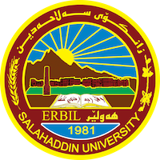
Academic Curriculum Vitae
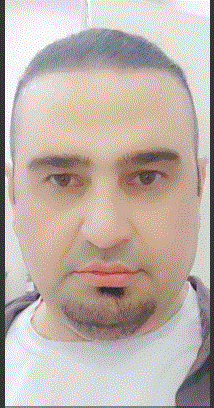
Personal Information:
Full Name: Ramadhan Ali Mohammed
Academic Title: assistan lecture
Email: ramadhan.mohammed@su.edu.krd
Mobile: 00964 750 4532728

Education:
- BSc (1990 – 1994) in Physics – Department of Physics, College of Education, University of Salahadin Erbil – Iraq.
- MSc (2012 - 2014) in image processing (computer science) – Department of computer / University of UTM – Malisia.

Employment:
- Teaching Assistant (1996) - Department of Physics, College of Education, University of Salahaddin Erbil – Iraq.
- High deploma(engineering college)-2005-2007
- Teaching Staff (2014 -2020) - Department of computer, College of Education, University of Salahaddin Erbil.

Qualifications
- Ph.D.student (Medical Physics),2020.
MSc (image processing), 2014.
High deploma,2007
BSc (Physics), 1994.
- Programming (MATLAB, Python, C++,JAVA,), Statistics (GraphPad, Origin,SPSS)

Teaching experience:
1. General physics (Undergraduate).
2. Computer skills (Undergraduate).
3. Image processing (Undergraduate).
4. Advance computer science (Master).
5. Advising nearly 5 projects of BSc students.
6. Programing (J++, Jave, Matlab)
7.OOP,OS,Architecture,

Research and publications
- An important of RGB color image watermarking technique using ISB stream bit and Hadamard matrix.2014

Conferences and courses attended
- N/A
Funding and academic awards
- N/A
Professional memberships
- Kurdistan Teacher Syndicate.
- Kurdistan Physicist Syndicate.
- Iraqi Medical Physics Society (IMPS).
- International Organization for Medical Physics (IOMP).

Professional Social Network Accounts:
- {https://www.researchgate.net/profile/Ramadhan-Mohammed-2?ev=hdr_xprf}

- https://scholar.google.com/citations?user=DQSY9LkAAAAJ&hl=en

