وه‌زاره‌تی خوێندنی باڵا و تۆێژینه‌وه‌ی زانستی
Ministry of Higher Education &
Scientific Research

پرۆپۆزەلى توێژینه‌وه‌ بۆ به‌ده‌ستهێنانی بروانامه‌ی دکتۆرا PhD Research Proposal
ناونيشانی پرۆپۆزه‌لی تۆێژینه‌وه‌ی پێشنیازکراو 1. Title of PhD research proposal
Solar Energy Development in Erbil Kurdistan and its implications in Air-conditioning and Refrigeration

زانیاری گشتی 2. General information
Name and surname  of the supervisor 1 | Dr.Eng.Ramzi Raphael Ibraheem Barwari | ناوی سیانی سه‌رپه‌رشتیار 1
Scientific title | Asst. Professor | پله‌ی زانستی سه‌رپه‌رشتیار 1
E-mail | ramzi.ibraheem@su.edu.krd | ئیمێلی سه‌رپه‌رشتیار 1
Mobile | 07504349609 | ژماره‌ی مۆبایل
Department | Mechanical &Mechatronics Engineering | ناوی به‌شی زانستی
College / faculty | Engineering | کۆلیژ / فاکه‌ڵتی/سكول
university's name | Salahaddin University | ناوى زانکۆى ميلاكى سه‌رپه‌رشتیار
Name and surname  of the supervisor 2 )If it is available) |  | ناوی سیانی سه‌رپه‌رشتیار 2  ئه‌گه‌ر هه‌یه‌))
Scientific title |  | پله‌ی زانستی سه‌رپه‌رشتیاری 2
E-mail |  | ئیمێلی سه‌رپه‌رشتیار 2
Mobile |  | ژماره‌ی مۆبایل
Department |  | ناوی به‌شی زانستی
College / faculty |  | کۆلیژ/ فاکه‌ڵتی/سكول
university's name |  | ناوى زانکۆ
3. Summary (Abstract) of PhD research proposal
This should be not more than 200 words and not less than 75 words.

Many people may not realize that solar collectors can be used for air-conditioning and refrigeration. By utilization of the heat driven technologies, called “absorption” and “adsorption”, thermally activated systems can utilize almost any source of heat, including a wide variety of fuels, solar energy as well as waste heat from incineration plants, industrial processes and cogeneration systems. Absorption cooling is the first and oldest form of air-conditioning and refrigeration. Rather Than using an electric compressor to pressurize the refrigerant, a heat source is used to evaporate the refrigerant liquid (ammonia/water or lithium bromide/water mix). Absorption coolers still need electricity to run a pump which circulates the refrigerant, but this is a fraction of the power used by a compressor in a conventional electric air conditioner or refrigerator. Thermal solar energy can replace or supplement the use of non-renewable heating fuels. Solar powered air-conditioning is currently only viable for large scale applications that employ absorption style cooling systems. In the future solar collectors that supply hot water and central heating .This will open up a new era for solar energy application in normal households.

ئەبستراکتی توێژینه‌وه‌ی پێشنیازکراو. له‌ 200 ووشه‌ زیاتر نه‌بێت و له‌ 75 ووشه‌ که‌متر نه‌بێت.

4. Introduction پێشه‌کی
Solar energy is considered beneficial for application in Erbil but it has not been used significantly in the society at present. The major barriers to large-scale deployment of solar energy systems are not difficult to comprehend. Removal of these barriers, however, will require careful analysis of technical, economic issues. This Study presents an overview of the solar energy potential and development in Erbil. The climate and geography are described; the technology options available in the local context are examined.
The institutional issues affecting the viability and feasibility of the solar systems are explained. Finally, the implications of wide-scale solar energy application In Air conditioning and refrigeration.
The concept of the sustainable development was accepted by the European Union in 1990. Strategy of the sustainable development was accepted at the UN Conference on Environment and Development, UNCED, in Rio de Janeiro in 1992. A notion of the sustainable development is defined as an integral economic, technological, social and cultural development adjusted to the needs of the environment protection, which enables current and future generations to meet their needs and improve their life quality. Underlying principle of the sustainable development is establishing of the effective resource distribution and application system for a long period.
At the UN Conference on Environment and Development held in Rio de Janeiro in 1992 a fundamental action program was passed on reaching sustainable development, better known as Agenda 21. Agenda 21 is comprised of four parts and 40 chapters, which consider attitudes of the international community of different question of environment protection and development in the world. Its basic message is a request for urgent changes and adaptation of all activities on the Planet to the possibilities and capacities of the single environment segments. The first part of Agenda 21 deals with social and economic issues (international cooperation on establishing a sustainable development in the developing countries and a corresponding local policy, fight against poverty, change in consumption, demographic dynamics and its sustainability, human health protection and upgrading, upgrading of sustainable development of human settlements, inclusion of environment and development in decision making, etc.) The second part of Agenda 21 deals with protection and management of development resources (atmosphere protection, integral approach to planning and management of country's resources, fight to preserve forests, management of tenable ecosystems: fight against draught and desert expansion, saving of biodiversity, ecologically healthy managing of biotechnology, ocean and all kinds of seas, by- the- sea region protection, rational use and development of their live resources, protection of the water quality and water supply sites: use of integral approach in development, management and use of water resources, management of toxic chemicals. These include the following as well: prevention of illegal international traffic of toxic and dangerous products, environmental friendly management of toxic waste including prevention of illegal international traffic of dangerous waste, environmental friendly management of solid waste, safe and environmental management of radioactive waste.)
لێره‌دا سه‌رپه‌رشتیاری سەرەکی پوخته‌یه‌ک ده‌رباره‌ی پرۆژه‌ی توێژینه‌وه‌که ده‌نووسێت‌، تیایدا باکگراوندی پرۆژه‌که‌ باس ده‌کات و ڕوونی دەکاتەوە کە بۆچی ئاراستەکردنی ئەم توێژینەوەیە گرنگە.

5. Research objectives
Clarify the research objectives and planned methodology to meet the challenges of the project. Include details of the research plan and relate to the previous work carried out by others.

Air-conditioning is one of the major consumers of electrical energy in many parts of the world today and already today air-conditioning causes energy shortage in for example Kurdistan. The demand can be expected to increase because of changing working times, increased comfort expectations and global warming. Air-conditioning systems in use are most often built around a vapor compression systems driven by grid-electricity. However, most ways of generating the electricity today, as well as the refrigerants being used in traditional vapor compression systems, have negative impact on the environment. Solar air-conditioning might be a way to reduce the demand for electricity. In addition many solar air-conditioning systems are constructed in ways that eliminate the need for CFC, HCFC or HFC refrigerants. Alternatives to using solar energy are to use waste heat from different industrial processes such as refineries, garbage treatment facilities etc. Even driving the air conditioning systems directly with fossil fuels might in some cases be a more environmental friendly alternative than using electricity.

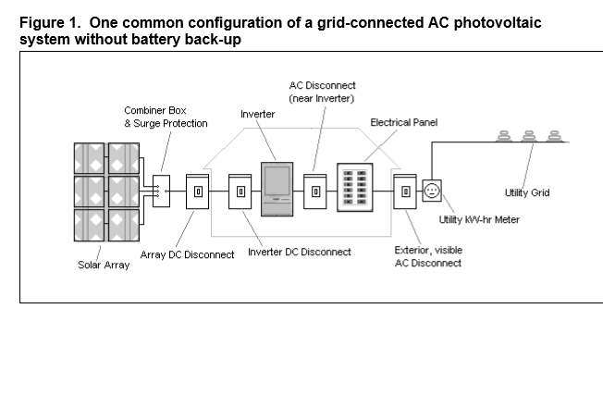

لێره‌دا سه‌رپه‌رشتیار ده‌بێت ئامانجه‌کانی توێژینه‌وه‌که ڕوونبکاته‌وه و‌ باس له میتۆدەکانی ڕووبەرووبوونەوەی ئەو تەحەدیاتانە دەکات کە لەکاتی توێژینەوەدا دێتە ڕێگای، هەروەها گرنگە کە پلانی توێژینەوەکە ببەستێتەوە بەو کارانەی کە پیشتر لەو بوارەدا ئەنجام دراون.

‌
6. Methodology and data collection
The hot and dry climate conditions in Erbil city has a main effect on the energy consumption and thermal performance of the house. In the last decade, residential sector in Kurdistan region government has consumed about 50% of total energy consumption.
Photovoltaics is the field of technology and research related to the devices which directly convert sunlight into electricity. The solar cell is the elementary building block of the photovoltaic technology. Solar cells are made of semiconductor materials, such as silicon. One of the properties of semiconductors that makes them most useful is that their conductivity may easily be modified by introducing impurities into their crystal lattice.
For instance, in the fabrication of a photovoltaic solar cell, silicon, which has four valence electrons, is treated to increase its conductivity. On one side of the cell, the impurities, which are phosphorus atoms with five valence electrons (n-donor), donate weakly bound valence electrons to the silicon material, creating excess negative charge carriers. On the other side, atoms of boron with three valence electrons (p-donor) create a greater affinity than silicon to attract electrons. Because the p-type silicon is in intimate contact with the n-type silicon a p-n junction is established and a diffusion of electrons occurs from the region of high electron concentration (the n-type side) into the region of low electron concentration (p-type side). When the electrons diffuse across the p-n junction, they recombine with holes on the p-type side. However, the diffusion of carriers does not occur indefinitely, because the imbalance of charge immediately on either sides of the junction originates an electric field. This electric field forms a diode that promotes current to flow in only one direction. Ohmic metal-semiconductor contacts are made to both the n-type and p-type sides of the solar cell, and the electrodes are ready to be connected to an external load.

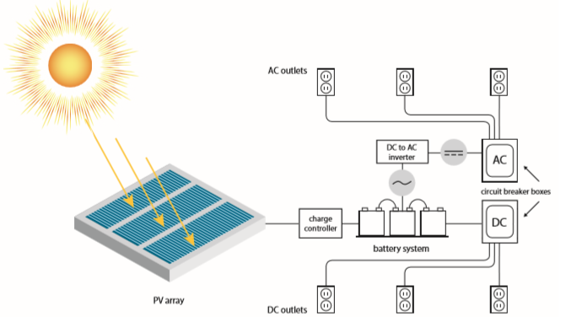

لێرەدا سەرپەرشتیار باس لە میتۆدەکانی ئەنجامدانی توێژینەوەکە و شێوازی کۆکردنەوەی داتاکان دەکات.

7. Scope and limit to the research

The results of the published research review, which study and examine the possibilities of operating various solar systems in Iraq, give hope not only to reduce the dependence on fossil fuels in energy production, but also to produce energy that is surplus to the needs of the country and can be exported to neighboring countries. All solar applications can be implemented and presented to the consumer as soon as possible and the financial and air conditions help to spread them. The main problem in the spread of solar energy applications lies in two main points: First: low public awareness of the reduction and rational of electricity consumption. Second: low public awareness and decision makers in the importance of using all solar applications as a renewable alternative instead of fossil fuels. The Iraqi researcher, despite the lack of fund resources available to him, studied objectively and thoroughly and scrutinized everything that helps decision-makers to get rid of the lack of clarity in the vision. The proliferation of solar energy applications today depends largely on the courage and determination of decision makers in Iraq.

لێرەدا باس لەو بەربەستانە دەکرێت کە دەشێت بێنە ڕێگای ئەنجامدانی توێژینەوەکە، هەروەها باس لە چارەسەری ئەو بەربەستانەش دەکرێت.

8. Duration and timeline
لێرەدا باس لە کاتی پێویست بۆ ئەنجامدانی توێژینەوەکە دەکرێت Three academic years

9. Conclusions
In the light of the above mentioned it can be concluded that a great attention is drawn to the use of clean sources of energy and sustainable development in the world. At the UN conference on environment and development, held in Rio de Janeiro in 1992, Agenda 21 was issued giving basic guidelines for the sustainable development. The cleanest source of energy is the Sun that for the 5 billion years has been enabling and sustaining life on Earth. In biosphere sun energy through the process of photosynthesis is used for the growth and development of plants. Besides, sun radiation can be transformed into thermal energy in passive and active photo-conversion systems. Passive photo-conversion systems encompass building objects constructed on the solar architecture principles. In active photo-thermal conversion systems we classify flat collectors, vacuum collectors, concentrators, etc. For the conversion of sun radiation into electric energy solar cells are used. For the simultaneous conversion of sun radiation into thermal and electric energy hybrid collectors are used.
لێرەدا سەرپەرشتیار باس لە گرنگی ئامانج و دەرئەنجامە چاوەڕوانکراوەکانی توێژینەوەکە دەکات، هەروەها ڕوونی دەکاتەوە کە بۆچی ئاکامەکانی ئەم توێژینەوەیە بەهای زانستیی هەیە.

10. References سەرچاوەکان
1- Kurdistan Regional Government. 2014. Instruction No.1 - Technical Guidelines on the Environmental Impact Assessment of Petroleum Operations in the in Kurdistan Region - Iraq.
2- United States Environmental Protection Agency. 2011. National Ambient Air Quality Standards. Office of Air and Radiation. Washington, D.C., United States.
3- World Health Organization. 2008. Guidelines for Drinking Water Quality. 3rd Edition. Volume 1. Geneva, Switzerland.
4- Aghaei, T. P. (2015). Potential for small solar water pasteurizer techniques for water disinfection in rural area of developing countries. San Diego..
5-Alternative Energy Tutorials. (n.d.). Solar Pool Heating. Retrieved from Alternative Energy Tutorials: http://www.alternative-energy-tutorials.com/solar-hot-water/solar-poolheating.html.
6- ASME. (2012). Solar thermal power plants. Retrieved from volker-quaschning.de: http://www.volker- quaschning.de/articles/fundamentals2/index_ e.php.

7- NASA. (n.d.). Advanced Energy Research. photovoltaic. Retrieved from grc.nasa.gov: http://www.grc.nasa.gov/WWW/portal/apps/pv/

8- H. M. Al-Maamary, H. A. Kazem, M. T. Chaichan, "Renewable energy and GCC States energy challenges in the 21st century: A review," International Journal of Computation and Applied Sciences IJOCAAS, vol.2, no. 1, pp. 11-18, 2017.
9- Z. Abdmouleh, R. A. Alammari, A. Gastli, "Recommendations on renewable energy policies for the GCC countries," Renewable and Sustainable Energy Reviews, vol. 50, pp. 1181-1191, 2015. DOI: 10.1016/j.rser.2015.05.057

11. General notes:

The candidate must be specialist in Mechanical engineering and has a good expertise in thermal powers and air conditioning performance evaluating.

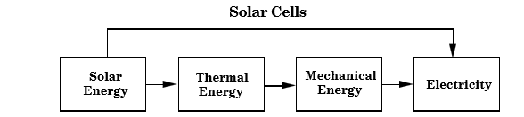

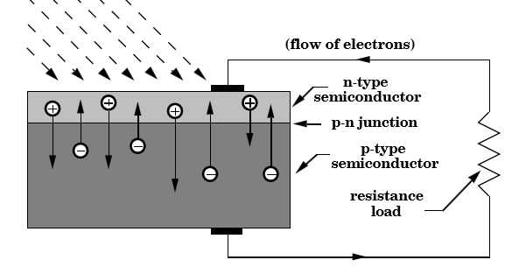

هەر زانیارییەکی گشتی دیکە کە سەرپەرشتیار بە گرنگی بزانێت

12.
په‌سه‌ندكردنی پرۆپۆزەل له‌ لایه‌ن لیژنه‌ی زانستی به‌ش

ژماره‌ی كۆنووسی كۆبوونه‌وه‌:
رێكه‌وتی كۆبوونه‌وه‌:
بریار: په‌سه‌ند كرا په‌سه‌ند نه‌كرا

ناوی سیانی و واژووی لیژنه‌ی زانستی به‌ش

واژوو:
ناوى سه‌رۆكی لیژنەى‌ زانستی به‌ش مۆری به‌ش

واژوو:
ناوى سه‌رۆكی به‌ش:
13.
په‌سه‌ندكردنی پرۆپۆزەل له‌ لایه‌ن ئه‌نجومه‌نی كۆلێژ/فاکەڵتى

ژماره‌ی كۆنوسی كۆبوونه‌وه‌:
رێكه‌وتی كۆبوونه‌وه‌:
بریار: په‌سه‌ند كرا په‌سه‌ند نه‌كرا

واژوو:
ناو راگری كۆلێژ: مۆری كۆلێژ

تێبینی: تكایه‌ فۆرمه‌كه‌ ته‌نها به‌ یه‌ك زمان (زمانی توێژینه‌وه‌) پڕ بكرێته‌وه‌.

