Manufacturing Meat
The main sources of manufacturing meats are.
- Cow
- Calf
- Steer, bullock
- Pig
- Sheep
- Poultry (Chicken, Turkey Other species)
- Gama meat
MANUFACTURING CUTS
‘Noble’ and ‘less noble’ meats
The ‘noble’ cuts are those most highly regarded by chefs and gourmets
Because they have:
- high contents of muscle
- small amounts of fat, which is on the outside of the meat and so can be easily removed if unwanted
- low contents of connective tissue
- Small amounts of bone, which can be easily removed.
Meat with these properties is:
- simple to cook, e.g. by grilling or roasting
- tender when lightly cooked
- simple to serve and provides large portions consisting almost entirely of desirable lean meat
- highly regarded and therefore highly priced.

The less ‘noble’ cuts they have.
- many and complex moving parts
- a complex bone structure
- many, smaller muscles
- more connective tissue. Cuts from the flank, where there are no bones to give support in the live animal, have particularly strong (therefore tough) connective tissues; there are also more or less thick layers of fat between the muscles.
Figure shows how some of these factors apply in typical cuts of beef.
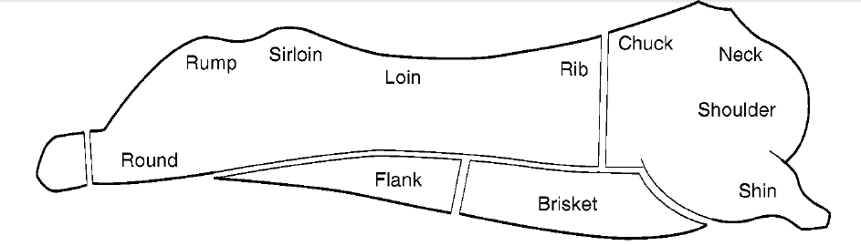
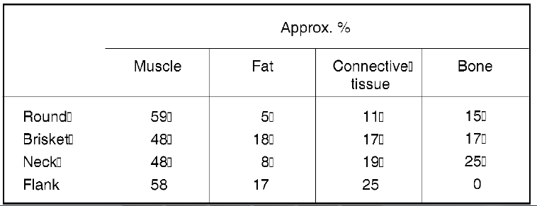
Fig. Composition of typical cuts of beef.

Muscle structure
The carcass is the product of the animal slaughtering process, and involves removing blood, viscera, hair, skin and other tissues from a recently slaughtered animal. Carcass meat consists of lean meat, fat, bone and connective tissue. The most important component of the carcass is the muscle. Because people’s concept of meat is usually associated with muscle; hence the terms meat and muscle are often used inter changeably, except in excessively fat animals, skeletal muscle constitutes the bulk (35 to 65%) of the carcass weight
The animal body has more than 600 muscles of various shapes, size and action. Specific characteristics of each muscle are dictated by the specialized function that particular muscle performs. Each muscle is covered with a connective tissue sheath, which is continuous with connective tissue that extends into the interior of the muscle (Figure below). Nerve fibers and blood vessels enter and exit the muscle along these connective tissue networks .
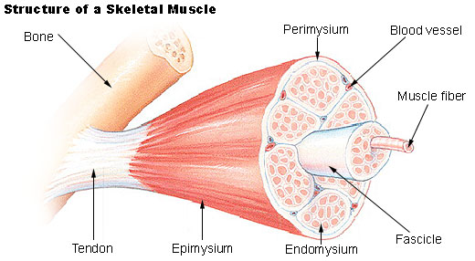Figure Diagrammatic representation of macroscopic and microscopic muscle structure
COMPONENTS OF MEAT AND THEIR PROPERTIES
Lean meat
Lean meat or muscle consists of %
- a contractile mechanism consisting of myofibrillar protein
(actin, myosin, etc.), in the form of many fibrils, fibres and fibre bundles 10.0
- each encased in light tubing or netting (connective tissue), 2.0
- surrounded by fluid (sarcoplasm), consisting of water (75.0%), sarcoplasmic protein (6.0%), and other soluble substances including myoglobin (red colour), salts, vitamins, etc. 84.5
- and some fat, sinews, nerves, blood vessels, etc. 3.5 consisting of collagen and elastin

The actin-myosin contractile system is represented simply in Fig.
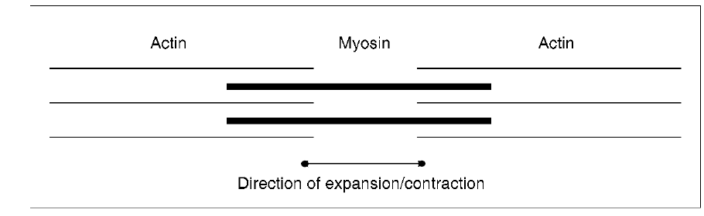
more detailed diagram of the structure of muscle is given in Fig. 1.4

