**Conversion of Muscle-to-Meat**

**1- Homeostasis** — Maintenance of a physiologically balanced internal environment. This includes pH, temperature, oxygen concentration, and energy supply. In the living animal, this is an important process that is activated quickly after death.

**2- Exsanguination (Blood Removal):**Immediately after bleeding, when the animal is dead (but the muscle is still responsive) muscle cells shift their energy (ATP) production from aerobic biochemical pathways to anaerobic processes. Two critical events occur with this metabolic shift. The ATP production is much less and cannot sustain normal muscle-energy needs. Without sufficient ATP, the muscle proteins start to form cross-bridges (irreversible muscle contraction) and the onset phase of rigor mortis occurs. Secondly, a new byproduct (lactic acid) is created by the anaerobic metabolism of glycogen and the pH starts to decline.

**3-Decline in Muscle pH:**The pH of living tissue is about 7.0, but after rigor, the pH of meat is normally about 5.5 to 5.7 ***.*** The increased acidity of post-mortem muscle results from the accumulation of lactic acid, which is formed as glycogen is degraded (anaerobic glycolysis) to produce ATP. Animals that are not handled optimally ante-mortem will likely have faster running muscle biochemistry and a more rapid decline in muscle pH. This change in pH during the conversion of muscle to meat is perhaps the most important event because it affects so many chemical, physical, and sensory traits of meat products.

**The most important changes with ph are as follows.**

**PSE condition** – pale, soft, exudative meat. If the pH falls very rapidly because of nervous excitement at the time of slaughter especially in stress-susceptible animals, the result is a low pH value (not abnormally low, but reached quickly while the carcass is still warm). This leads to precipitation of soluble proteins (sarcoplasmic protein), poor water binding and pale colour.

**DFD condition** – dry, firm, dark meat. If the glycogen supply is low because of hunger (starvation), exercise (exhaustion), or long-term stress in the live animal, little lactic acid can be formed and the ultimate pH is high. **This leads to deeper colour, closer texture and better water binding, but poorer microbiological quality.**



|  |  |  |  |  |
| --- | --- | --- | --- | --- |
| **Muscle color** | **Glycogen at death** | **Glycogen at 24 hr** | **Lactate production** | **Ultimate muscle pH** |
| Normal | 1.0% | 0.1% | high | 5.6 |
| Dark | 0.3% | 0.1% | low | 6.0 to 6.5 |
| Pale | 0.6% | 0.1% | very high | 5.1 |

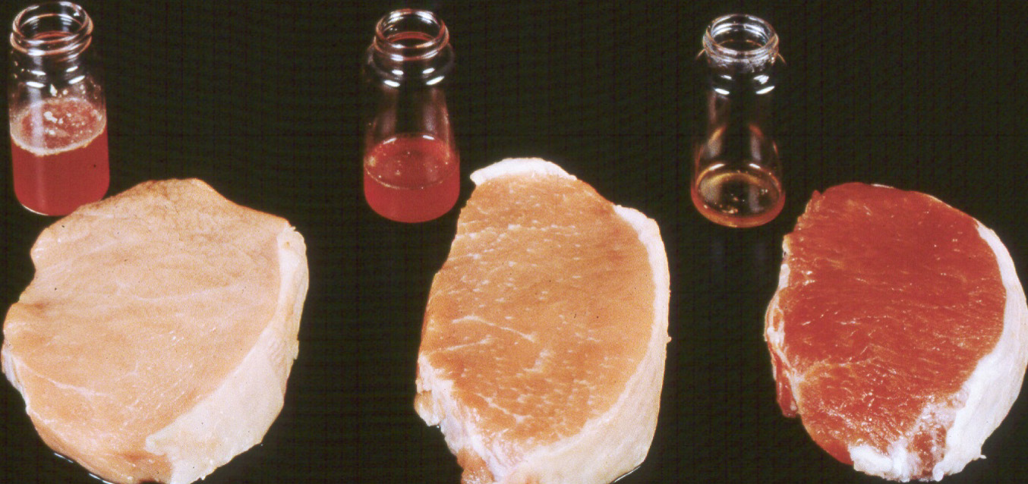

**4- Effects related to rigor mortis**

On the death of the animal the ATP (adenosine tri phosphate) in the muscles goes to ADP (adenosine di phosphate) and AMP (adenosine mono phosphate), with a release of energy which causes contraction, i.e. rigor mortis. After a time the muscles relax again, that is, there is resolution of rigor mortis.The onset of rigor mortis muscle **loss of elasticity** , **loss of extensibility, shortening and tension development ,** The time required for muscle of different animal species to enter the onset of rigor mortis will be showed in Table.

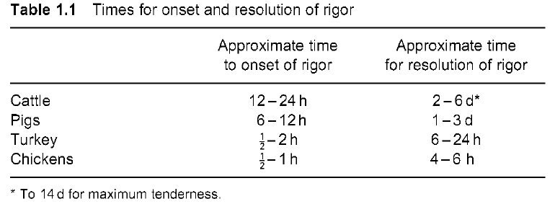

**freezing.**

***Freezing*** the meat early in rigor or before rigor commences, when residual ATP is still present, leads to **‘thaw rigor’:** strong contraction with toughening when the meat is thawed. If the frozen meat is stored for a long time (months), the ATP gradually disappears and thaw rigor diminishes. If the meat is held at -5°C for several hours before thawing, the chemical changes continue but the meat is unable to contract and therefore does not toughen. Freezing after rigor gives no special problems.



**Cooking.** If this is done **before onset of rigor** (i.e. immediately after slaughter) it produces very tender meat (in theory: in practice it may not be possible to work fast enough and rigor will commence before or during cooking). Cooking **during rigor** results in tough meat. Cooking **after resolution of rigor** produces tender meat. Tenderness increases with time before cooking, up to a maximum.

The toughness of contracted muscles is probably due to a combination ofthe muscle structure as the actomyosin system contracts.

**Resolution or softening of rigor mortis**

1-Alteration in ultra-structure of myofilaments

2-Changes in other protein of the cytoskeleton

3-Action of neutral protease enzymes relate directly to tenderization in meat aging.

**Cathepsins** Proteolytic enzymes hold in lysosomes.As the pH of the muscle drop(pH<5.6), these enzymes are released and probably begin to degrade protein structure of the muscle.

**Calpains**

Calcium activated muscle protease enzyme optimal pH at 6.6-6.8 Are found in sarcoplasm in myofibers