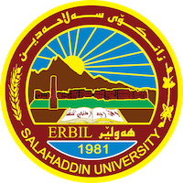
Academic Curriculum Vitae

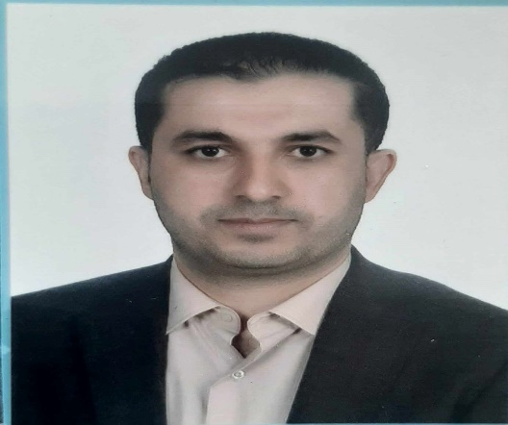
Personal Information:
Full Name: RANJDAR KAMERAN RAHMAN
Academic Title: Assistant lecturer
Email: ranjdar.rahman@su.edu.krd
Mobile: 07504861456

Education:
- Jul 2008: Obtained a BSc in Geography from Salahaddin University, College of Arts, Department of Geography, Erbil, Iraq.

- Jun 2016: Obtained an MSc in Geography from Salahaddin University, College of Arts, Department of Geography, Erbil, Iraq.
MSc Title: Potentials of Rural Development in The Erbil Plain District(A Study of Rural Geography)
Employment:
- Assistant Lecturer at (Geography Department)-College of Arts- Salahaddin University-Erbil from 2020 till now

- Research Assistant at (Geography Department)-College of Arts- Salahaddin University-Erbil from 2009 till 2020.

Qualifications
- Teaching Methods course, Salahaddin University, 17,7, 2016till 26,3, 2017
- Participating English language Proficiency course from 15,12, 2019 till 15,3, 2020, Language Centre Salahaddin University-Erbil.

Teaching experience:
- Kurdistan Geography, Regional Planning, Asian Geography, European Geography, African and Australian Geography, Computer Skills, Academic Skills… etc.

Research and publications
- Mudhafar Ahmed Rasool, Sasan Hikmat Ali andRanjdar Kamaran Rahman " Effect Of Transportation Factors on Noise Pollution in Erbil City Center." Journal of the Kurdish Akademy. Volume (8) No. (2), Spring (2023): 496-525.

Conferences and courses attended
- The question of Loyalty and the challenges of nation building process in Kurdistan region of Iraq, 1st International Scientific Conference of the College of Arts Salahaddin University – Erbil,
On 1-2 3،2023
- 3rd Conference (Awarding Grants for the Best Graduation Projects and Ideas for Students of Salahaddin University-Erbil) 2,2,2

Funding and academic awards

Professional memberships
- Member of Kurdistan Geographers Union in Erbil

Professional Social Network Accounts:

- Ranjdar kamaran/Facebook

It is also recommended to create an academic cover letter for your CV, for further information about the cover letter, please visit below link:
https://career-advice.jobs.ac.uk/cv-and-cover-letter-advice/academic-cover-letter/

