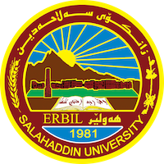
Academic Curriculum Vitae

Personal Information:

Full Name: Razaw Mohyaldeen Abdulrahman
Academic Title: assistant Lecturer
Email: razaw.abdulrahman@su.edu.krd
Mobile: 0750 4659418

Education:
- bachelor's in College of Basic Education/Salahaddin University/ kurdish language.
- Master in College of Basic Education/Salahaddin University/Methods of teaching
- PhD Student - College of Education - Department of kurdish language.

Employment:
On 28/8/2008 – Ministry of Higher Education – Salahaddin University – College of basic Education – Department of kurdish language

Qualifications
- ICDL Computer Training Course Certificate. in 2010
- Certificates of English Language Center/Salahaddin University Training Course in 2010 and 2023
- Pedagogy Course Certificate in 2015
Teaching experience:
-- Assistant Researcher at Salahaddin University, College of basic Education, Department of kurdish language.
- Assistant Lecturer at Salahaddin University / College of basic Education, Department of kurdish language 2015-2023, (Teaching Methods).
Research and publications
-Conferences and courses attended

Funding and academic awards
- Receiving 28 thanks and appreciation from the Dean of the College, the President of the University and the Minister of Higher Education.-

Professional memberships
- Member of Kurdistan teachers union.

Professional Social Network Accounts:

- -Research gate – google scholar- linkedin

