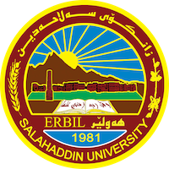

**Academic Curriculum Vitae**

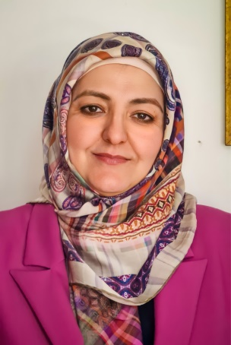

**Personal Information:**

Full Name: Razaw Rasheed Sabri

Academic Title: Lecturer

Email: razaw.sabri@su.edu.krd

**Education:**

* BA in Kurdish Language and Literature, 1999
* MA in Kurdish Literature, 2007
* PhD in Kurdish Literature, 2021

**Employment:**

* First employment in the Ministry of Education on 31st October, 2001
* Ministry of Higher Education since 2007

**Qualifications**

* Teaching Methods Course from 6th September, 2008 to 17th March, 2009
* Microsoft Word Course on 16th May 2009
* Microsoft Powerpoint Course on 30th January 2010
* Learning Management System (Moodle) Course from 13th to 17th September 2020
* IELTS Test Score of 5, on 4/4/2018.

**Teaching experience:**

* Teaching Children Literature, Entrepreneurship Education, Modern Literature, Old Literature, General Methods of Teaching, Kurdology, Literary Movements, Mental Health Education, The Technology of Learning at Salahaddin University and Soran University.
* Entrepreneurship Education training for Kurdistan’s university lecturers.

**Research and publications**

1. چەمك و ڕەگەزەكانى چیڕۆكى منداڵان لە ئەدەبى كوردیدا published in the Kurdish Academy Journal No.7 in 2008
2. هەندێك لایەنى سینتاكسی لە شێوەزارى ڕواندزدا published in the Journal of Linguistics No.1 and 2 in 2009
3. بەها پەروەردەییە نەتەوەیی و نیشتیمانییەکان لە تێکستی شانۆی منداڵاندا – تێکستی (نێرگزەکانی مام نەورۆز) بە نموونە published in the Twejer Magazine Vol.3. No. 2 / on Spring 2020
4. بەها پەروەردەییەکان بە پێی بنەما سەرەکییەکانی بونیاتی درامی لە شانۆی منداڵاندا - شانۆگەری (ڕێوی گۆرانی دەڵێت) وەک نموونە published in the Lebanese French Magazine
5. Children Literature: Reimagining Disability and Adopting Inclusive Discourses in Sara Ismail’s *Listen to the Silence* and Kazm Koy’s *Shanogary Zhyan*

(accepted to be published in the Twejer Magazine)

1. Publishing several articles in magazines such as: Psyche Magazine, Asoy Parwarda Magazine, Zhyar Educational Magazine, Khezan Magazine.

**Conferences and courses attended**

* Give details of any conferences you have attended, and those at which you have presented delivered poster presentations.
* Presenting several seminars yearly.
* Attended 5 local conferences.
* Participation in several workshops and training courses between Salahaddin University and the FAU University of Germany in the field of leadership, teaching, and community education under the following titles:
* “Entrepreneurship Education” from 22/9/2016 to 6/10/2016 at the German University (FAU) in Nuremberg.
* “Current Trends in Diversity Education”, “Higher Education Didactics”, Competence Oriented Assessment in Teaching”, and “Videos in Higher Education and Training” from 19/07/2019 to 21/07/2019 at FAU, Germany in the city of Nuremberg.
* “Teacher Education and Society: Potentials and Innovations in the Kurdistan Region of Iraq” from 29/10/2020 to 22/12/2020 and 13/07/ 2020 to 23/07/2020
* Participation in the training course “Teacher Training & Development: Entrepreneurship and Diversity Education” at Salahaddin University, Entrepreneurship Education Center, College of Basic Education.

**Funding and academic awards**

* As part of the German-Iraqi University Partnerships (Hochschulpartnerschaften mit dem Irak 2019-2020) offered by the German Academic Exchange Service (DAAD) and financed by the German Federal Foreign Office (AA), the scholarship provider awards the scholarship holder a scholarship for the participation in several workshops and training courses between Salahaddin University and the FAU University of Germany in the field of leadership, teaching, and community education under the “Entrepreneurship Education” title at the German University (FAU) in Nuremberg from **22/9/2016 to 6/10/2016**.
* As part of the German-Iraqi University Partnerships (Hochschulpartnerschaften mit dem Irak 2019-2020) offered by the German Academic Exchange Service (DAAD) and financed by the German Federal Foreign Office (AA), the scholarship provider awards the scholarship holder a scholarship for the participation in several workshops and training courses between Salahaddin University and the FAU University of Germany in the field of leadership, teaching, and community education under the titles “Current Trends in Diversity Education”, “Higher Education Didactics”, Competence Oriented Assessment in Teaching”, and “Videos in Higher Education and Training” at the German University (FAU) in Nuremberg from **19/07/2019 to 21/07/2019.**
* As part of the German-Iraqi University Partnerships (Hochschulpartnerschaften mit dem Irak 2019-2020) offered by the German Academic Exchange Service (DAAD) and financed by the German Federal Foreign Office (AA), the scholarship provider awards the scholarship holder a scholarship for the participation of a total of 12 days in online training courses (workshops, further trainings, consultations, etc.) as part of the project “Teacher Education and Society: Potentials and Innovations in the Kurdistan Region of Iraq” provided by the Chair of Diversity Education and International Educational and the Professorship for Teaching Economy and Law within the period from: **01/10/2020 to 11/12/2020**.

**Professional memberships**

* Member of the Kurdistan Teachers Union since 01/08/2007.

**Professional Social Network Accounts:**

* <https://scholar.google.com/citations?user=cSCnBL8AAAAJ&hl=en>
* <https://www.researchgate.net/profile/Razaw-Rasheed>
* <https://www.linkedin.com/in/razaw-rasheed-b17758123/>
* <https://www.facebook.com/razaw.rasheed>