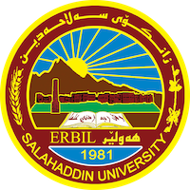
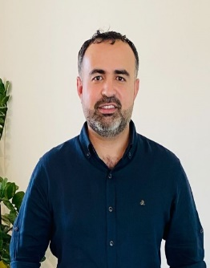
Academic Curriculum Vitae

Personal Information:
Full Name: Rebar Tahseen Ali
Academic Title: Lecturer
Email: rebar.ali@su.edu.krd
Mobile: 0750 448 9752

Education:
2019 to 2022: PhD in remote sensing and GIS in environmental Geology, College of Science, University of Salahaddin, Erbil-Iraq.
2012 to 2014: Master of Science in Geology, College of Science, University of
Salahaddin, Erbil-Iraq. Master thesis titled “Extraction and Analysis of Tectonic
Lineaments using Geoinformatics Techniques in the Tawke Oil field, Duhok Area,
Iraqi Kurdistan Region.”
2008 to 2009: Postgraduate Diploma in Geoinformation Science and Earth
Observation, Stream: Earth Resource Exploration, ITC International Institute for
Geoinformation Science and Erath Observation, Enschede, the Netherlands. High diploma titled “Mineral exploration and mapping using spectral and geochemical methods in Moura province, Portugal.
2001 to 2005: Bachelor of Science in Geology, College of Science, University of
Salahaddin, Erbil-Iraq.

Employment:
- Geology department/ College of Science- Salahaddin University-Erbil
October 5, 2005 – as Assistant geology
- Geology department/ College of Science- Salahaddin University-Erbil
May 2, 2014 - February 2023, as assistant lecturer
- Geology department/ College of Science- Salahaddin University
February 2023 – present as Lecturer

Qualifications
- Teaching methods, Salahaddin university, 2014
- IELTS

Teaching experience:
- Remote sensing, from 2009 till present
- GIS, from 2022 till present

Research and publications
- Monitoring and Evaluating Land Cover Change in The Duhok City, Kurdistan Region-Iraq, by Using Remote Sensing and GIS.

- Extraction and Analysis of Tectonic Lineaments using Geoinformatic Techniques, in Tawke Oil Field, Duhok area, Iraqi Kurdistan Region

- Spatiotemporal Analysis of Vegetation Cover and Its Response to Terrain and Climate Factors in Duhok Governorate, Kurdistan Region, Iraq

- Spatiotemporal Analysis of Land Surface Temperature and Vegetation Changes in Duhok District, Kurdistan Region, Iraq

- Land Degradation assessment using AHP and GIS-based modeling in Duhok District, Kurdistan Region, Iraq

Conferences and courses attended.
- 3rd Joint planning conference “Rapid urban growth and opportunities for sustainable development”, held between September 30 – October 3, 2012 in University of Duhok, Duhok, Iraq.
- 2nd Geokurdistan conference, held between October 6 – 8, 2015 in University of Sulimania, Sulimani, Iraq.
- Erbil city flood conference, held between September 17 – 18, 2022 in Erbil city.

Professional memberships
- European Association of Geoscientists & Engineers (EAGE).
- Kurdistan Geologists Syndicates.

Professional Social Network Accounts:
- https://scholar.google.com/citations?user=YccjkgcAAAAJ&hl=en
- https://www.researchgate.net/profile/Rebar-Mzuri
- https://orcid.org/0000-0001-7677-4174
- https://independent.academia.edu/RebarTahseenAli

