Introduction Questions
Q1: Define the economics.
The Demand Curve
Multiple Choice questions
Q2: When the price of a good increases the quantity demanded ____. *
a. decreases
b. increases
c. stays the same
Q3: When will people search harder for substitutes for oil? *
a. when the price of oil is low
b. when the price of oil is high
c. people are not incentivized to search for substitutes for oil
Q4: Which best describes a demand curve?
a) The quantity consumers would like to buy in an ideal world
b) The quantity consumers are willing to sell
c) The quantity consumers are willing and able to buy at each Price and all other things unchanged
d) The quantity consumers are willing and able to buy at each and every price all other things unchanged
Q5: A fall in price:
a) Will cause an inward shift of demand
b) Will cause an outward shift of supply
c) Leads to a movement along a demand curve
d) Leads to a higher level of production
Q6: Define the demand curve
Q7: Describe the following Demand curve:
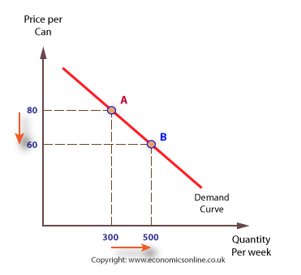
Q8: Explain why the demand curve has a downward slope?
Q9: by Looking at the demand curve for a good, we see a familiar relationship between the quantity demanded for the good and its price. Explain it in few sentences.
Q10: Translate the following paragraph:
Supply and demand are fundamental concepts in economics. Usually, they're represented by a graph. So what does this mean? Well, let's start with the demand curve. In short, a demand curve shows how much of a good people will want at different prices.
Q11: Give the meaning in Kurdish or Arabic for the following words.
The supply curve
Q12: Define the supply curve.
Q13: Talk about the relationship between the quantity supplied of a good and its price.
Q14: There is an intuitive relationship between the quantity supplied of a good and the price of that good. Explain this by using a graph and only one example.
Q15: Translate the following paragraph:
The supply curve slopes upward because the only way the quantity of oil can be increased is to exploit higher and higher cost sources of oil. As the price of oil goes up, the depth of the oil wells goes down. With this simple line the supply curve summarizes the way suppliers respond to a change in price including how suppliers will enter and exit the market depending on the price.
Q15: If you have the below supply curve graph, Then describe it:
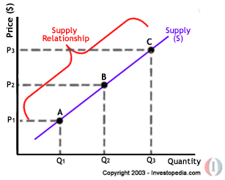

Multiple Choice questions
Q16: Along a supply curve, if the price of oil falls, what will happen to the quantity of oil supplied? *
a. it will decrease
b. it will increase
c. it will not change
Q17: If the price of cars falls, are carmakers likely to make ___________. *
a. more cars
b. fewer cars
c. the same amount of cars
Q18: Write a paragraph you explain the relationship about price and the quantity supplied, use a graph and an example.
Q19: Give the English meaning of the following words
خواست(الطلب)، خستنةرِوو(العرض)، هاوسةنطي (التوازن)
The equilibrium price
Multiple choice prices
Q20: If the price in a market is above the equilibrium price, this creates ___________. *
a. a shortage
b. a surplus
c. neither a shortage nor a surplus
Q21: When the price is above the equilibrium price, greed (in other words, self-interest) tends to _________. *
a. push the price down
b. push the price up
c. have no effect on price
Q22: Jon is on eBay, bidding for a first edition of the influential Frank Miller graphic novel Batman: The Dark Knight Returns. In this market, who is Jon competing with? *
a. The seller of the graphic novel
b. The other bidders
c. eBay’s stakeholders
Q23: Now, Jon is in Japan, trying to get a job as a full-time translator; he wants to translate English TV shows into Japanese and vice versa. He notices that the wage for translators is very low. Who is the “competition” that is pushing the wage down? *
a. Businesses who hire translators
b. Other translators
c. Prospective clients
Q24: Talk about shortage and surplus, use the equilibrium graph.
Q25: Define the Equilibrium price.
Q26: Define the equilibrium quantity
Q27: What happens when the price is above the equilibrium price?
Q28: What happens when the price is under the equilibrium price?

Q29: Talk about the following equilibrium graph:
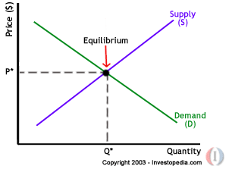
Q30: Translate this passage into Kurdish or Arabic:
In a free market, buyers and sellers acting in their own self interest end up at a price and quantity that allocates oil to the highest value buyers produced by the lowest cost sellers in a way that maximizes the gains from trade, the sum of the benefits to buyers and sellers. This is one of the reasons Adam Smith said that the market process works like an invisible hand to promote the social good. If you want to test yourself, click Practice Questions or if you're ready to move on, just click Next Video.
Q31: Write down five English words about equilibrium then translate them into Kurdish or Arabic.
S | The word | Meaning
1
2
3
4
5

The demand Curve Shifts
Multiple Choices
Q32: When the price of Apple computers goes down, what probably happens to the demand for Windows-based computers? *
a. The demand for Windows-based computers increases
b. The demand for Window-based computers decrease
c. A change in the price of Apple computers has no effect on the demand for Windows-based computers
Q33: When the price of olive oil goes up, what probably happens to the demand for corn oil? *
a. The demand for corn oil increases
b. The demand for corn oil decreases
c. A change in the price of olive oil has no effect on the demand for corn oil
Q34: When the price of petroleum goes up, what probably happens to the demand for natural gas? *
a. The demand for natural gas increases
b. The demand for natural gas decreases
c. A change in the price of petroleum has no effect on the demand for natural gas
Q35: If everyone thinks that the price of tomatoes will go up next week, what is likely to happen to demand for tomatoes today? *
a. The demand for tomatoes increases
b. The demand for tomatoes decreases
c. Expectations about the price of tomatoes has no effect on the demand for tomatoes today
Q36: Talk in detail about the following demand curves, of course in the demand curve shifting terms. Take the D curve as the original demand curve.
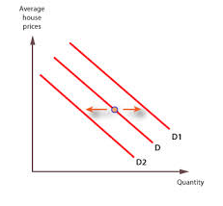
Q37: What is the demand curve?
Q38: what is the Quantity Demanded?
Q39: What is an increase and a decrease in demand means?
Q40: Explain the vertical and horizontal method in explaining the demand curve shifting.
Q41: Count four demand shifters, then show the effect one of them on the demand curve and use graph to enhance your answer.
Q42: What is the difference between change in quantity demanded and change in demand? Use the graph to enhance your answer.

The Supply curve Shifts
Q43: If you have the following supply curves, when A is the original supply curve of a good:
P
Q
B
C
A

What are difference(s) between Curve B and C depending on the origin Curve A.
Q44: Explain the effect of following supply shifters technological innovations, input prices, Taxes and subsidies, expectations, entry or exit of producers. Using graph is necessary.
Q45: What does a decrease or an increase in supply mean to you, use diagram to enhance your answers?
Q46: Make a list of 10 different Economic terms with their meanings in Kurdish or Arabic.
Q47: Explain the effect of time horizon on the supply curve. Use a diagram to prove your answer.

Elasticity of demand
Q48/ Why elasticity of demand is important for economists?
Q49/ What do the elasticity measure?
Q50/What is an Elastic demand?
Q51/ What is an inelastic demand?
Q52/ The demand curve is said to be ……………….., when the same increase in price reduces the quantity demanded just a little.
- Inelastic
- Elastic
- Unitary
Q53/ When the demand curve slopes sharply (more vertical) this is called an …………………………. Demand curve.
- Inelastic
- Elastic
- Unitary
Q54/ When a change in price leads to a change in the quantity demanded by a lot, this said to be an……………………… demand curve.
- Inelastic
- Elastic
- Unitary
Q55/ The elasticity of demand is going to be a measure of how responsive the quantity demanded is to a change in the price. Discuss this use graphs to enhance your answer.
Q56/ Which type of the elasticity of demand has more slope, explain it and use graphs to enhance your answer.
Q57/ Which one of the following curves is more elastic and less elastic demand curve?
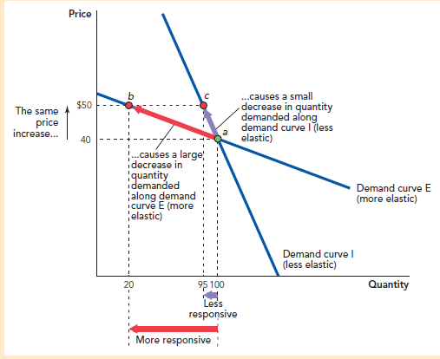
Q58/ Which kind of curves demonstrates the elastic demand curve, flatter or the more vertical? Enhance your answer by using a graph.
Q59/ when we have the following Demand Elasticity Determinants: The availability of substitutes , The time horizon, The category of product, Necessities versus luxuries, and The purchase size: Explain how they affect the elasticity of demand then use graph(s) to make your answer stronger.
Q60/ Translate the following passage into Kurdish or Arabic:
The availability of substitutes is really the key determinant of how elastic a demand curve is. The idea is pretty intuitive. If there's lots of substitutes for a good then when the price of that good goes up, people are going to switch from it, the good whose price is increased towards the substitutes. They're going to buy the substitutes instead. That means that when a good with lots of substitutes, when the price of that good goes up, the quantity demanded is going to go down a lot as people switch to the substitutes.
Q61: if the price goes up and there are very few substitutes, consumers aren't going to be able to switch out of that good into another good. Which kind of elasticity of demand is this? Explain it by using a graph.

62: What does the elasticity of supply measure?
63: So when the quantity supplied is very responsive to the price, we say the supply curve is ……………………… .
64: When the same increase price increases the quantity supplied by just a little then the supply curve is said to be……………………………… .
65: when you have two curves which go through a common point than the one which is flatter is more …………..…………. at any given quantity. The one which is steeper is more …………………….. .
66: Count three major determinants of the elasticity of supply? Explain one of them in detail use graphs to enhance your answer.
67: How per-unit costs affect the elasticity of supply? Use graphs to enhance your answer.
68: Which one of the following two goods Picasso paintings and toothpicks is more elastic and which one is less elastic? Use graphs to enhance your answer.
69: How the time horizon influences the elasticity of supply? Using necessary graphs is demanded.
70: Does the elasticity of supply depends on “ the industry is a small or big demander in its input markets”? use the graph to enhance your arguments.
71: How the Geographical scope determines the elasticity of supply? Prove your arguments by using graphs.
72: Which one of the following situations has more or less elastic supply “ expanding supply in Hawler or worldwide? Prove your arguments by using graphs.
73: Supply curves tend to be more elastic in the long run compared to the short run. How? Prove your arguments by using graphs.
74: The elasticity of supply is defined as………………………………………….. .
75: If the elasticity of supply is less than one, the supply curve is said to be………………. . If it's greater than one, the supply curve is said to be ……………… . If it's equal to one, it's said to be unit ………………. .
76: Translate the following passage into Kurdish or Arabic:
Let's summarize. What makes a supply curve more elastic? Fundamentally, a supply curve will be elastic when it's easy to increase production at constant unit cost or when it's easy to increase production without increasing the unit cost very much. Supply curves tend to be more elastic in the long run compared to the short run. They tend to be more elastic when the good has a small share of the market for its inputs, so it doesn't raise the price of its inputs when the market expands. And goods tend to be more elastic when we're just talking about the local supply of a good rather than the global supply which tends to be less elastic.
77: Which of the two goods is more likely to be elastically supplied? *
- Supply of apples over the next growing season
- Supply of apples over the next decade
78: Which of the two goods is more likely to be elastically supplied? *
- Supply of construction workers in Binghamton, NY
- Supply of construction workers in New York State
79: Which of the two goods is more likely to be elastically supplied? *
- Supply of breakfast cereal
- b. Supply of food
80: Which of the two goods is more likely to be elastically supplied? *
- Supply of gold
- Supply of computers
81: If a new process for manufacturing diamonds is created, will the supply curve for diamonds become more elastic or more inelastic? *
- More elastic
- More inelastic
82: If a larger share of oil output is required to make plastic, will the supply curve for plastic become more elastic or more inelastic? *
- More elastic
- More inelastic
83: If pesticides and fertilizers are banned, will the supply curve for food become more elastic or more inelastic? *
- More elastic
- More inelastic

84: Which one of the following curves is more or less elastic?
