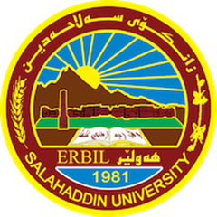**Academic Curriculum Vitae**

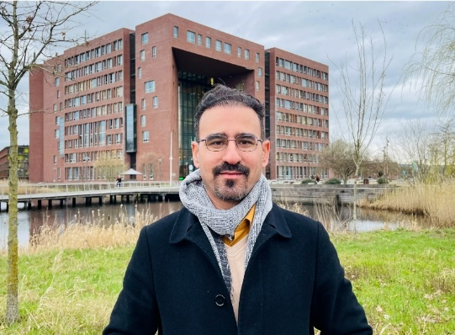**Personal Information**

Full Name: Rebaz Aswad Mirza Koy

Academic Title: Lecturer

Phone No: 07504703476

Email: [rebaz.mirza@su.edu.krd](mailto:rebaz.mirza@su.edu.krd)

**Education**

* **(2012-2017)** Degree of Ph.D. in Food safety and Quality University of Plymouth- Plymouth, Devon, United Kingdom School of Biological and Marine Sciences Faculty of Science and Engineering
* **(2007-2010)** Degree of M.Sc. in Food Microbiology. Department of Food Technology, College of Agricultural Engineering Sciences, University of Salahaddin-Erbil
* **(1999-2003)** Degree of BSc. in Animal Resource, College of Agricultural Engineering Sciences, University of Salahaddin-Erbil

**Employment**

Doctor of philosophy of Food Technology, Food Safety and Quality

**(2003-2007)** Administration of Food Microbiology Laboratory in Department of Food Technology, College of Agricultural Engineering Sciences, Salahaddin University-Erbil

I was working as a technician in Food Microbiology Lab.

Responsibility: To help undergraduate’s student in term of practical, e.g. enumeration of microorganisms (bacteria and fungi) in different food products by using culture media,

isolation and identification of microorganisms via specific method and media.

**(2007-2010)** I finished M.Sc. degree on lactic acid bacteria as a bio-preservatives to increase safety and shelf life of different food products (cheese, meat and cake)

(2010-2011) Teaching Practical Food Safety and Food Microbiology for undergraduate’s student in Department of Food Technology, College of Agricultural Engineering Sciences, Salahaddin University-Erbil

**(2012-2017)** I finished Ph.D. on lactic acid bacteria as bio-preservatives in bakery – Role of sourdough systems in the quality, safety and shelf life of bread.

I have used different types of fermented buttermilk with *Lactococcus lactis* subsp. *lactis* as bio-preservatives on the shelf life and safety of bread product (part of the study)

**(2018 till date)**, Lecturer in Department of Food Technology, College of Agricultural Engineering Sciences

**(2018 till date)**, Head of Health and Safety Units, College of Agricultural Engineering Sciences

**Qualifications**

- Teaching qualifications

- IT qualifications

- Language qualifications such as IELTS or any equivalent

**Teaching experience**

- Advanced Functional Food – Master Student

- Advanced Food Safety and Quality – Master Student

- Food Quality Control – Master Student

- Food Additives

- Food Marketing

- Food Science

- Functional Food

- English language

- Academic debate

**Research and publications**

Rastegar, S., Shojaie, A. and Koy, R.A.M., 2022. Foliar application of salicylic acid and calcium chloride delays the loss of chlorophyll and preserves the quality of broccoli during storage. *Journal of Food Biochemistry*, 46(8), p.e14154.

Ibrahim, P.S., Aziz, K.E. and Koy, R.A., 2021. Application of locally isolated lactic acid bacteria metabolites as bio-preservatives to increase shelf-life, safety and quality of some fruits. *Anbar Journal of Agricultural Sciences*, 19(2), pp.269-284.

Nasif, Z.M. and Mirza, R.A., 2012. The uses of *Lactobacillus plantarum* metabolites locally isolated in bio-preservation for some foods. *Euphrates* Journal of Agricultural

Science, 4, pp.93-108.

زينب محمد نصيف و ریباز اسود میرزە. تأثير الفعالية التثبيطية لعزلات كريات بكتريا حامض اللبنيك المحلية ضد بعض أنواع البكتريا المرضية ودراسة بعض خواصها الفسيولوجية كمعزز حيوي.

*Euphrates Journal of Agricultural Science*. 2012;4(2).

**Conferences and courses attended**

* The shelf life and safety of bread crumpets using fermented buttermilk and bacteriocins produced by *lactococcus lactis* subsp. *Lactis*

Flour-Bread '13" & 9th Croatian Congress of Cereal Technologists, Opatija, Croatia from 16-18 October 2013.

Society for Applied Microbiology Summer Conference, Dublin-Ireland from 29th June 02 July 2015.

* Diversity of lactic acid bacteria from fermented dough – Potential use as sourdough bread starters

Sixth Sourdough Symposium, Nantes, France. 30th September – 2 nd October 2015. Annual Research Day. Plymouth University. Plymouth, UK. 20th January 2016.

**Professional memberships**

* Agricultural Engineers Syndicate- Iraq - Kurdistan
* Kurdistan teachers Union – Kurdistan - Erbil.

**Professional Social Network Accounts:**

**Academic Profile:** <https://academics.su.edu.krd/rebaz.mirza>

**Scholar Account:** <https://scholar.google.com/citations?authuser=1&user=YweZ7xYAAAAJ>

**Research Gate:** [**www.researchgate.net/profile/Rebaz-Koy**](http://www.researchgate.net/profile/Rebaz-Koy)

**ORCID Profile:** <https://orcid.org/0009-0007-2328-4308>