Kurdistan Regional Government-Iraq
Ministry of Higher Education & Scientific Research
Salahaddin University
College of Education
Department of Mathematics
Advanced Programming
loop
Lecture: Rebaz Yaseen Taha
rebaz.taha@su.edu.krd
2022 -2023

Nested Loops
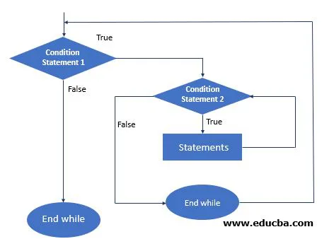
Ex\ Write a C++ program to display 7 days of 3 weeks.
#include <iostream>
using namespace std;
int main() {
int weeks = 3, days_in_week = 7;
for (int i = 1; i <= weeks; ++i)
{
cout << "Week: " << i << endl;
for (int j = 1; j <= days_in_week; ++j)
{
cout << " Day:" << j << endl;
}
}
return 0;
}

break and continue Inside Nested Loops
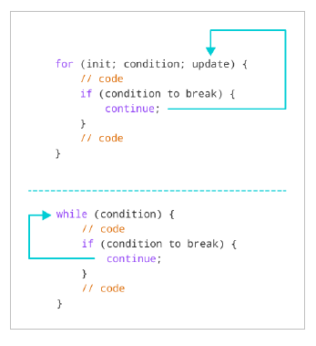
When we use a break statement inside the inner loop, it terminates the inner loop but not the outer loop.
Ex\ Write a C++ program to display 7 days of 3 weeks, then break the days during the 2nd week.
#include <iostream>
using namespace std;
int main() {
int weeks = 3, days_in_week = 7;
for (int i = 1; i <= weeks; ++i)
{
cout << "Week: " << i << endl;
for (int j = 1; j <= days_in_week; ++j) {
// break during the 2nd week
if (i == 2) {
break; }
cout << " Day:" << j << endl;
}
}
return 0; }
Week: 1
Day:1
Day:2
... .. ...
Week: 2
Week: 3
Day:1
Day:2

Similarly, when we use a continue statement inside the inner loop, it skips the current iteration of the inner loop only. The outer loop is unaffected.
Ex\ Write a C++ program to display 7 days of 3 weeks, then continue if the day is an odd.
#include <iostream>
using namespace std;
int main() {
int weeks = 3, days_in_week = 7;
for (int i = 1; i <= weeks; ++i) {
cout << "Week: " << i << endl;
for (int j = 1; j <= days_in_week; ++j) {
// continue if the day is an odd number
if (j % 2 != 0) {
continue;
}
cout << " Day:" << j << endl;
}
}
}
Week: 1
Day:2
Day:4
Day:6
Week: 2
Day:2
Day:4
Day:6
Week: 3
Day:2
Day:4
Day:6
===================------------------------------------------
C++ while and do...while Loop
Ex\ Write a C++ program to Reverse an Integer number.
#include <iostream>
using namespace std;
int main() {
int n, reversed_number = 0, remainder;
cout << "Enter an integer: ";
cin >> n;
while(n != 0) {
remainder = n % 10;
reversed_number = reversed_number * 10 + remainder;
n /= 10;
}
cout << "Reversed Number = " << reversed_number;
return 0;
}
n n != 0 remainder reversed_number
2345 true 5 0 * 10 + 5 = 5
234 true 4 5 * 10 + 4 = 54
23 true 3 54 * 10 + 3 = 543
2 true 2 543 * 10 + 2 = 5432
0 false ----- Loop terminates.

C++ program to display a pattern with 5 rows and 3 columns
#include <iostream>
using namespace std;
int main() {
int rows = 5;
int columns = 3;
for (int i = 1; i <= rows; ++i) {
for (int j = 1; j <= columns; ++j) {
cout << "* ";
}
cout << endl;
}
return 0;
}

* * *
* * *
* * *
* * *
* * *
Q/ Write a C++ program to display the following form
#include <iostream>
using namespace std;
int main()
{
int i, j, n;
cout << "Enter number of rows: ";
cin >> n;
for(i = 1; i <= n; i++)
{
for(j = 1; j <= i; j++)
{
cout << "* ";
}
//Ending line after each row
cout << "\n";
}
return 0;
}

Example 2- Write a C++ program to print inverted half star pyramid pattern
#include <iostream>
using namespace std;
int main()
{
int i, j, n;
cout << "Enter number of rows: ";
cin >> n;
for(i = n; i >= 1; i--)
{
for(j = 1; j <= i; j++)
{
cout << "* ";
}
// ending line after each row
cout << "\n";
}
return 0;
}
Output:
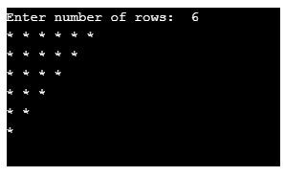
Example 3- Program in C++ to print star pyramid pattern
#include<iostream>
using namespace std;
int main()
{
int n, s, i, j;
cout << "Enter number of rows: ";
cin >> n;
for(i = 1; i <= n; i++)
{
//for loop for displaying space
for(s = i; s < n; s++)
{
cout << " ";
}
//for loop to display star equal to row number
for(j = 1; j <= (2 * i - 1); j++)
{
cout << "*";
}
// ending line after each row
cout << "\n";
}
}
Output:
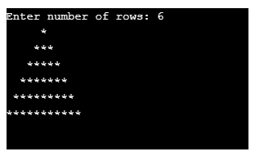
Q/ Write a C++ program to display the following form
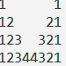
#include <iostream>
using namespace std;
int main()
{
int n, x, y, k;
cout << "Enter the number of rows to show number pattern: ";
cin >> n;
for(x = 1; x <= n; x++)
{
for(y = 1; y <= n; y++)
{
if(y <= x)
cout << y;
else
cout << " ";
}
for(y = n; y >= 1; y--)
{
if(y <= x)
cout << y;
else
cout << " ";
}
cout << "\n";
}
return 0;
}
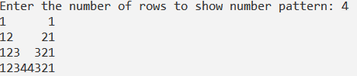
H.W
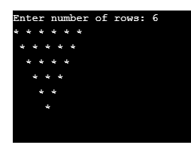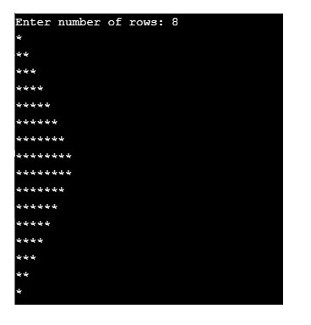
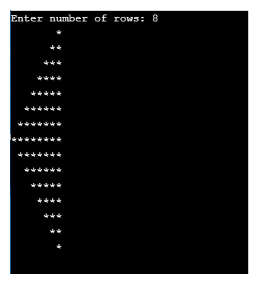

/* Write a C++ program to check the weather a fix name is in the list of names or not */
#include <iostream>
using namespace std;
int i,n;
string name, fname;
int main()
{cout << "enter the number of names" << endl;
cin>>n;
cout << "enter the fix name" << endl;
cin>> fname,
cout << "enter "<< n <<"names" << endl;
for(i=1;i<=n;i++)
{cin>>name;
if(name==fname)
{
cout<<<<name<<" is in the list" <<endl;
goto L;
}
continue;
}
cout<<name<<" is not in the list" <<endl;
L:
return 0;
}

/* Write a program to print the list names of students whose exam score greater than 45. */
#include <iostream>
using namespace std;
int i,n, degree;
string name;
int main()
{cout << "enter the number of students" << endl;
cin>>n;
cout << "input exam score and name of "<<n<< " students" << endl;
cout << "enter name" << endl;
for(i=1;i<=n;i++)
{cin>>degree>>name;
if(degree>=45)
cout<<name<<endl;
}
return 0;
}

Declaring Arrays
To declare an array in C++, the programmer specifies the type of the elements and the number of elements required by an array as follows –
1) A single-dimension array
type arrayName [ arraySize ];
The arraySize must be an integer constant greater than zero and type can be any valid C++ data type.
For example, to declare a 10-element array of type double, use this statement
double A[10]; Or double A[5] = {1000.0, 2.0, 3.4, 17.0, 50.0};
The number of values between braces { } can not be larger than the number of elements that we declare for the array between square brackets [ ].

If you omit the size of the array, an array just big enough to hold the initialization is created. Therefore, you can write
double A[] = {1000.0, 2.0, 3.4, 17.0, 50.0};
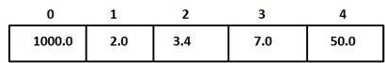
A=

The statement A[4] = 50.0 assigns element number 5th in the array has a value 50.0. Array with 4th index will be 5th , i.e., last element because all arrays have 0 as the index of their first element which is also called base index.
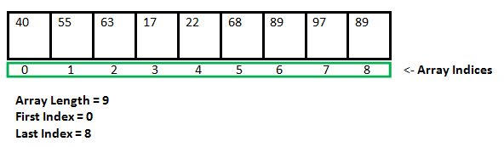
Arrays example
#include <iostream>
#include <iomanip>
using namespace std;
int A[7] = {16, 2, 77, 40, 12, 7, 1};
int i;
int main ()
{
for ( i=0 ; i<7 ; i++ )
{
cout << A[i]<< setw(3);
}
return 0;
}

Ex/ Write a c++ program to find sum of elements in a given array
#include <iostream>
using namespace std;
int main() {
// initialise array
int arr[100] = {2, 4, 6, 8};
int sizea = 4;
// initialise sum to zero
int sum = 0;
// for loop runs from 0 to size - 1
for(int i = 0; i < sizea; i++)
{
sum = sum + arr[i];
}
cout << "The sum of the elements in the array: " << sum;
}
Ex/ Write a c++ program to print the elements of a given array and find sum of all elements.
#include <iostream>
#include <iomanip>
using namespace std;
int main () {
int s=0, B[ 10 ]; // B is an array of 10 integers
// initialize elements of array B to 0
for ( int i = 0; i < 10; i++ ) {
B[ i ] = i + 100; // set element at location i to i + 100
}
cout << "Element" << setw( 13 ) << "Value" << endl;
// output each array element's value
for ( int j = 0; j < 10; j++ ) {
cout << setw( 7 )<< j << setw( 13 ) << B[ j ] << endl;
}
for ( int k = 0; k < 10; k++ ) {
s=s+B[k];
}
cout << "total" << setw( 13 ) << s << endl;
return 0;
}

Ex/ Write a C++ program to find the largest element in an array.
#include<iostream>
using namespace std;
int main()
{
int large, arr[100], size, i;
cout<<"\n Enter Array Size (Max 100): ";
cin>>size;
cout<<"\n Enter Array Elements : \n";
for(i=0; i<size; i++)
{
cin>>arr[i];
}
cout<<"\n Searching for Largest Number ...\n\n";
large=arr[0]; int j;
for(i=0; i<size; i++)
{
if(large<=arr[i])
{j=I;
large=arr[i];
}
}
cout<<"Largest Number = "<<large;
return 0;
}

Ex/ Write a C++ program to search any element in an array.
#include<iostream>
using namespace std;
int main()
{
int arr[10], i, num, n, cnt=0, pos;
cout<<"\n Enter Array Size : ";
cin>>n;
cout<<"\n Enter Array Elements : \n";
for(i=0; i<n; i++)
{
cout<<" ";
cin>>arr[i];
}
cout<<"\n Enter Element to be Searched : ";
cin>>num;
for(i=0; i<n; i++)
{
if(arr[i]==num)
{
cnt=1;
pos=i+1;
break;
}
}
if(cnt==0)
{
cout<<"\n Element Not Found..!!";
}
else
{
cout<<"\n Element "<<num<<" Found At Position "<<pos;
}

Example for string
#include <iostream>
using namespace std;
int I;
int main() {
string cars[4] = {"Volvo", "BMW", "Ford", "Mazda"};
for(i=0;i<4;i++)
{ cout << cars[i]≪endl;
}
return 0;
}

//Program to input a word and print individual characters on separate lines.
/* We have used gets() function to take multi-word string input from the user. To use the gets()
function we have to include stdio.h header file in our program.*/
#include <iostream>
#include <conio.h>
#include <stdio.h>

using namespace std;
int main()
{
char data[20];
int i;

cout<<"Enter Name ";
gets(data);
for(i=0; data[i]!='\0'; i++)
{
cout<<data[i]<<endl;
}
return 0;
}

/*Example (store a multi-word string using cin.get() statement)*/
/* In example 3, we have used a cin.get() statement
to take a multi-word string input from the user.
In cin.get() statement, the first argument is the name
of the character array and the second argument is the size
of the character array.*/

#include <iostream>
#include <conio.h>

using namespace std;

int main()
{
char data[20];

cout<<"Enter Full Name ";
cin.get(data,20);
return 0;
}

//Ex/ Write a C++ program to read two vectors A and B, then print each pair with its sum in the three columns with header.
#include<iostream>
#include<iomanip>
using namespace std;
int main()
{ int const n=2;
int A[n], B[n], C[n], i;
cout<<"\n Enter Elements of Array A: \n";
for(i=0; i<n; i++)
{
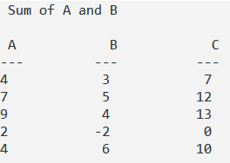
cin>>A[i];
}
cout<<"\n Enter Elements of Array B: \n";
for(i=0; i<n; i++)
{
cin>>B[i];
}
cout<<"\n Sum of A and B \n\n";
for(i=0; i<n; i++)
{
C[i]= A[i] +B[i];
}
cout<<" A"<<setw(13) <<"B"<<setw(13)<<"C"<<endl;
cout<<"---"<<setw(12) <<"---"<<setw(13)<<"---"<<endl;
for(i=0; i<n; i++)
{
cout<<A[i]<<setw(13) <<B[i]<<setw(13)<<C[i]<<endl;
}
return 0;
}
Ex/ Write a C++ program to read two vectors and print all pairs of values which its addition is greater than 10.
#include<iostream>
#include<iomanip>
using namespace std;
int main()
{ int const n=2;
int A[n], B[n], i;
cout<<"\n Enter Elements of Array A: \n";
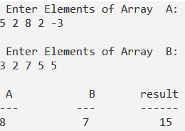
for(i=0; i<n; i++)
{
cin>>A[i];
}
cout<<"\n Enter Elements of Array B: \n";
for(i=0; i<n; i++)
{
cin>>B[i];
}
cout<<"\n\n\n";
cout<<" A"<<setw(13) <<"B"<<setw(13)<<"result"<<endl;
cout<<"---"<<setw(12) <<"---"<<setw(13)<<"------"<<endl;
for(i=0; i<n; i++)
{
if (A[i] +B[i]>10)
{
cout<<A[i]<<setw(13) <<B[i]<<setw(13)<<A[i]+B[i]<<endl;
}
}
return 0;
}

//Ex/ Write a C++ program to rearrange (sort) from largest to smallest.
#include<iostream>
#include<iomanip>
using namespace std;
int main()
{ int const n=5;
int A[n], B[n], i,j,c;
cout<<"\n Enter Elements of Array A: \n";
for(i=0; i<n; i++)
{
cin>>A[i];
}
cout<<"\n Print vector A before sort \n";
for(i=0; i<n; i++)
{
cout<< A[i]<<setw(13);
}
for(i=0; i<n; i++)
{
for(j=i; j<n; j++)
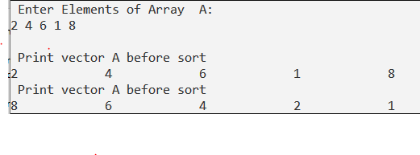
{
if (A[i]<A[j])
{
c=A[i];
A[i]=A[j];
A[j]=c;
}}}
cout<<"\n Print vector A before sort \n";
for(i=0; i<n; i++)
{
cout<< A[i]<<setw(13);
}
return 0;
}

Two-dimensional array
A two-dimensional array is also called a matrix. It can be of any type like integer, character, float, etc. depending on the initialization. We can initialize 2D arrays.
int arr[4][2] = {4, 56, 12, 3, 4, 80, 2, 8} ;
char arr[3][3]= { 'c', 'a', 't' , 'b', 'a', 't' , 'g', 'a', 't' };

The code below shows us how we can do that.
#include<iostream>
using namespace std;
main( )
{
int arr[4][2] = {10, 11 ,20, 21 ,30, 31 ,40, 41 } ;
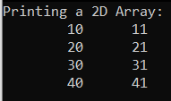
int i,j;
cout<<"Printing a 2D Array:\n";
for(i=0;i<4;i++)
{
for(j=0;j<2;j++)
{
cout<<"\t"<<arr[i][j];
}
cout<<endl;
}
return 0;
}

Also we can make it as a user input

#include<iostream>
using namespace std;
main( )
{
int s[2][2];
int i, j;
cout<<"\n2D Array Input:\n";
for(i=0;i<2;i++)
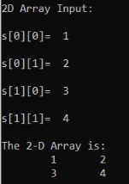
{
for(j=0;j<2;j++)
{
cout<<"\ns["<<i<<"]["<<j<<"]= ";
cin>>s[i][j];
}
}
cout<<"\nThe 2-D Array is:\n";
for(i=0;i<2;i++)
{
for(j=0;j<2;j++)
{
cout<<"\t"<<s[i][j];
}
cout<<endl;
}
return 0;
}

Ex/ Write a C++ program to read and print of two dimensional arrays A and B then find sum of them.

#include<iostream>
using namespace std;
main()
{
int A[5][5], B[5][5], D[5][5];
int i, j, r, c;
cout<<"Enter the no.of rows of the matrices:";
cin>>r;
cout<<"Enter the no.of columns of the matrices :";
cin>>c;

cout<<"\n1st Matrix Input:\n";
for(i=0;i<r;i++)
{
for(j=0;j<c;j++)
{
cout<<"\nmatrix1["<<i<<"]["<<j<<"]= ";
cin>>A[i][j];
}
}
cout<<"\n2nd Matrix Input:\n";
for(i=0;i<r;i++)
{
for(j=0;j<c;j++)
{
cout<<"\nmatrix2["<<i<<"]["<<j<<"]= ";
cin>>B[i][j];
}
}

// Printing matrix A //
cout << "Matrix A : \n ";
for (i = 0; i < r; i++)
{
for (j = 0; j < c; j++)
cout << A[i][j] << " ";
cout << "\n ";
}
// Printing matrix B //
cout << "Matrix B : \n ";
for (i = 0; i < r; i++)
{
for (j = 0; j < c; j++)
cout << B[i][j] << " ";
cout << "\n ";
}
cout<<"\nAdding Matrices...\n";
for(i=0;i<r;i++)
{
for(j=0;j<c;j++)
{
D[i][j]=A[i][j]+B[i][j];
}
}
cout<<"\nThe resultant Matrix is:\n";
for(i=0;i<r;i++)
{
for(j=0;j<c;j++)
{
cout<<"\t"<<D[i][j];
}
cout<<endl;
}
return 0;
}

Ex/ Write a C++ program to read and print of two-dimensional array A, and print the diagonal elements of a matrix:
#include <iostream>
using namespace std;
int const n= 5;
int A[n][n];
int main()
{
//Take input into Matrix
cout << "Enter elements into the matrix: \n";
for(int i=0; i<n ; i++)
{ for(int j=0; j<n; j++)
{ cin >> A[i][j];
}
}
// Printing matrix A //
cout << "Matrix A : \n ";
for (i = 0; i < n; i++)
{
for (j = 0; j < n; j++)
cout << A[i][j] << " ";
cout << "\n ";
}

//Output the diagonal elements
cout << "Diagonal Elements: \n";
for(int i=0; i<n; i++){
for(int j=0; j<n; j++){
if(i==j)
cout << A[i][j] << "\t";
else
cout << " " << "\t";
}
cout << "\n";
}
return 0;
}

Ex/ Write a C++ program to read and print of two dimensional array A, then find summation of the diagonal matrix:
#include <iostream>
using namespace std;
int const n= 5;
int A[n][n], s=0;
int main()
{
//Take input into Matrix
cout << "Enter elements into the matrix: \n";
for(int i=0; i<n ; i++)
{ for(int j=0; j<n; j++)
{ cin >> A[i][j];
}
}

// Printing matrix A //
cout << "Matrix A : \n ";
for (i = 0; i < n; i++)
{
for (j = 0; j < n; j++)
{ cout << A[i][j] << " ";
}
cout << "\n ";
}
cout << " Sum of Diagonal Elements: \n";
for(int i=0; i<n; i++)
{
for(int j=0; j<n; j++)
{
if(i==j)
{ s=s+ A[i][j] ;
}
}
cout << "s="<<s;
}
return 0;
}

Ex/ Write a C++ program to find multiplication of arrays A and B, then find multiplication #include<iostream>
using namespace std;
int main ()
{
int F1, c1, F2, c2, i, j, k;
int A[5][5], B[5][5], C[5][5];
cout << "Enter the number of columns and rows of matrix A : ";
cin >> F1 >> c1;
cout << "Enter number of Cloumns and rows of matrix B : ";
cin >> F2 >> c2;
if (c1 != F2)
{
cout << "Matrices can't be multiplied..";
exit(0);
}
cout << "Input the elements of matrix A : ";
for (i = 0; i < F1; i++)
for (j = 0; j < c1; j++)
cin >> A[i][j];
cout << "Input the elements of matrix B : ";
for (i = 0; i < F2; i++)
for (j = 0; j < c2; j++)
cin >> B[i][j];
for (i = 0; i < F1; i++)
{
for (j = 0; j < c2; j++)
{
C[i][j] = 0;
for (k = 0; k < F2; k++)
{
C[i][j] += A[i][k] * B[k][j];
}
}
}
cout << "Product of matrices\n";
for (i = 0; i < F1; i++)
{
for (j = 0; j < c2; j++)
cout << C[i][j] << " ";
cout << "\n";
}
return 0;
}

HW :
Q/ Write a C++ program to check whether the given matrix A is an identity matrix or not.

H.W.

Q1/ Write a C++ program to find the transpose of a matrix A.
Q2/ Write a C++ program to print second row and first column of a matrix A.
Q3/ Write a C++ program to replace second row with third row in matrix A_{3x3}.
Q4/ Write a C++ program to replace zero element with 7 in matrix A_{3x3}.
Q5/ Write a C++ program to check the whether a matrix A is orthogonal or not.
Q6/ Write a C++ program to check the whether a matrix A is a triangular matrix or not.
Q7/ Write a C++ program to check the whether a matrix A is a diagonal matrix or not.
Q8/ Write a C++ program to find multiplication of two matrixes A and B.
Q9/ Write a C++ program to check the whether a matrix A is symmetric, skew-symmetric or non them.

Note:
A square matrix is defined as an orthogonal matrix if its transpose matrix is same as its inverse matrix.
A triangular matrix is a square matrix which has all elements above or below the main diagonal as 0.

Ex\ Write a C++ program to read and print two dimensional array A, then find summation of the elements of first row.
#include <iostream>
using namespace std;
int main()
{int A[5][5],i, j, r, c,s=0;
cout<<"Enter the no.of rows of the matrices:";
cin>>r;
cout<<"Enter the no.of columns of the matrices :";
cin>>c;
//Take input into Matrix
cout << "Enter elements into the matrix: \n";
for(int i=0; i<r ; i++)
{ for(int j=0; j<c; j++)
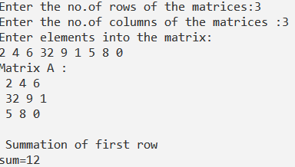
{ cin >> A[i][j];
}
}
// Printing matrix A //
cout << "Matrix A : \n ";
for (i = 0; i < r; i++)
{
for (j = 0; j < c; j++)
{
cout << A[i][j] << " ";
}
cout << "\n ";
}
cout << "\n ";
cout << "Summation of first row\n";
for(int i=0; i<r; i++)
{
for(int j=0; j<c; j++)
{
if(i==0)
{
s=s+A[i][j];
}
}
}
cout << "sum="<<s;
return 0;
}

Ex\ Write a C++ program to read and print two dimensional array A, then find summation of the elements of first column.
#include <iostream>
using namespace std;
int main()
{int A[5][5],i, j, r, c,s=0;
cout<<"Enter the no.of rows of the matrices:";
cin>>r;
cout<<"Enter the no.of columns of the matrices :";
cin>>c;
//Take input into Matrix
cout << "Enter elements into the matrix: \n";
for(int i=0; i<r ; i++)
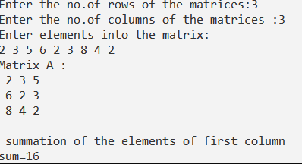
{ for(int j=0; j<c; j++)
{ cin >> A[i][j];
}
}
// Printing matrix A //
cout << "Matrix A : \n ";
for (i = 0; i < r; i++)
{
for (j = 0; j < c; j++)
{
cout << A[i][j] << " ";
}
cout << "\n ";
}
cout << "\n ";
cout << " summation of the elements of first column \n";
for(int i=0; i<r; i++)
{
for(int j=0; j<c; j++)
{
if(j==0)
{
s=s+A[i][j];
}
}
}
cout << "sum="<<s;
return 0;
}
Ex\ Write a C++ program to read and print two dimensional array A, then find summation of the elements of first row and first column.
#include <iostream>
using namespace std;
int main()
{int A[5][5],i, j, r, c,s=0;
cout<<"Enter the no.of rows of the matrices:";
cin>>r;
cout<<"Enter the no.of columns of the matrices :";
cin>>c;
//Take input into Matrix
cout << "Enter elements into the matrix: \n";
for(int i=0; i<r ; i++)
{ for(int j=0; j<c; j++)
{ cin >> A[i][j];
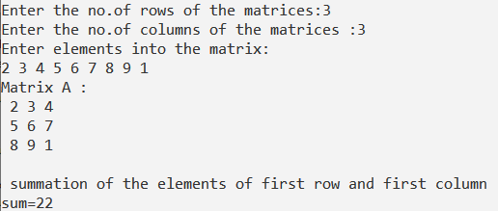
}
}
// Printing matrix A //
cout << "Matrix A : \n ";
for (i = 0; i < r; i++)
{
for (j = 0; j < c; j++)
{
cout << A[i][j] << " ";
}
cout << "\n ";
}
cout << "\n ";
cout << " summation of the elements of first row and first column \n";
for(int i=0; i<r; i++)
{
for(int j=0; j<c; j++)
{
if(i==0 || j==0)
{
s=s+A[i][j];
}
}
}
cout << "sum="<<s;
return 0;
}

Ex\ Write a C++ program to read and print two dimensional array A, then find summation of the odd elements of first row.
#include <iostream>
using namespace std;
int main()
{int A[5][5],i, j, r, c,s=0;
cout<<"Enter the no.of rows of the matrices:";
cin>>r;
cout<<"Enter the no.of columns of the matrices :";
cin>>c;
//Take input into Matrix
cout << "Enter elements into the matrix: \n";
for(int i=0; i<r ; i++)
{ for(int j=0; j<c; j++)
{ cin >> A[i][j];
}
}
// Printing matrix A //
cout << "Matrix A : \n ";
for (i = 0; i < r; i++)
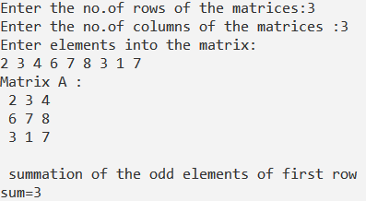
{
for (j = 0; j < c; j++)
{
cout << A[i][j] << " ";
}
cout << "\n ";
}
cout << "\n ";
cout << " summation of the odd elements of first row \n";
for(int i=0; i<r; i++)
{
for(int j=0; j<c; j++)
{
if(i==0 && A[i][j] %2 !=0)
{
s=s+A[i][j];
}
}
}
cout << "sum="<<s;
return 0;
}

Function

Ex\ Write a C++ function program to find average of three integer number.

#include <iostream>

using namespace std;
double AV(int x,int y,int z);
int main()
{
double a, b, c, ave;
cin>> a>>b>>c;
ave=AV(a,b,c);
cout << "ave=" <<ave<< endl;
return 0;
}
double AV(int x,int y,int z)
{ double sum, average;
sum=x+y+z;
average=sum/3;
return (average);
}

Ex\ Write a C++ function program to find area of square.

#include <iostream>
using namespace std;
int area(int x);
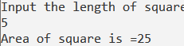
int main()
{
int a, Er;
cout << "Input the length of square "<< endl;
cin>> a;
Er=area(a);
cout << "Area of square is =" <<Er<< endl;
return 0;
}
int area(int z)
{ int Ar;
Ar=z*z;
return (Ar);
}

Ex\ Write a C++ function program to check whether an integer number is even or not.

#include <iostream>

using namespace std;
int ev(int x);
int main()
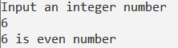
{
int n, EV;
cout << "Input an integer number "<< endl;
cin>> n;
EV=ev(n);
if (EV==0)
cout << n<< " is even number" << endl;
else
cout << n<< " is odd number" << endl;
return 0;
}
int ev(int z)
{ int E;
if(z%2==0)
E=0;
else
E=1;
return (E);
}

Ex\ Write a C++ function program to find remainder when the integer numbers a divided by b.

#include <iostream>

using namespace std;
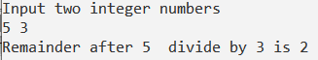
int rema(int x, int y);
int main()
{
int a, b, RE;
cout << "Input two integer numbers "<< endl;
cin>> a>>b;
RE=rema(a,b);
cout << "Remainder after " <<a <<" divide by"<<b <<" is " <<RE<< endl;
return 0;
}
int rema(int z, int w)
{ int REE;
REE=z%w;

return (REE);
}

