Ex/ Write a C++ program to find the largest element in an array with its index.
#include<iostream>
using namespace std;
int main()
{
int large, arr[100], size, i;
cout<<"\n Enter Array Size (Max 100): ";
cin>>size;
cout<<"\n Enter Array Elements : \n";
for(i=0; i<size; i++)
{
cin>>arr[i];
}
cout<<"\n Searching for Largest Number \n\n";
large=arr[0]; int j;
for(i=0; i<size; i++)
{
if(large<=arr[i])
{j=i;
large=arr[i];
}
}
cout<<"Largest Number = "<<large≪” in index≪j ;
return 0;
}

Ex/ Write a C++ program to read two vectors and find the sum of them, and print each pair with its result.
#include<iostream>
#include<iomanip>
using namespace std;
int main()
{ int const n=5;
int A[n], B[n], C[n], i;
cout<<"\n Enter Elements of Array A: \n";
for(i=0; i<n; i++)
{
cin>>A[i];
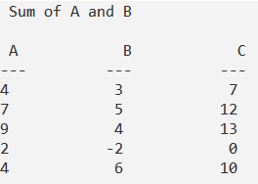
}
cout<<"\n Enter Elements of Array B: \n";
for(i=0; i<n; i++)
{
cin>>B[i];
}
cout<<"\n Sum of A and B \n\n";
for(i=0; i<n; i++)
{
C[i]= A[i] +B[i];
}
cout<<" A"<<setw(13) <<"B"<<setw(13)<<"C"<<endl;
cout<<"---"<<setw(12) <<"---"<<setw(13)<<"---"<<endl;
for(i=0; i<n; i++)
{
cout<<A[i]<<setw(13) <<B[i]<<setw(13)<<C[i]<<endl;
}
return 0;
}
Ex/ Write a C++ program to read two vectors and print all pairs of values which its addition is greater than 10.
#include<iostream>
#include<iomanip>
using namespace std;
int main()
{ int const n=5;
int A[n], B[n], i;
cout<<"\n Enter Elements of Array A: \n";
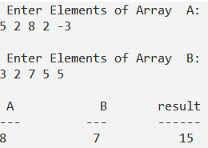
for(i=0; i<n; i++)
{
cin>>A[i];
}
cout<<"\n Enter Elements of Array B: \n";
for(i=0; i<n; i++)
{
cin>>B[i];
}
cout<<"\n\n\n";
cout<<" A"<<setw(13) <<"B"<<setw(13)<<"result"<<endl;
cout<<"---"<<setw(12) <<"---"<<setw(13)<<"------"<<endl;
for(i=0; i<n; i++)
{
if (A[i] +B[i]>10)
{
cout<<A[i]<<setw(13) <<B[i]<<setw(13)<<A[i]+B[i]<<endl;
}
}
return 0;
}

Ex/ Write a C++ program to rerange (sort) from largest to smallest.
#include<iostream>
#include<iomanip>
using namespace std;
int main()
{ int const n=5;
int A[n], B[n], i,j,c;
cout<<"\n Enter Elements of Array A: \n";
for(i=0; i<n; i++) {
cin>>A[i]; }
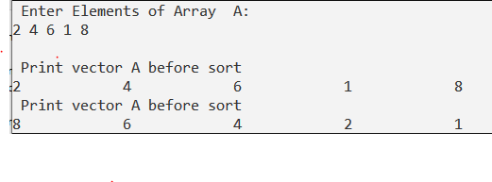
cout<<"\n Print vector A before sort \n";
for(i=0; i<n; i++)
{
cout<< A[i]<<setw(13);
}
for(i=0; i<n; i++)
{
for(j=i; j<n; j++)
{
if (A[i]<A[j])
{
c=A[i];
A[i]=A[j];
A[j]=c;
}}}
cout<<"\n Print vector A before sort \n";
for(i=0; i<n; i++)
{
cout<< A[i]<<setw(13);
}
return 0;}

