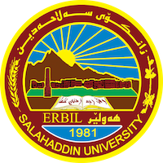
Academic Curriculum Vitae

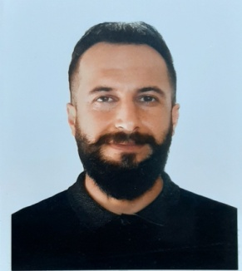
Full Name: Rebeen Khaleel Qader
Academic Title: Lecturer
Email: rebeen.qader@su.edu.krd
Mobile:

Education:
- B.A. degree in Kurdish language & literature 2007
- M.A. degree in Kurdish literature 2010
- PH. D. degree in Kurdish literature – Literary Criticism 2023

Employment:
- State employment starting from first employment in 2010 in the college of education – English department.

Qualifications
- Teaching qualifications: • Bachelor's Degree in Kurdish Language and Literature - College of Language - Department of Kurdish Language - Salahaddin University -
• Master's Degree in Kurdish Literature – College of Language – Salahaddin University –
- IT qualifications: I have very good knowledge of using computer programs and the Internet, as well as knowledge of the Internet and many of its programs, systems and information I know the world of the Internet and how to search for information and have good experience in this regard.

Teaching experience:
- Initially, I taught Kurdology in the first year of English, Biology, Chemistry and Physics. Later, I taught literary criticism in the third grade and practical criticism in the fourth grade in the Kurdish language department. also
- In 2015, I taught literary genres in the Kurdish department of Makhmur College of Education.

Research and publications
- Poetry of Prison in Kurdish Literature (Four Kurdish Poets for Example), University Journal, No. (5), Volume (20).
- Historical Criticism Method in Mr. Fallah's New Kurdish Poetry Caravan, Academic Journal.
- Features of scientific criticism within the framework of the presence of a single critical approach PhD thesis (Structural criticism from theory to practice) as an example.
- Integrative Criticism in the of Kurdish poetry Criticism Master's thesis (The Poetic Language and the new Literary Criticism) as an example

