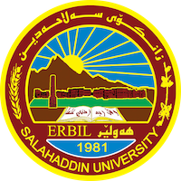
Academic Curriculum Vitae

Personal Information:
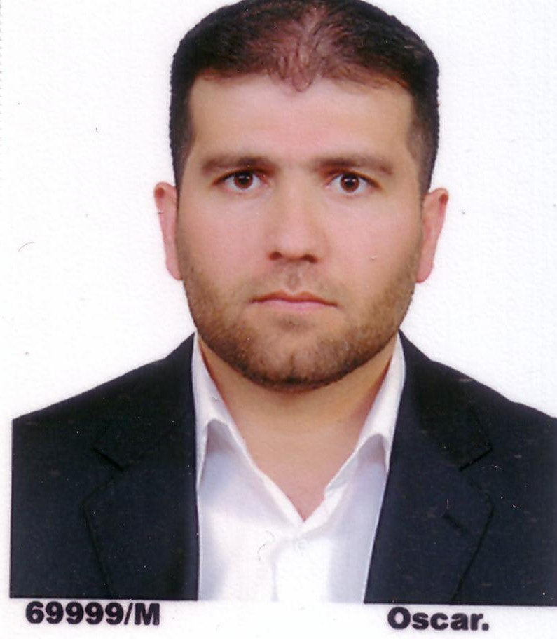
- Full Name: REBWAR MUHAMMAD HAMASALIH
- Academic Title: Assistant Professor
- Email: rebwar.hamasalih@su.edu.krd
- Mobile: 07512686561
Education:
- B.Sc. in Biology (2002–2003), College of Education, Salahaddin University-Erbil
- M.Sc. in Microbiology (February, 2009), Salahaddin University-Erbil
- Ph.D. in Molecular Biology (May 2020), Salahaddin University-Erbil
Employment:
- Assistant Biologist/Demonstrator (November 2003-November 2006) at Department of Biology, College of Education, Salahaddin University-Erbil
- Assistant Lecturer (May 2010-2015).
- Lecturer (August 2015-2020).
- Assistant Professor (June 2020-present).
- The decider of the Biology Department (September 2013-January 2014).
- Member of the Examination Committee of the College of Education (2009-2015, 2020-2021, and 2022-2023).
Qualifications
- Microsoft Windows Training Course (September 2002).
- First Aid Course (November 2002).
- Teaching Methods Course (November 2009 – May 2010).
- IELTS (August 2014).

Teaching experience:
- Biostatistics (2nd Class, Department of Biology).
- Molecular Biology (4th Class, Department of Biology).
- Ecology and Pollution (3rd Class, Department of Biology).
- Microbiology (3rd Class, General Science Department).
- Phycology (3rd Class, Pathological Analysis Department).
- Pathogenic Bacteria and Immunology (4th Class, Department of Biology).
- Advanced Biology (M.Sc. students, Department of General Science, Basic Science College).
- Advanced Molecular Biology (M.Sc. students, Department of Biology.
Research and publications
- Rebwar M. Hama Salih and Adel K. Kheder. (2009). Effects of Both Aqueous and Alcoholic Extracts of Quercus infectoria against Antibiotic Resistance Pseudomonas aeruginosa: In vitro and in vivo Study. ZANKO JOURNAL OF PURE AND APPLIED SCIENCE, 3 (2): 89-99.
- Hêro F.S. Akrayi, Rebwar M.H. Salih and Pishtiwan A. Hamad. (2015). In Vitro Screening of Antibacterial Properties of Rhus coriaria and Origanum vulgare against Some Pathogenic Bacteria. ARO THE SCIENTIFIC JOURNAL OF KOYA UNIVERSITY, 3 (2): 35-41.
- Suhaila N. Darogha, Rebwar M. Hama Salih and Mahmoud K. Nuri. (2013). Antimicrobial Resistant Patterns of Bacterial Isolates from Patients Attending Erbil Hospitals. 4th International Conference and Workshop on Basic and Applied Science, And 11th Regional Annual Fundamental Science Symposium 2013 (ICOWOBAS-RAFSS 2013), Johor, Malaysia.
- Rebwar M.H.S. Hallabjaiy, Suhaila N.R. Darogha Pishtiwan A. Hamad. (2016). Vancomycin Resistance among Methicillin Resistant Staphylococcus aureus Isolated from Clinical Samples in Erbil City-Iraq. KIRKUK UNIVERSITY JOURNAL/ SCIENTIFIC STUDIES (KUJSS), acceptant letter.
- Rebwar M. Hama Salih, Khadija Khalil Mustafa and Zirak F. A. Abdulrahman. (2015). Anti-biotype of Different Bacteria Isolated from Different Clinical Sources. TIKRIT JOURNAL OF PURE SCIENCE, 21 (1): 21-30.
- Rebwar M. Hama Salih, and Zirak F. A. Abdulrahman. (2019). Antibiofilm Potency of Ginger (Zingiber officinale) and Quercetin against Staphylococcus aureus Isolated from Urinary Tract Catheterized Patients, Applied Ecology and Environmental Research 18 (1), 219-236.
- Rebwar M. Hama Salih, and Zirak F. A. Abdulrahman. (2020). Prevalence and diversity of virulence genes among Staphylococcus aureus isolated from urinary tract catheterized patients, Biochemical and Cellular Archives 20 (1), 213-225.
- Rebwar M. Hama Salih, Ahmed N. Hassan and Rastee H. Saeed. (2020). Plasmid Profile and Transformation Efficiency in Staphylococcus aureus isolated from different clinical specimens. Pakistan journal of medical and health sciences, 14(3): 1484-1593.
- Rebwar M. Hama Salih. (2020). In Vitro Analysis of Single and Combined Antibiotic Combination in Alone and Plant Extract against Escherichia coli and Staphylococcus aureus, European Journal of Molecular & Clinical Medicine, 7(11): 2840-2852.
- Rebwar M. Hama Salih, Karzan M. Abdulmuhsin and Pinar K. Sardar. (2020). Contaminant investigations of regularly used eye contact lenses, Indian Journal of Forensic Medicine & Toxicology, 15(2): 121-134.
- Kamal Ismael Bakr, Sherko Muhammed Abdul-Rahman, Rebwar Muhammad Hamasalih. (2021). Molecular detection of β-lactamase genes in Klebsiella pneumoniae and Escherichia coli isolated from different clinical sources. Cellular and Molecular Biology, 67(4):170-180.
Conferences and courses attended
- Training course about First Aid and Safety (November 6-7, 2002).
- Teaching Method Course (November 1, 2009 – May 5, 2010).
- Training course about the use of Camtasia Studio Program (March 2010).
- Workshop on (the use of PowerLab Data Acquisition Systems in teaching and research) held at the University of Zakho, Faculty of Science, Department of Biology (October 26-27, 2011).
- Workshop on (PowerLab Data Acquisition System as a Modern and Advanced High-Tech instrument for Teaching and Research) held in MRC in Hawler Medical University (February 22, 2012).
- Workshop on Microscope by MEIJI Company, Japan in Biology School, Faculty of Science, Garmian University (March 11 and 12, 2013).
- Workshop on (EndNote Software) held in the Department of Biology, College of Education, Salahaddin University-Erbil (April 10-11, 2013).
- Training course on Successful Political Discourse (February 18-20, 2014).
- 4th Scientific Conference on 4th Class Students Researches held in College of Education, Salahaddin University-Erbil during 20-21 May 2014.
- The 2nd International Ecology, Environment, and Energy Conference (ICEEE2015) were held in Erbil-Iraq in collaboration between the Faculty of Education of Ishik University and the College of Education of Salahaddin University-Erbil during 12-13 April 2015.
- 1st Scientific Conference on 4th Class Students Researches held in College of Education/Shaqllawa, Salahaddin University-Erbil (May 18, 2016).
- The 4th International Scientific Conference of Cihan University-Erbil on Biological Sciences (CIC-BIOS´17) was held in Erbil, Kurdistan Region-Iraq, during 26-27 April 2017.
- 2nd EPU Symposium Internationalization of Scientific Research in Kurdistan (May 2 and 3, 2017).
- Workshop on (Food Borne Diseases) held at Knowledge University (May 14, 2017).
- Workshop on (Public Health Hazards Caused by the Presence of Antibiotic Residues in Food) held at Knowledge University (May 17, 2017).
- A workshop on (Research Excellence) was held at Erbil Polytechnic University (December 13, 2017).
- The 5th International Conference on Applied Science, Energy and Environment (ICASEE2018) was held in Erbil, KRG - Iraq, by the Faculty of Education of Ishik University, during 7-8 April 2018.
- Workshop on (Article Preparation and Publishing in International Journals for Ph.D. Students) held in College of Education, Salahaddin University-Erbil (4th & 6th March 2018).
- Training Course about (Endnote and GraphPad Prism 6 Training Course for Ph.D. Students) held in College of Education, Salahaddin University-Erbil (7-8 March 2018).
- 1st International Conference on Pure and Applied Science (ICPAS 2018) held at Koya University, Kurdistan Region-Iraq, during 23-24 April 2018.
- Workshop on (1st Moodle Platform Workshop-EDU) held in College of Education, Salahaddin University-Erbil (January 23, 2020).
- 1st Cancer and Oncology Research Endeavour Symposium (CORE Symposium) (February 20, 2020).
- Bio-Risk Management Workshop (Online) held by the Directorate of Health and Safety, Salahaddin University-Erbil (4-6 September 2020).
- Fourth Excellent Paper Symposium (Online) held by Kscien Organization for Scientific Research (March 17, 2021).
- Student-Centered Learning (Online) Workshop Jointly organized by Salahaddin University-Erbil, College of Education & Centre of Pedagogical Training (April 25, 2021).
- First Scientific Conference of the College of Health Sciences (Online) held by the College of Health Sciences at Hawler Medical University (6-7 September 2021).
- Common Obstacles in Student Projects Workshop held by Salahaddin University-Erbil (November 4, 2021).
- Computer Vision: Applications and Technologies (Online) Workshop organized by the University of Garmian (December 6, 2021).
- Diagnostic Quality and Trust (DIQAT) – Symposium held by the General Directorate of Scientific Research Center at Salahaddin University-Erbil (February 23, 2023).
Funding and academic awards
- No.
Professional memberships
- Kurdistan Biology Syndicate (2004 – Present).
- Kurdistan Teachers Union (2005 – Present).
- Centre of Culture and Society of Salahaddin University-Erbil (2008 – Present)
Professional Social Network Accounts:
- ReserchGate: https://www.researchgate.net/profile/Saman-Abdulkareem
- Google Scholar: https://scholar.google.com/citations?user=xfhkcE4AAAAJ&hl=en
- LinkedIn: https://www.linkedin.com/in/saman-muhsin-5b1815121/
- Academia: https://salahaddin-erbil.academia.edu/smuhsin
- ORCID: https://orcid.org/my-orcid?orcid=0000-0001-9008-6917

