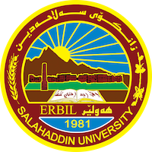
Academic Curriculum Vitae
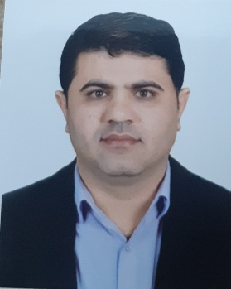
Personal Information:
Full Name: Rebwar Khdir Shekha
Academic Title: Assist Lecturer
Email: rebwar.shekha@su.edu.krd
Mobile:0750 4899355

Education:
- M. Sc. Degree in Biology -Ecology (water pollution), Department of Biology College of Education, University of Salahaddin – Erbil. Iraq.
Title of thesis “Physico-chemical characterization and bacteriological of Balakyan River, Oran District-Erbil Province, Kurdistan Region -Iraq”
Date of attainment August 24, 2015.
- B. Sc. Degree General Biology, Department of Biology, College of
Education, University of Salahaddin–Erbil. Iraq.
Title of Research Project “Solid waste in Erbil city”
Date of attainment July 06, 2008
Employment:
- Juley 19, 2009 Demonstrator. At Biology Dept., Education College, Salahaddin University – Erbil, Iraq.
- March 06, 2014 Assist. Lecturer.
Qualifications
- Teaching qualifications
- An excellent user of office programs and internet surfing and emailing
- Latest exam of IELTS I scored 5.5
- Any professional qualification
- You could put any professional courses you have attended

Teaching experience:
- I taught the following courses so far in public and private universities:
  - Ecology and pollution (practical + theory)
  - Animal physiology (practical and theory)
  - plant anatomy(theory)

Research and publications
- State all researches, publication you made.

Conferences and courses attended
- Give details of any conferences you have attended, and those at which you have presented delivered poster presentations.

Funding and academic awards
- List any bursaries, scholarships, travel grants or other sources of funding that you were awarded for research projects or to attend meetings or conferences.

Professional memberships
- Member of Kurdistan Biologists Syndicate
- Member of Teaching Kurdistan.

Professional Social Network Accounts:

- ORCID Link : https://orcid.org/0009-0000-8091-6382
- Google Scholar Citation (GSC) Link : https://scholar.google.com/citations?view_op=list_works&hl=en&user=R3i3MioAAAAJ&gmla=AJsN-F4AUkheiq1chw5V3K9zaD3NAOWEEjnVacJX4GGieSUkR7iRPcPdlTG6wyZtycnmRft0AIgaoyDR1aU9JNY0L1iRhKPLv8DS61WhfosS69cWnoBL7Ox0lqkYZIR_382QhGXQ_xQW
- ResearchGate Link : https://www.researchgate.net/profile/Rebwar-Shekha

