Practical Ecology and pollution
--------------------------------------------------------------------------------------------------------------------

Q/ A- Define the following:
- Softening hard water
2- Water acidity
3-Turbidity
4-Temparary Hardness
5-soil
6-texture

Fill the following blanks with appropriates word and phrase:
1- There are two methods to detect soil texture classes such as ---------------------& ---------------------that using in --------------------- & -------------------- respectively.
2-The instruments that use to measuring humidity are ---------------, --------------& ----------------.
3 -Forms of soil water are -------------------------, -----------------------------& ---------------------------
4- water holding capacity is ----------------
5-components of the soil are---------------
6- The instruments that use to measuring wind speed and direction are---------------------
- The main sources of carbon dioxide in the water are …………………… and………………….
- Phenonaphthaline indicator produce pink color when it is added to water with pH ………………….
- ……………………… It is a type of measured acidity in water by titration to a pH of less than 4.5 and by using ……………………… indicator to determined it.
- The indicator that uses to determine total hardness is called ………………. and to determine calcium hardness is called ……………………
- Before each water sampling, the turbidimeter should be calibrated by using standard solution of …………………, …………………and …………………… NTU.
- Salts of calcium and magnesium in the hard water are as ………………., ………………, and …………………...
- Despite of geological formation, other factor that affects the values of total hardness is ………………
- Main components of alkalinity are …………………, ………………….and…………….
- …………………………. is hardness that cannot be removed by boiling.
- In laboratory, turbidity is measured by …………………... method using a turbidimeter.
- The ability to resist changes in pH by neutralizing acids or bases is called …………………….

Define the following:
1- Atmospheric pressure 2- water holding capacity 3- Meteorological station
4- Air quality Index 5- wind direction 6- anemometer 7-hygrometer 8- psychrometer

Match A & B:
No | A | No | B
1 | Sand |  | Wind speed
2 | anemometer |  | maximum thermometer
3 | Psychrometer |  | Organisms
4 | R horizon |  | Wind direction
5 | Mercury thermometer |  | Has large pore, lacks the ability to hold nutrient and water.
6 | Synodor |  | Wind direction
7 | vane |  | Water vapor in air
8 | Factors effect on soil |  | Maximum and minimum temperature
9 | Silt |  | Surface layer
 |  |  | Precipitation
 |  |  | Diameter is 0.002 to 0.05 mm
 |  |  | Has Small pore, large particles, has ability to save water
 |  |  | final layer
 |  |  | Atmospheric pressure
 |  |  | Diameter <0.002 mm

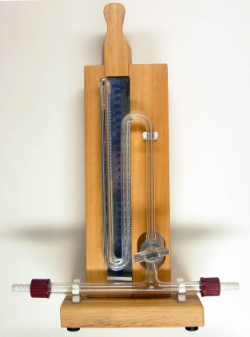
Answer the following according on this figure:
- Name of it?
- Function of it?
- Mechanism work of it?

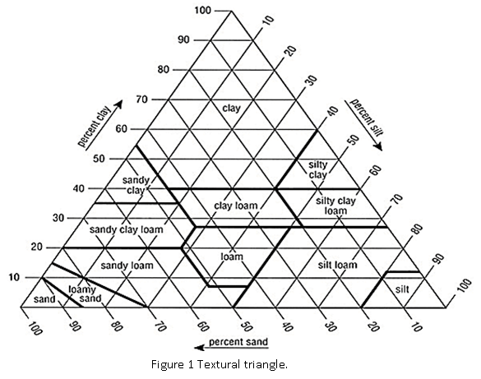
In the sample soil, the clay% is three times greater than sand%, (if sand is 20), calculating soil textural class depending on this figure? Then, write characteristics of it?

Q/-Write briefly about the following:
- Alkalinity is important to aquatic organisms.

- Using PH 10 to determining Ca⁺² hardness?

- Moderate acidity in irrigation water is beneficial to alkali soils.

- Turbidity can harm fish and other aquatic life.

Q/ A 50 mL water sample is tested for Alkalinity. If 1.2 mL titrant (0.02 N H2SO4) is used to pH 8.3 and and 4 mL titrant is used to pH 4.5, calculate:
- phenolphthalein alkalinity

- Total alkalinity

- Acidity

- Name indicators and its colors that used in this test

Q- Count the methods of softening hard water and write about one of them.
C- Count the sources of H⁺ in water.

