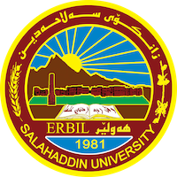
Academic Curriculum Vitae

Personal Information: 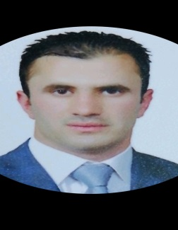
Full Name: REDAR KHUDHUR RAHMAN
Academic Title: Assistant Lecturer
Email: redar.rahman@su.edu.krd
Mobile:07504720475

Education:
- Zhangar Primary School, Erbil- Iraq, 1996-1997.
- Barzany Namr Scientific High School, Erbil-Iraq, 2003-2004
- B.A of Law- Salahaddin University ,Erbil-Iraq, 2007-2008
- Master of Private Law-Salahaddin University, Erbil-Iraq, 2016.

Employment:
- Shagull Medical Supplies Company, As An Accountant and Cashier
for three months.
- Move One Logistic Company, As An Operator for six months.
- Salahaddin University (Colleges of Arts, Physical Education and
Law), As An Employment for Thirteen Years.
- Tishknet Internet Services Company, As A Representative for two
months.
- Salahaddin University- Eerbil, College of Law, As An Assistant
Lecturer for three years ,and I am still on my job.
Qualifications
- Computer Training Course (word and Excel), Salahaddin University-
- Erbil, (from 1/6/2009 to 1/7/2009).
- Taking Course of English qualification, Salahaddin University-Erbil, (from
- 1/2/2010 to 1/5/2010).
- Taking Course of learning English language, Cambridge University, (from 1/10/2010
- to 1/1/2011).
- Computer Training Course (word and Excel), Salahaddin University-
- Erbil, (from 4/6/2011 to 3/7/2011).
- Teaching Methods and Research Methodology, Salahaddin University
- Erbil, (from 24/7/2017 to 24/3/2018).
- Training Workshop om Bologna Process, Salahaddin University-
- Erbil, (from 3-4/11/2019).
- E-Learning Course, Salahaddin University, (21,23/9/2020).
- Participating in Workshop, Soran University, (14/4/2021).
- Participating in Course Continuing Education, Musl University, (20-
- 21/4/2021).
- Student Centered Learning, Salahaddin University- Erbil, (25/4/2021).

Teaching experience:
- Academic Year, College of Law, Salahaddin University- Erbil, 2019-
2020.
- Academic Year, College of Law, Salahaddin University- Erbil, 2020-
2021.
- Academic Year, College of Law, Salahaddin University- Erbil, 2021-
2022.

Research and publications
- Obligations arising from the contract of air transportation of dangerous goods and responsibility arising from breach (A Comparative study)- Master’s Thesis

Conferences and courses attended
- conferences I have attended: Third International Conference (The phenomenon of child addiction to drugs in a period of COVID19-20) University of Tikrit and University of Kufa and BCR, 29-30/6/2021.
- Funding and academic awards
- Non.

Professional memberships
- Kurdistan Jurists Union
Professional Social Network Accounts:
- redar.rahman@su.edu.krd-ReserchGate
- redar dizaye – LinkedIn
- @redar_rahman – Twitter

It is also recommended to create an academic cover letter for your CV, for further information about the cover letter, please visit below link:
https://career-advice.jobs.ac.uk/cv-and-cover-letter-advice/academic-cover-letter/

