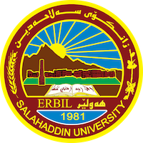
Academic Curriculum Vitae
Personal Information:
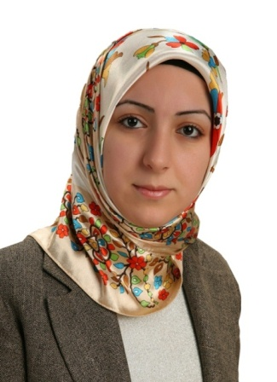
Full Name: Reka Husamaddin Yasin
Academic Title: Assistant Lecturer
Email: Reka. yaseen@su.edu.krd
Mobile:+964750 4613194

Education: Bachelor degree in English Language.

Employment: Full time (Lecturer)

Qualifications: Masters in TESOL in U.K.

Teaching experience: 7 years of experience.

Research and publications:

